

## AI Data Powered Analysis Early Internship - Sub-Group 7

**Week-2 Final Report**

# Report Title: “Week-2: Exploratory Data Analysis, Insight Generation and Hypothesis Development Report ”

**Associate Members:**

|  |  |
| --- | --- |
| **Name** | **Email** |
| Kolawole Oparinde | [kolawole@vempower.org](mailto:kolawole@vempower.org) |
| Akanksha Choudhary | [akanksha@vempower.org](mailto:akanksha@vempower.org) |
| Sakshi Sahu | [sakshisahu@vempower.org](mailto:sakshisahu@vempower.org) |
| Shishir Jaiswal | [shishir@vempower.org](mailto:shishir@vempower.org) |
| Shruti Mishra | [shrutimishra@vempower.org](mailto:shrutimishra@vempower.org) |

**Team Members:**

|  |  |  |
| --- | --- | --- |
| **Name** | **Role** | **Email** |
| Sumaiya Tasnim | Team Lead | [sumaiyaa.tasnim.18@gmail.com](mailto:sumaiyaa.tasnim.18@gmail.com) |
| Saniya Dantal | Project Scribe | [dantalsb04@gmail.com](mailto:dantalsb04@gmail.com) |
| Zaheer 123 | Project Manager | [mianzaheer4195@gmail.com](mailto:mianzaheer4195@gmail.com) |
| Devadharshini T | Project Lead | [dharshinideva83@gmail.com](mailto:dharshinideva83@gmail.com) |
| Peter Macharia | Team Member | [mpeter778@gmail.com](mailto:mpeter778@gmail.com) |
| Bokka Hamsini | Team Member | [bokkahamsini@gmail.com](mailto:bokkahamsini@gmail.com) |

## Introduction:

In the second week of the internship, we will focus on Exploratory Data Analysis (EDA), which is an essential step in understanding datasets before moving toward advanced AI-driven analytics. Through EDA, we will explore data to uncover patterns, identify anomalies, and summarize key characteristics using both statistical methods and visual techniques. The insights gained during this phase will form the foundation for building predictive models and driving meaningful AI-powered decisions in the coming weeks.

## Objectives:

* Explore the dataset to understand its structure, key variables, and potential challenges.
* Perform statistical analysis to summarize data distributions, trends, and correlations.
* Apply visualization techniques to represent data clearly and identify hidden patterns.
* Generate preliminary insights and hypotheses for guiding advanced analysis.
* Compile findings into a structured EDA report that documents trends, anomalies, and recommendations.

**Assigned Dataset : “**SLU_Opportunity_Wise_Data.csv”

**Cleaned Dataset was exported as :** “Cleaned_Preprocessed_Dataset.csv”

**Applied Features in dataset was renamed as :** “Featured_Dataset.csv”

**Tools We Will Use:**

* **Excel / Google Sheets** – For basic data exploration, cleaning, and simple visualizations (if required).
* **Python** – The primary programming language for advanced data analysis and modeling.
* **Pandas** – For efficient data manipulation, cleaning, and exploration.
* **NumPy** – For numerical computations and handling arrays.
* **Matplotlib & Seaborn** – For creating clear and meaningful charts, graphs, and plots.
* **Plotly Express** – For interactive visualizations and dashboards.
* **SciPy** – For statistical analysis and hypothesis testing.
* **Jupyter Notebook / Google Colab** – Interactive environments for performing, documenting, and sharing analysis.
* **Warnings Library** – To manage and suppress unnecessary warning messages for cleaner outputs.

## Expected Outcomes:

* Review and Verification of Week-1 Final Dataset.
* A comprehensive EDA report summarizing the dataset’s structure, trends, and anomalies.
* Clear visualizations (charts, graphs, heatmaps, plots) that highlight key patterns.
* Identification of missing values, outliers, and inconsistencies for data cleaning.
* Hypotheses and preliminary insights that will guide subsequent AI-powered modeling.
* A dataset that is well-understood and ready for predictive analytics.

## Learning Outcomes:

1. Developing a strong understanding of EDA principles and their role in data science.
2. Gaining hands-on experience in data exploration and visualization using Excel and Python.
3. Building proficiency in identifying trends, correlations, and anomalies within datasets.
4. Learning to generate insights and form hypotheses from raw data.
5. Improving skills in documenting and reporting findings effectively through an EDA report.

# Review & Verification of Dataset

## Dataset column’s Review:

|  |  |  |  |  |
| --- | --- | --- | --- | --- |
| **Column Name** | **Previous Data Cleaning** | **Latest Data Cleaning** | **Updates** | **Purpose / Reason** |
| Learner SignUp DateTime | Filled missing values with most frequent date; corrected corrupted date formats; standardized datetime64 | Filled missing values with the most frequent date in dataset; kept consistent datetime format "MM/DD/YYYY HH:MM:SS AM/PM" | Updated | To handle missing entries, ensure temporal consistency for feature engineering and analysis |
| Opportunity Id | Verified for duplicates | Already clean | Already Cleaned | Unique identifier verified, ensures integrity of records |
| Opportunity Name | Standardized categorical data, corrected capitalization | Already clean | Already Cleaned | Consistent naming for analysis and grouping |
| Opportunity Category | Standardized categorical data, corrected capitalization | Already clean | Already Cleaned | Uniform representation for statistical and visual analysis |
| Opportunity End Date | Fixed corrupted date formats, standardized datetime64, verified sequences | Filled missing values using median duration added to start date; ensured datetime consistency | Updated | To handle missing values and maintain accurate temporal calculations (duration, engagement) |
| First Name | Verified consistency | Already clean | Already Cleaned | Ensures correct identification without missing entries |
| Date of Birth | Verified formats, converted to datetime64 | Already clean | Already Cleaned | Required for age calculation, verified consistency |
| Gender | Standardized categorical data, corrected variations | Already clean | Already Cleaned | Uniform gender representation for analysis |
| Country | Standardized categorical data, corrected typos and variations, harmonized values | Already clean | Already Cleaned | Uniform country representation to avoid misclassification |
| Institution Name | Corrected typos, expanded abbreviations, replaced mismatched entries, standardized text | Filled missing values with "Not Applicable" | Updated | To handle missing entries and ensure consistency in educational institution field |
| Current/Intended Major | Corrected typos, standardized text, harmonized categories | Filled missing values with "Other"; corrected misc/others categories | Updated | To handle missing entries and ensure consistent representation of majors |
| Entry created at | Standardized datetime64 format | Already clean | Already Cleaned | Ensures temporal consistency for analysis |
| Status Description | Standardized categorical data, corrected capitalization | Already clean | Already Cleaned | Uniform representation of status for analysis |
| Status Code | Checked numeric outliers, ensured valid range | Already clean | Already Cleaned | Numeric validation ensures consistency |
| Apply Date | Fixed corrupted date formats, standardized datetime64 | Already clean | Already Cleaned | Required for engagement calculations and temporal analysis |
| Opportunity Start Date | Fixed corrupted date formats, standardized datetime64 | Filled missing values per Opportunity Name median; ensured datetime consistency | Updated | To handle missing entries and maintain accurate temporal calculations for analysis |

**Features columns- Review:**

|  |  |  |  |  |  |
| --- | --- | --- | --- | --- | --- |
| **Feature Column's Name** | **Applied Formula** | **Formula Representation** | **Explanation** | **Updates** | **Why Used / Benefit** |
| Age | =DATEDIF(G2, TODAY(), "Y") | G2 → Date of Birth | Calculates learner’s current age. | Same as previous | Helps analyze engagement across age groups; demographic insights. |
| Opportunity Duration | =E2 - P2 | E2 → Opportunity End Date, P2 → Opportunity Start Date | Measures duration of each opportunity. | Same as previous | Useful for understanding if longer or shorter opportunities affect participation and satisfaction. |
| Normalized Age | =(Q2- MIN(Q$2:Q$100))/(MAX( Q$2:Q$100)- MIN(Q$2:Q$100)) | Q2 → Age | Scales age to 0– 1 range for comparability. | Updated (Newly Added Feature) | Ensures Age contributes fairly in models without dominating due to larger numeric scale. |
| Normalized Status Code | =(N2 - MIN(N$2:N$100)) / (MAX(N$2:N$100) - MIN(N$2:N$100)) | N2 → Status Code | Converts status codes to 0–1 scale. | Same as previous | Enables fair comparison in analysis and prevents scale distortion. |
| Normalized Opportunity Duration | =IF(MAX(R$2:R$100)- MIN(R$2:R$100)=0, 0, (R2- MIN(R$2:R$100))/(MAX( R$2:R$100)- MIN(R$2:R$100))) | R2 → Opportunity Duration | Scales opportunity durations between 0–1. | Updated | Makes opportunity duration comparable and suitable for ML or statistical analysis. |
| Encoded Gender | =IF(H2="Male", 1,  IF(H2="Female", 2,  IF(H2="Prefer Not To Say", 3, IF(H2="Other", 4, "")))) | H2 → Gender | Converts gender categories to numeric codes. | Updated | Prepares gender for ML models and prevents inconsistencies with text data. |
| Encoded Opportunity Category | =IF(D2="Internship", 1,  IF(D2="Course", 2,  IF(D2="Event", 3,  IF(D2="Competition", 4,  IF(D2="Engagement", 5, ""))))) | D2 → Opportunity Category | Converts opportunity types to numeric codes. | Updated | Enables predictive analysis of different opportunity types and their impact on engagement. |
| Encoded Country | =IF(I2="United States", 1,  IF(I2="India", 2,  IF(I2="Nigeria", 3,  IF(I2="Ghana", 4,  IF(I2="Pakistan", 5,  IF(I2="Bangladesh", 6,  IF(I2="Egypt", 7,  IF(I2="Ethiopia", 8,  IF(I2="Kenya", 9,  IF(I2="Rwanda", 10,  11))))))))))) | I2 → Country | Converts countries to numeric codes. Used Top 10 Countries in encoding. | Updated | Simplifies country analysis, enables grouping and numeric computation for models. |
| Extracted SignUp Month | =MONTH(A2) | A2 → Learner SignUp DateTime | Extracts the month number from the sign- up date. | Same as previous | Useful for analyzing trends, seasonality, and monthly patterns in engagement. |
| Extracted SignUp Year | =YEAR(A2) | A2 → Learner SignUp DateTime | Extracts the year from sign- up date. | Same as previous | Helps detect long- term trends and yearly growth in engagement. |
| Extracted SignUp Day | =DAY(A2) | A2 → Learner SignUp DateTime | Extracts the day of the month from sign-up date. | Same as previous | Allows detailed daily pattern analysis of engagement. |

|  |  |  |  |  |  |
| --- | --- | --- | --- | --- | --- |
| **Feature Column's Name** | **Applied Formula** | **Formula Representation** | **Explanation** | **Updates** | **Why Used / Benefit** |
| Weekly Patterns | =TEXT(A2, "ddd") | A2 → Learner SignUp DateTime | Shows abbreviated day of the week (Sun, Mon, Tue…). | Updated | Helps detect weekday vs weekend engagement patterns. |
| Seasonal Patterns | =IF(OR(Y2=12,Y2=1,Y2=2  ),"Winter",  IF(OR(Y2=3,Y2=4,Y2=5),"  Spring", IF(OR(Y2=6,Y2=7,Y2=8),"  Summer", IF(OR(Y2=9,Y2=10,Y2=11  ),"Fall","")))) | Y2 → Extracted Month | Assigns season based on month number. | Same as previous | Detects seasonal trends, peaks, and troughs in engagement. |
| Engagement Days | =O2 - P2 | O2 → Apply Date, P2 → Opportunity Start Date | Measures lag between application and opportunity start. | Same as previous | Identifies quick vs delayed engagement, uncovering friction or motivation factors. |
| Duration × Age | =Q2 * R2 | Q2 → Age, R2 → Opportunity Duration | Multiplies age by opportunity duration to create an interaction metric. | Same as previous | Explores combined effects of learner age and opportunity length on engagement. |
| Engagement Score | =U2\**0.4 + Q2*\*0.2 + AD2\**0.3 + AE2*\*0.1 | U2 → Normalized Opportunity Duration, Q2 → Age, AD2 → Engagement Days, AE2 → Duration  × Age | Weighted composite score combining multiple engagement metrics. | Same as previous | Provides a holistic engagement measure combining duration, age, and interaction features. |

***Important Note:*** *We took out the ABS() function from the formulas and kept the original calculations, since ABS was distorting values and creating false outliers. Real outliers were then handled using* ***winsorization****, which pulls extreme values back into a reasonable range without removing any data. As a result, the dataset is now clean — with no nulls, NaNs, duplicates, inconsistencies, or negative values — and all rows remain intact.*

***Note:*** *The dataset has undergone comprehensive cleaning and feature engineering. All missing or null values have been addressed, and inconsistencies or errors in the data have been resolved. The integrity of the dataset has been maintained, ensuring that no information has been altered incorrectly. With all features accurately prepared and validated, the dataset is now fully ready for Exploratory Data Analysis (EDA) to extract meaningful insights.*

**Renamed the final Verified Dataset as : “Verified_Processed_Dataset.csv” Total Records:** 8246 rows

**Total columns:** 32

## You can view the “Verified_Processed_Dataset.csv” at the following link:

<https://drive.google.com/file/d/1es7BV21UQYphGL5-NuV1uG1TVxAHTNNp/view?usp=sharing>

# Exploratory Data Analysis

***Exploratory Data Analysis (EDA)*** is a crucial process used to examine datasets, summarize their key characteristics, and identify patterns or irregularities through statistical measures and visualizations. It helps transform raw data into meaningful insights that guide further modeling and decision-making.

**Benefits of EDA:**

* Detects missing values, duplicates and outliers
* Provides understanding of data distributions
* Validates assumptions and highlights inconsistencies
* Uncovers hidden relationships between variables
* Ensures data quality for reliable analysis
* Improves accuracy and performance of predictive models

## Performing EDA of our Dataset:

1. **Data Understanding and Exploration:**

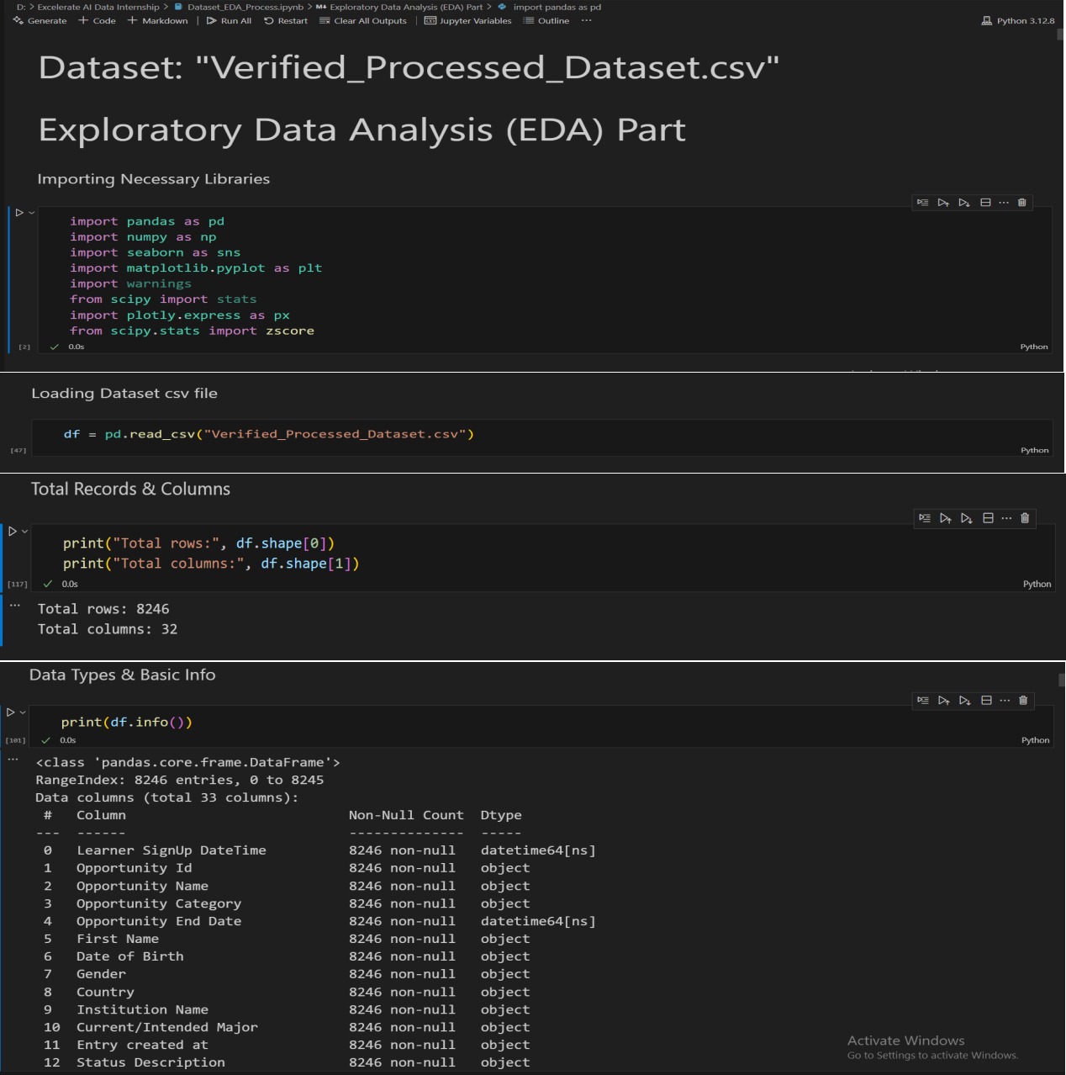

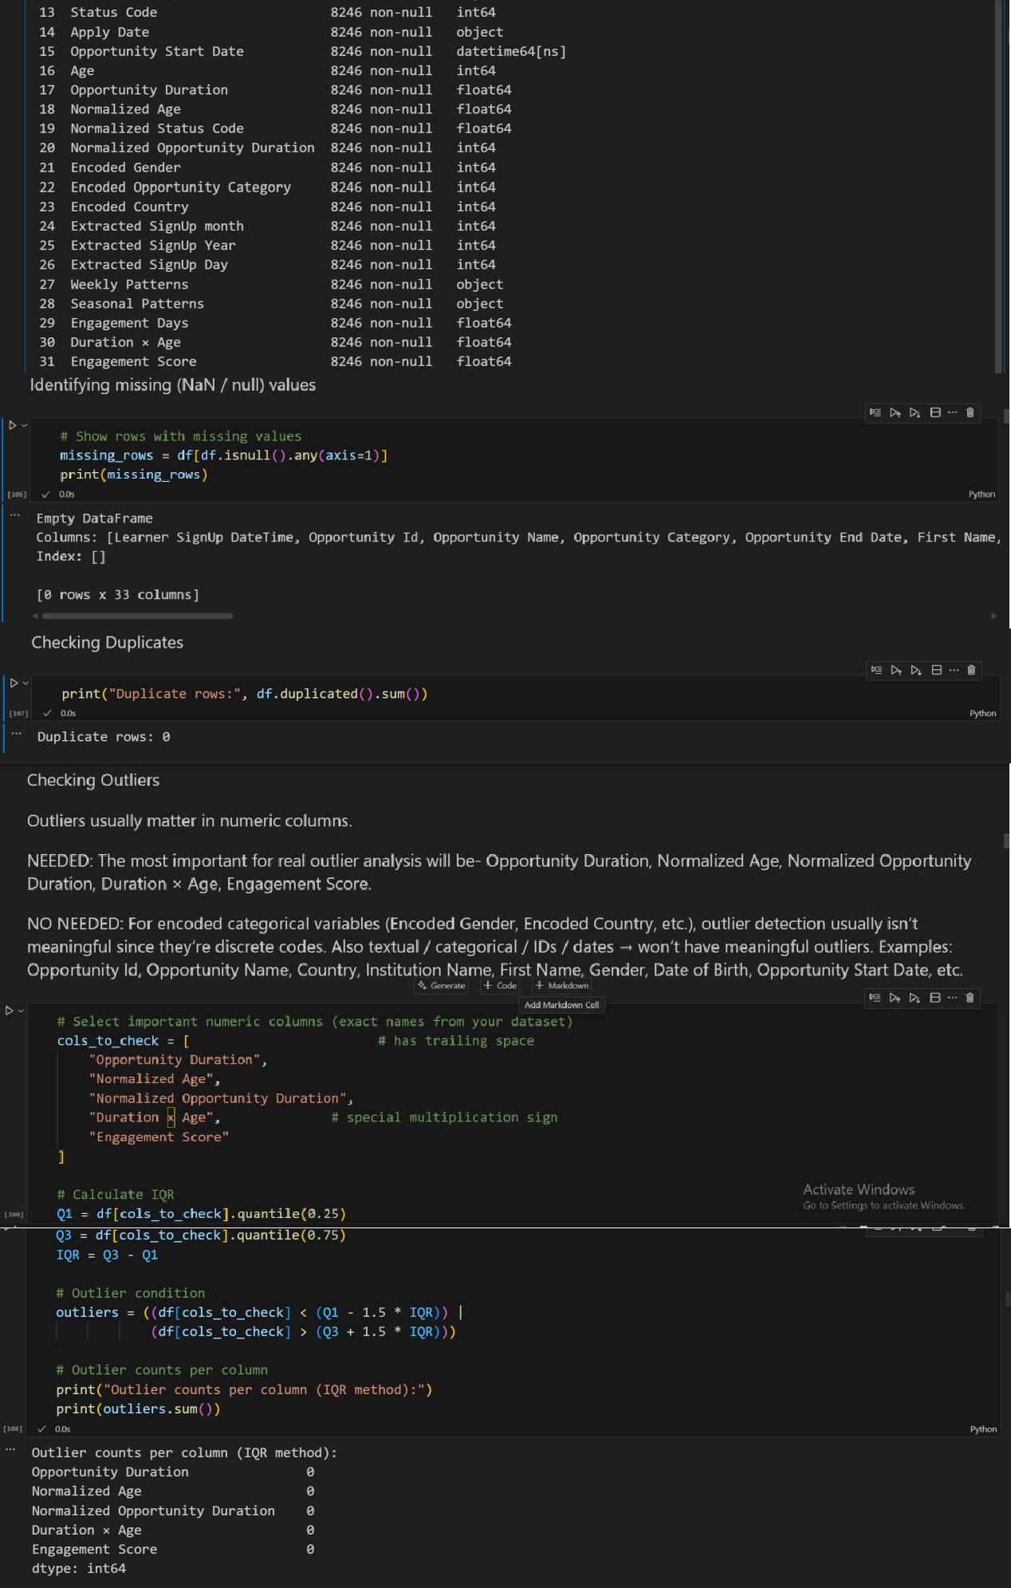

**Data Structure and Initial Checks summary:**

At the start, the dataset contains 8,246 rows and 32 columns covering various data types including dates, categorical, and numerical fields.

* + All columns have complete data with no missing values detected so far.
  + Data types were reviewed using pandas info function:
    - Date columns such as 'Learner SignUp DateTime', 'Opportunity End Date', and others were converted into datetime format for consistency.
    - Categorical columns like 'Gender', 'Country', and 'Opportunity Category' are identified as object/string types.
    - Numeric columns include 'Age', 'Opportunity Duration', 'Engagement Score', and normalized or encoded versions of several features.

**Data quality checks show:**

* No missing/NaN/NULL values
* No duplicate rows
* No outliers in key numeric columns (Opportunity Duration, Normalized Age, Normalized Opportunity Duration, Duration × Age, Engagement Score)
* No inconsistencies; all remaining data are valid and unchanged.

Overall, the dataset is clean and ready for analysis of patterns, engagement, and opportunity participation.

**DATA CATEGORY ANALYSIS**

|  |  |
| --- | --- |
| **Category** | **Columns** |
| **Identifiers** | Opportunity Id, Opportunity Name, First Name |
| **Dates** | Learner SignUp DateTime, Opportunity End Date, Date of Birth, Entry created at, Apply Date, Opportunity Start Date |
| **Numeric** | Age, Opportunity Duration, Status Code, Normalized Age, Normalized Status Code, Normalized Opportunity Duration, Engagement Days, Duration × Age, Engagement Score |
| **Categorical** | Opportunity Category, Gender, Country, Institution Name, Current/Intended Major, Status Description |
| **Encoded** | Encoded Gender, Encoded Opportunity Category, Encoded Country |
| **Seasonal Patterns** | Weekly Patterns, Seasonal Patterns, Extracted SignUp Month, Extracted SignUp Year, Extracted SignUp Day |

1. **Highlighing Basic Key Insights:**

**Identifiers**

*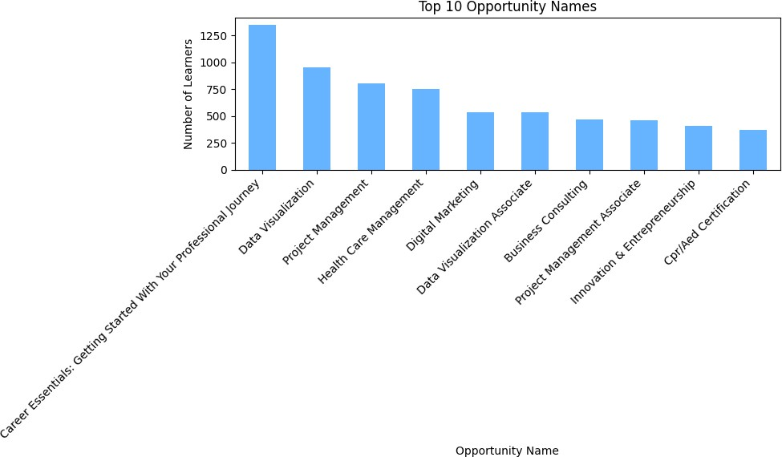(Visualized in Excel)*

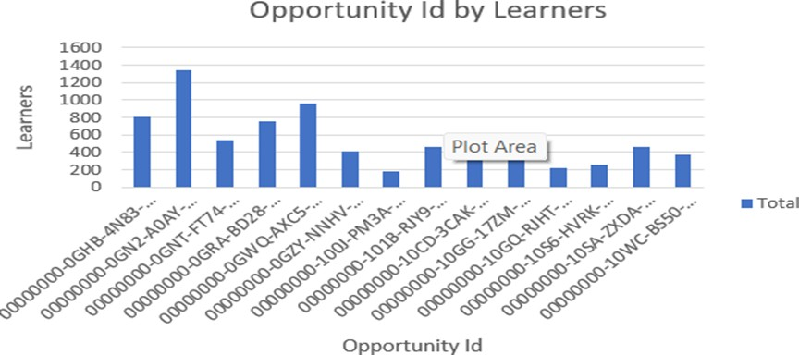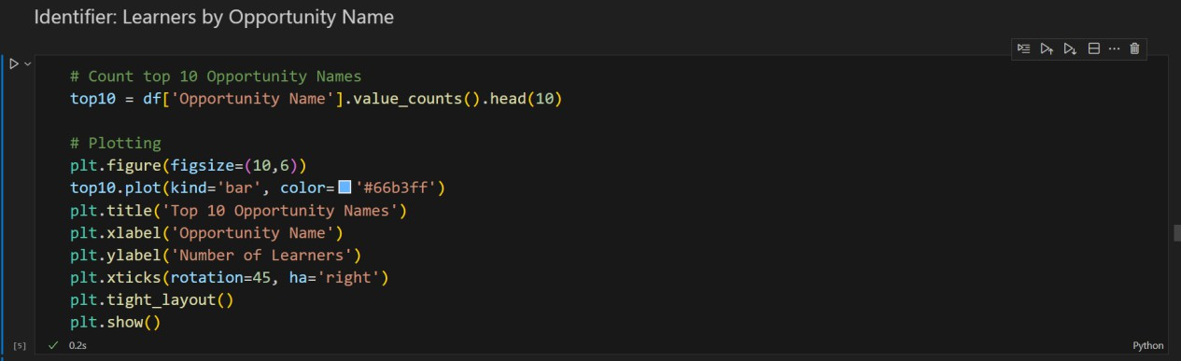

|  |  |
| --- | --- |
| **Aspect** | **Details** |
| **Figure** | Opportunity ID by Learners (Bar Chart) Opportunity Names by Learners (Bar Chart) Top 10 |
| **Columns used** | * Opportunity ID * Opportunity Name |
| **Why used** | * **Opportunity ID:** To visualize the number of learners per opportunity, identifying popular or less-attended courses, products, or events. * **Opportunity Name:** To focus on the **top 10 most- attended opportunities**, highlighting learner preferences. |

|  |  |
| --- | --- |
| **Aspect** | **Details** |
| **How it matters** | - Shows which opportunities attract more learners.- Helps in **resource allocation and planning**.- Identifies underperforming opportunities for improvement.- Highlights **learner trends and preferences** for the most popular offerings. |
| **Importance** | Important for understanding **learner engagement at the opportunity level**, enabling targeted interventions and optimizing content offerings. |

**Categorical**

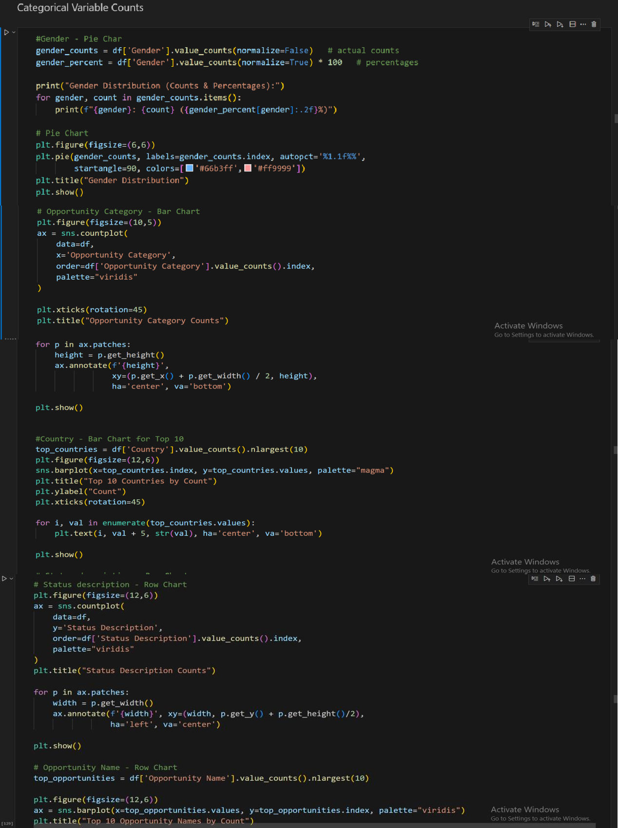

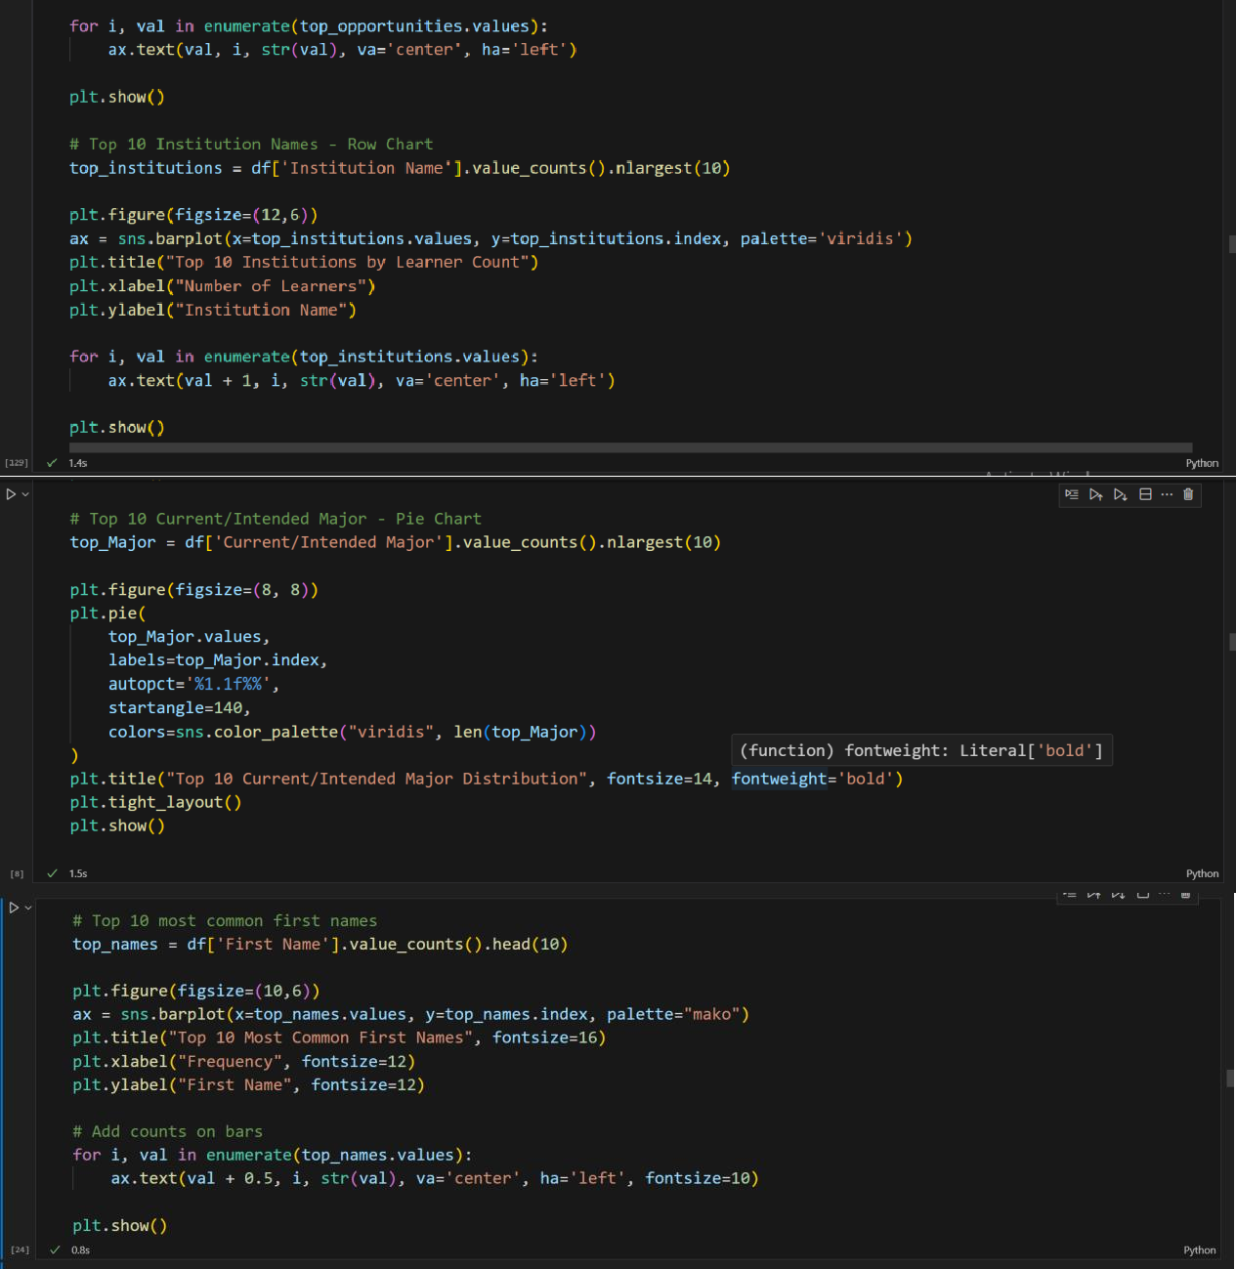

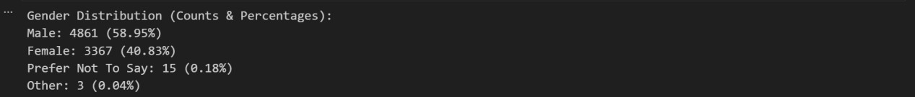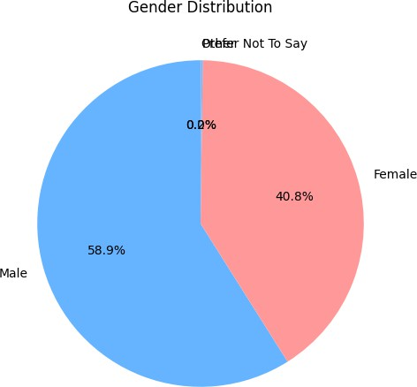

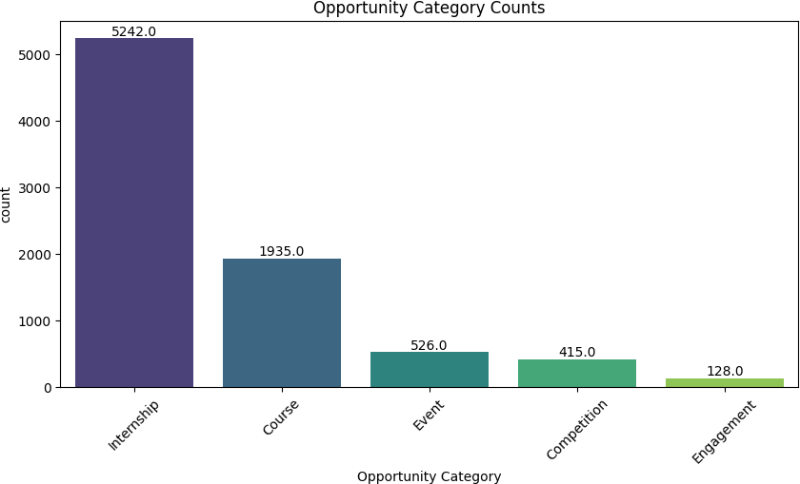

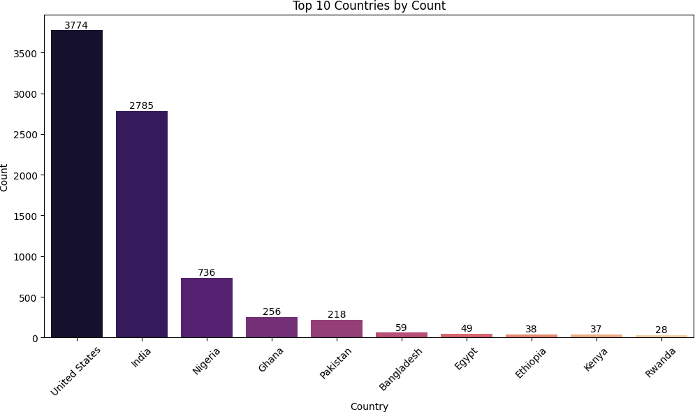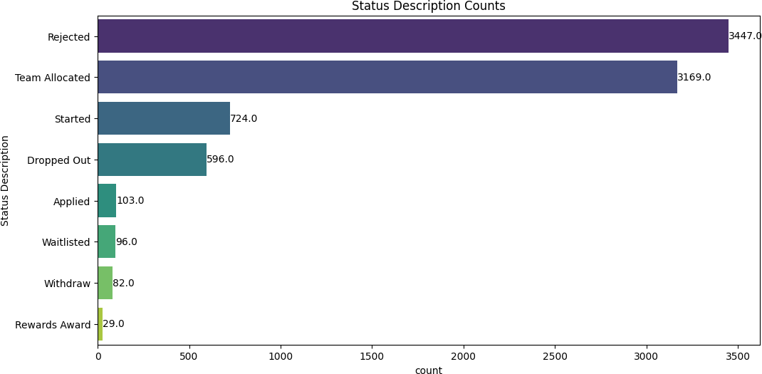

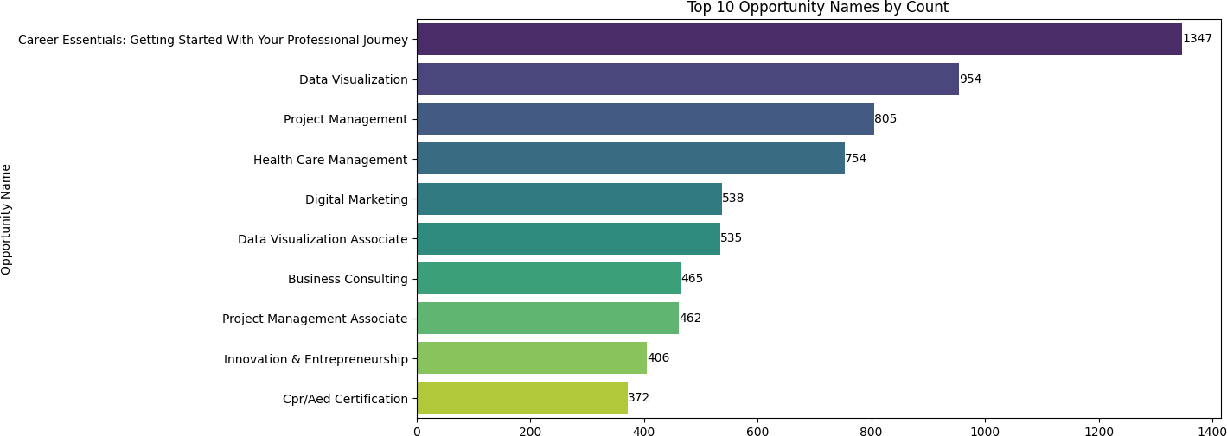

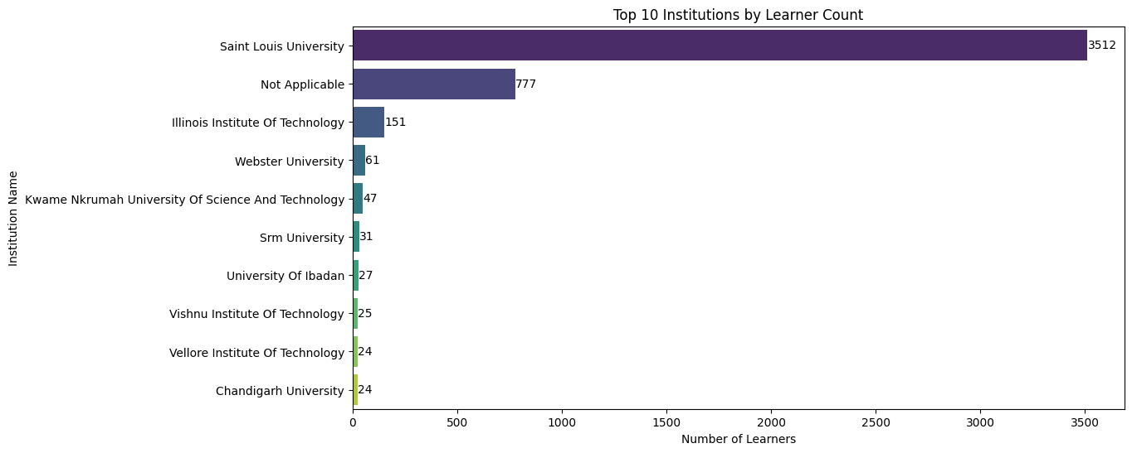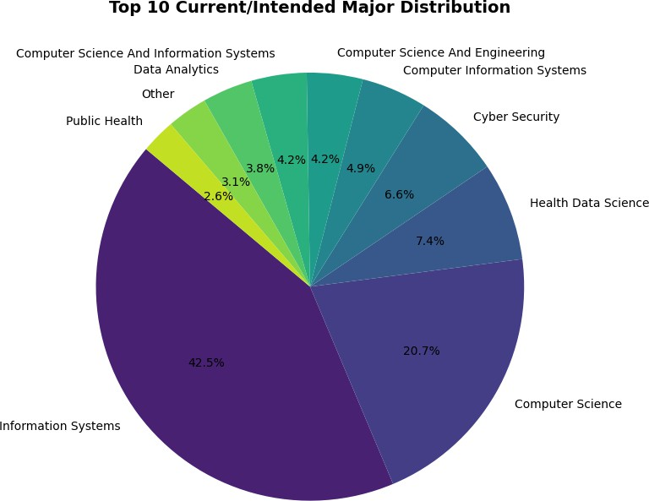

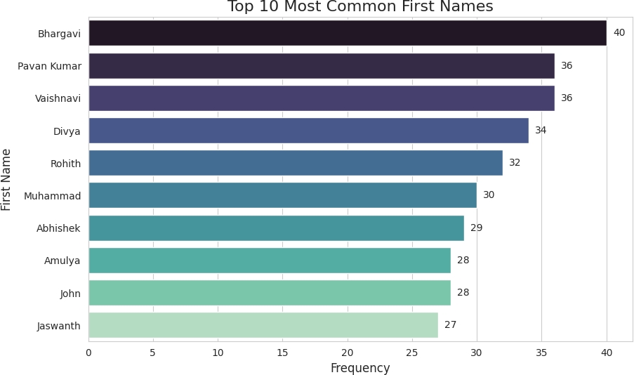

|  |  |
| --- | --- |
| **Aspect** | **Details** |
| **Figure** | Gender Distribution (Pie Chart) , Opportunity Category Counts (Bar Chart) , Top 10 Countries by Count (Bar Chart), Status Description Counts (Row Chart), Top 10 Opportunity Names by Count (Row Chart), Top 10 Institutions by Learner Count (Row Chart), Top 10 Current/Intended Major (Pie Chart), Top 10 Most Common First Names (Bar Chart) |
| **Columns used** | Gender, Opportunity Category, Country, Status Description, Opportunity Name, Institution Name, Current/Intended Major, First Name |
| **Why used** | To visualize categorical distributions across key features, highlighting patterns in learner demographics, participation, institutional representation, academic interest areas, and common names. Pie charts, bar charts, and row charts provide an intuitive understanding of counts and proportions. |
| **How it matters** | * Gender Pie Chart shows the proportion of male and female learners * Opportunity Category and Status Description charts identify popular categories and statuses. * Top 10 Countries, Opportunity Names, and Institutions highlight key contributors and trends. * Top 10 Majors Pie Chart highlights learners’ academic preferences, showing the most common fields of study. * Top 10 First Names Bar Chart shows the most frequent names among learners, which can be useful for personalization or demographic insights. * Helps in decision-making, resource allocation, and targeting strategies. |
| **Importance** | These visualizations are important for stakeholder insights, program planning, and understanding learner engagement patterns across demographics, institutions, and academic interests. They also help in detecting imbalances or gaps in participation that may require attention, and provide insight into learner naming trends for personalization or community engagement. |

1. **Visualizing Data Distributions:**

**Numerics**

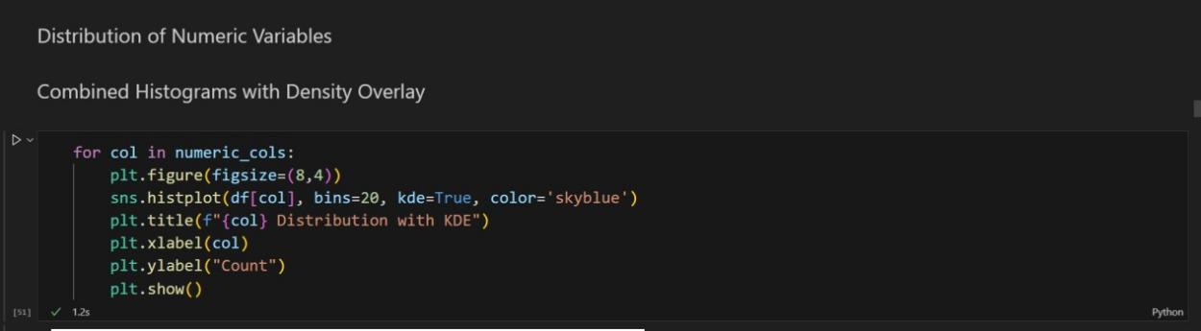

*Histograms: Detects unusual peaks or gaps.*

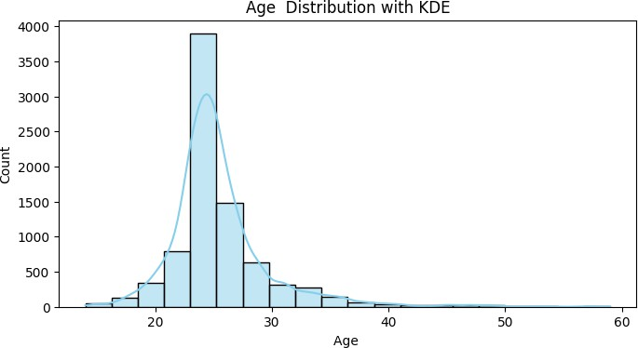

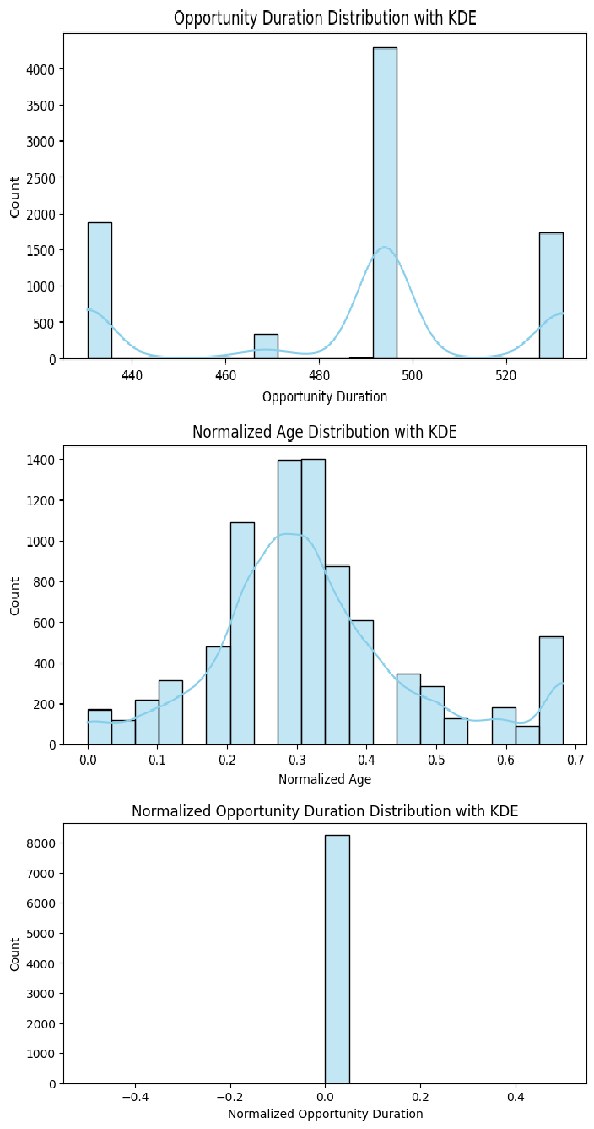

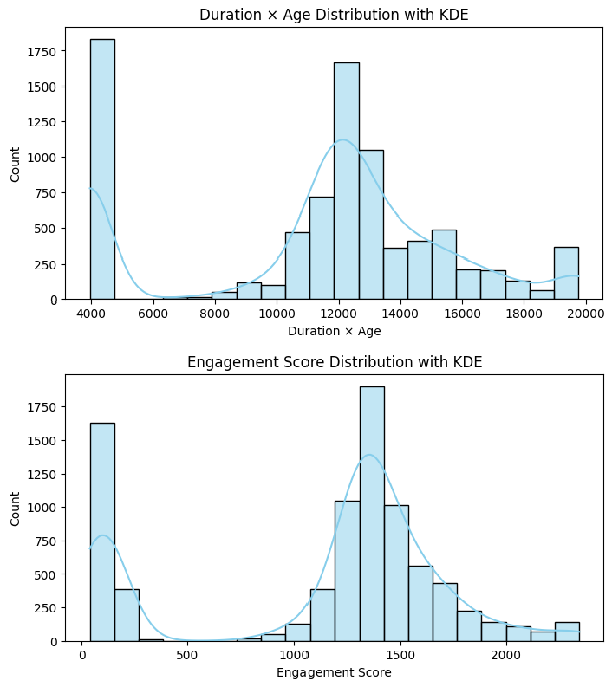

|  |  |
| --- | --- |
| **Aspect** | **Details** |
| **Figure** | Distribution of Numeric Variables with KDE (Histogram) |
| **Columns used** | Age, Opportunity Duration, Normalized Age, Normalized Opportunity Duration, Duration × Age, Engagement Score |
| **Why used** | To visualize the **distribution and density** of key numeric features. Histograms show frequency, while KDE overlays show the estimated probability density of the data. |
| **How it matters** | * Helps understand the **spread, central tendency, and skewness** of numeric features. * Identifies **potential outliers or unusual patterns**. * Useful for **data preprocessing** and selecting appropriate statistical methods. * Assists stakeholders in understanding the **overall behavior** of numeric variables. |
| **Importance** | KDE curves provide a **smooth view of data distribution**, making patterns easier to interpret than raw histograms alone. |

**Dates**

*(Visualized in Excel)*

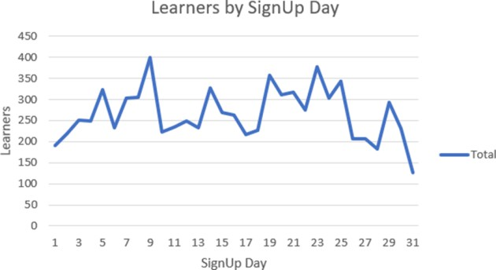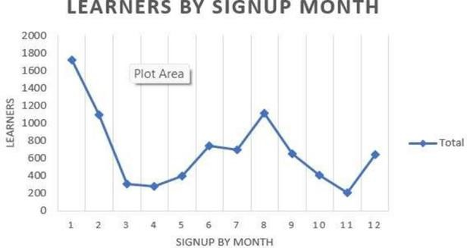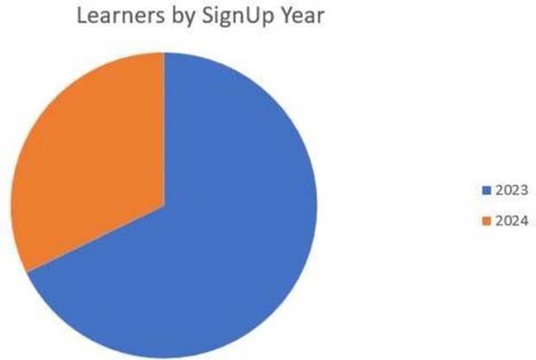

|  |  |  |  |
| --- | --- | --- | --- |
| **Aspect** | **Learners by Signup Day** | **Learners by Signup Month** | **Learners by Signup Year** |
| **Figure** | Bar chart showing learner counts per day of the month | Line chart showing monthly learner signups | Line chart showing yearly learner signups |
| **Columns used** | Extracted SignUp Day | Extracted SignUp Month | Extracted SignUp Year |
| **Why used** | To visualize daily trends in learner signups | To identify seasonal patterns and peak months | To identify yearly growth or decline trends |
| **How it matters** | Shows which days have higher learner activity, useful for short-term planning | Helps allocate resources or campaigns during high-demand months | Supports long-term planning and trend analysis |
| **Importance** | Useful for **day-level engagement insights** | Highlights **seasonal engagement patterns** | Enables **strategic decision- making over years** |

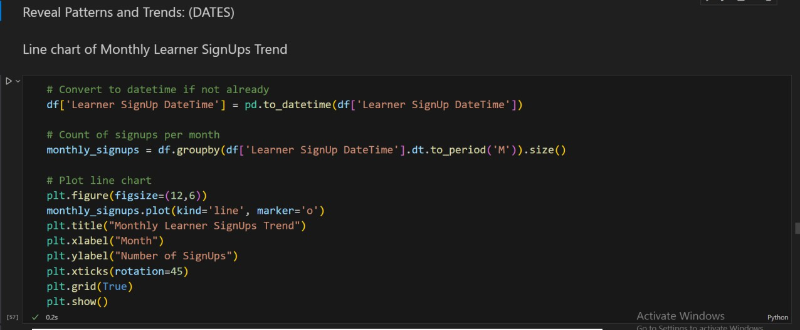

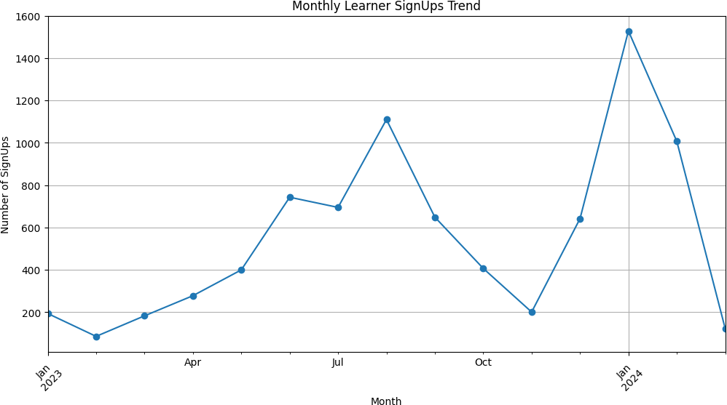

|  |  |
| --- | --- |
| **Aspect** | **Details** |
| **Figure** | Monthly Learner SignUps Trend (Line Chart) |
| **Columns used** | - Learner SignUp DateTime |
| **Why used** | To visualize **temporal trends** in learner sign-ups over time. Line charts help track patterns, growth, or seasonal fluctuations in registrations. |
| **How it matters** | * Identifies **peak months and trends** in learner registration. * Helps in **planning resources, programs, and campaigns** according to demand. * Useful for detecting **seasonal patterns** and growth rates. |
| **Importance** | Line charts provide a **clear visual of trends over time**, allowing stakeholders to make informed decisions for scheduling and outreach strategies. |

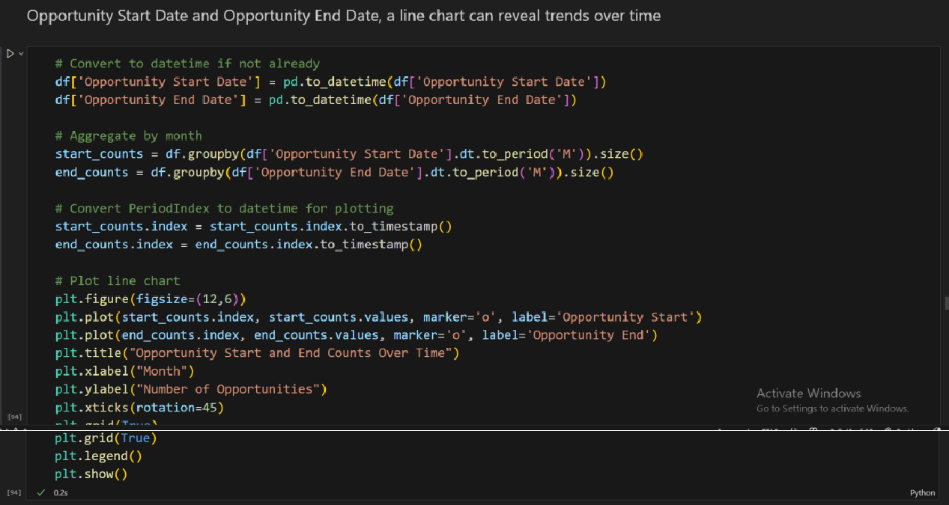

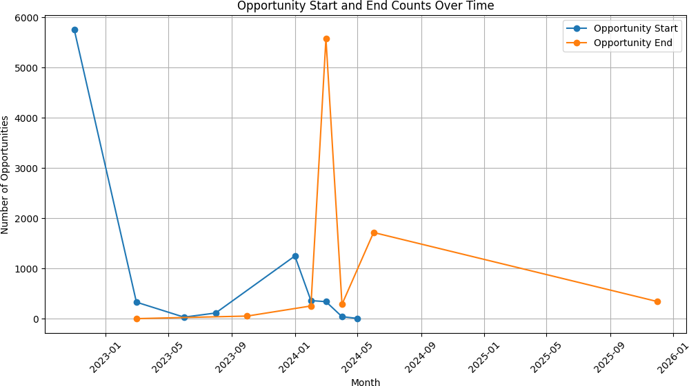

|  |  |
| --- | --- |
| **Aspect** | **Details** |
| **Figure** | Opportunity Start and End Counts Over Time (Line Chart) |
| **Columns used** | Opportunity Start Date, Opportunity End Date |
| **Why used** | To visualize **temporal trends** in when opportunities begin and end. Line charts help track scheduling patterns and detect overlaps or gaps. |
| **How it matters** | * Shows trends in **opportunity availability** over time. * Helps in **planning resources** and forecasting periods of high or low activity. * Useful for detecting **seasonal or monthly patterns** in opportunity scheduling. |
| **Importance** | Comparing start and end counts provides insights into **opportunity durations and distribution**, helping stakeholders manage timing and workload efficiently. |

1. **Enhance Communication:**

**Seasonal Patterns**

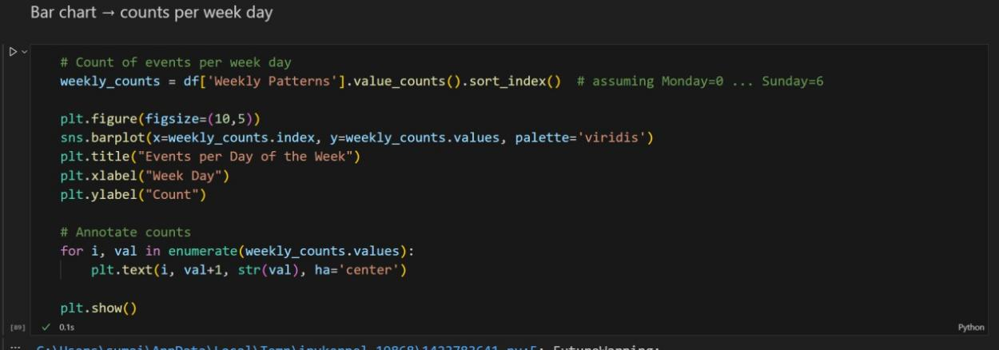

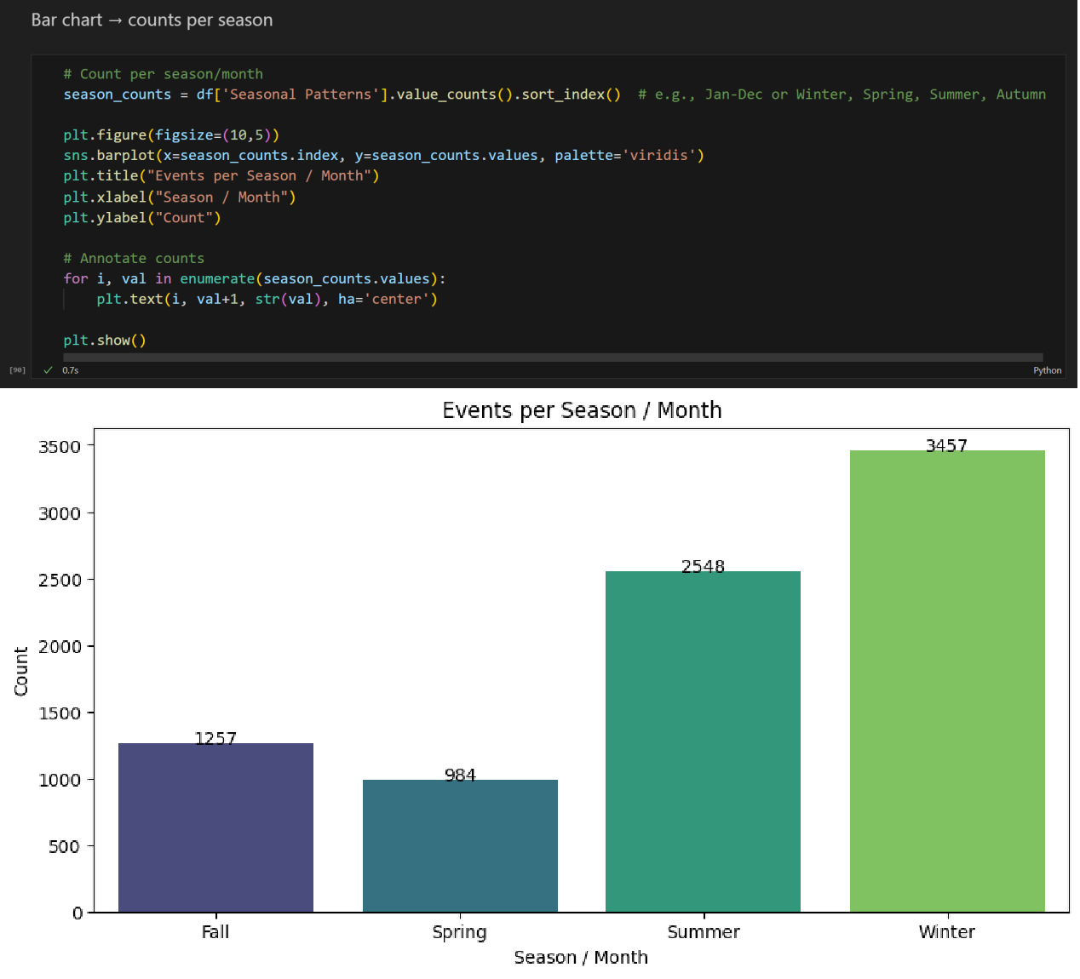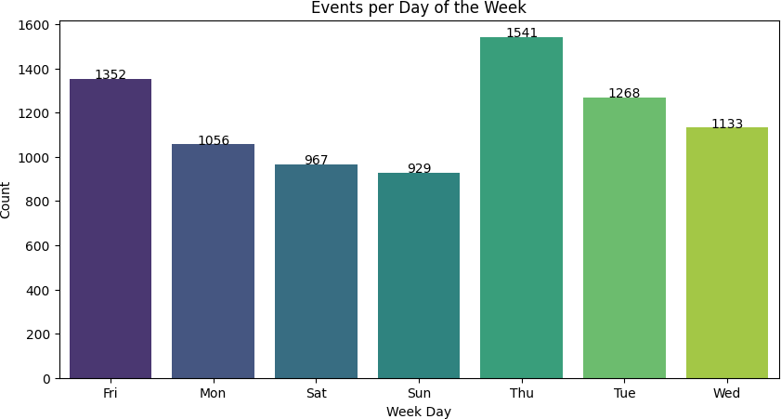

|  |  |
| --- | --- |
| **Aspect** | **Details** |
| **Figure** | Events per Day of the Week (Bar Chart) Events per Season / Month (Bar Chart) |
| **Columns used** | - Weekly Patterns (Weekdays) - Seasonal Patterns (Seasons/Months) |
| **Why used** | To visualize **temporal distribution of events** across weekdays and seasons/months, helping identify patterns in learner activity or opportunity scheduling. |

|  |  |
| --- | --- |
| **Aspect** | **Details** |
| **How it matters** | - Shows which **days of the week** have higher or lower event counts.- Reveals **seasonal trends or monthly peaks** in events.- Useful for **planning and resource allocation** based on temporal activity patterns.- Helps detect patterns or gaps in engagement over time. |
| **Importance** | Annotating counts on bars provides a **clear numeric perspective**, making trends easier to interpret and communicate to stakeholders. |

1. **Calculating initial summary statistics:**

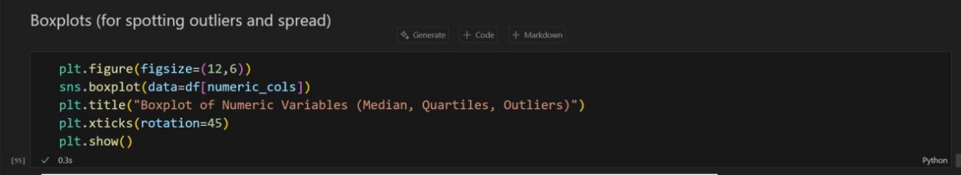

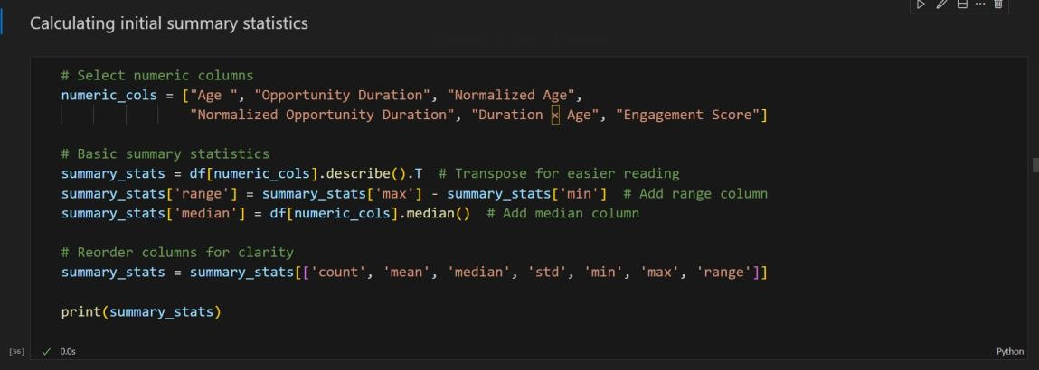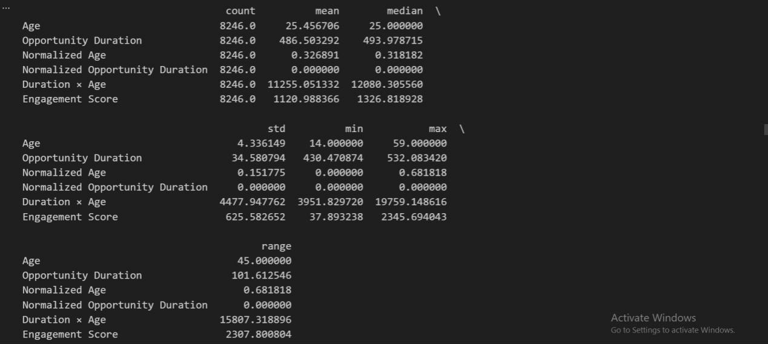

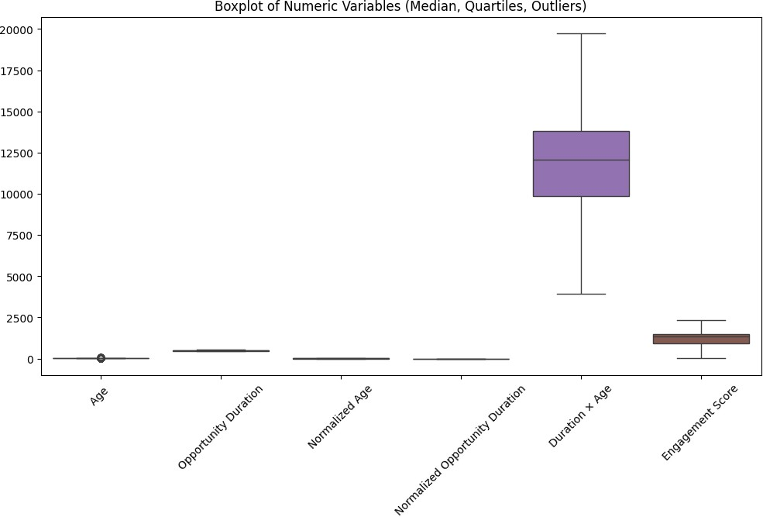

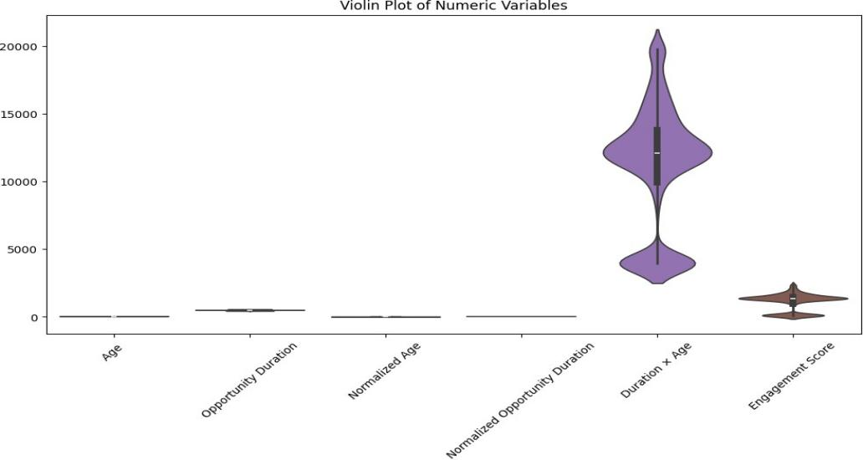

|  |  |
| --- | --- |
| **Aspect** | **Details** |
| **Figure** | Boxplot and Violin Plot of Numeric Variables (Median, Quartiles, Outliers, and Distribution) |
| **Columns used** | Age, Opportunity Duration, Normalized Age, Normalized Opportunity Duration, Duration  × Age, Engagement Score |
| **Why used** | To visualize the **distribution, central tendency, spread, and outliers** of all numeric features. Boxplots highlight medians, quartiles, and outliers, while violin plots show the **full distribution and density** of each variable. |
| **How it matters** | * Boxplots show **medians, quartiles, and outliers**, helping detect variability and extreme values. * Violin plots reveal **density and skewness**, showing the shape of the data. * Together, they allow **comparison across multiple features** and help identify potential data transformations.- Useful for understanding patterns before modeling or statistical analysis. |
| **Importance** | Combining boxplots and violin plots provides a **comprehensive overview** of numeric data,  highlighting both summary statistics and detailed distributions for informed decision- making. |

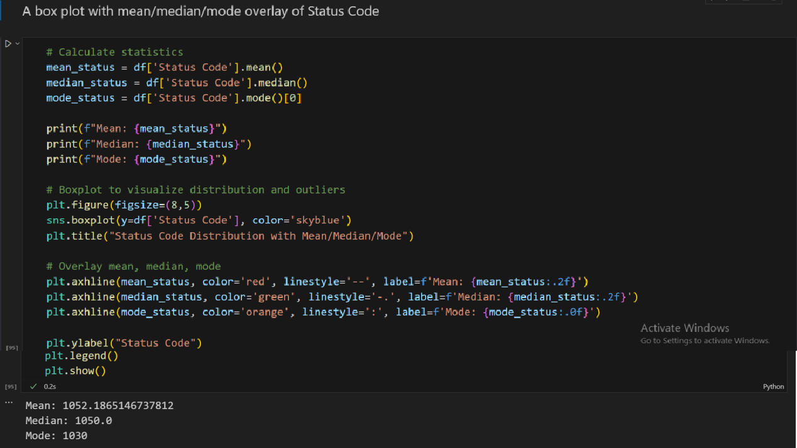

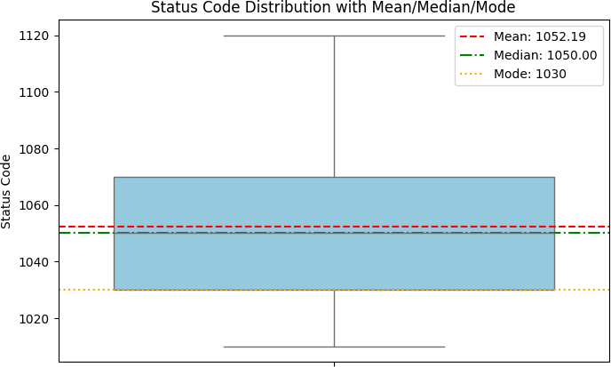

|  |  |
| --- | --- |
| **Aspect** | **Details** |
| **Figure** | Status Code Distribution with Mean, Median, and Mode (Boxplot) |
| **Columns used** | - Status Code |
| **Why used** | To summarize the central tendency and distribution of the Status Code. Mean, median, and mode provide key statistical measures, while the boxplot visualizes the spread and potential outliers. |
| **How it matters** | * Helps understand the **typical status code** and how values are distributed. * Identifies **outliers** that may require attention. * Comparing mean, median, and mode shows **skewness** or asymmetry in the data. * Useful for monitoring overall **status trends** in opportunities. |
| **Importance** | Overlaying mean, median, and mode on the boxplot provides an intuitive visual summary of the data’s central tendencies and variability. |

# Insight Generation and Hypothesis Development

Insight generation and hypothesis development play a vital role in transforming raw data into meaningful knowledge. By carefully analyzing patterns, trends, and anomalies, organizations can generate actionable insights that guide decision-making. Hypothesis development further allows the formulation of testable assumptions, ensuring that strategies and solutions are grounded in evidence rather than intuition.

## Importance

* Provides a structured approach to exploring and understanding complex data.
* Helps identify potential causes, correlations, and opportunities.
* Ensures research and business decisions are evidence-based.
* Strengthens problem-solving through systematic testing and validation.

## Benefits

* Improves decision-making accuracy and reduces risks.
* Supports innovation by uncovering hidden opportunities.
* Enhances efficiency in experiments and analyses.
* Builds a foundation for predictive modeling and advanced analytics.
* Promotes data-driven culture across teams and organizations.

1. **Understanding Data Through Univariate and Bivariate Analysis**

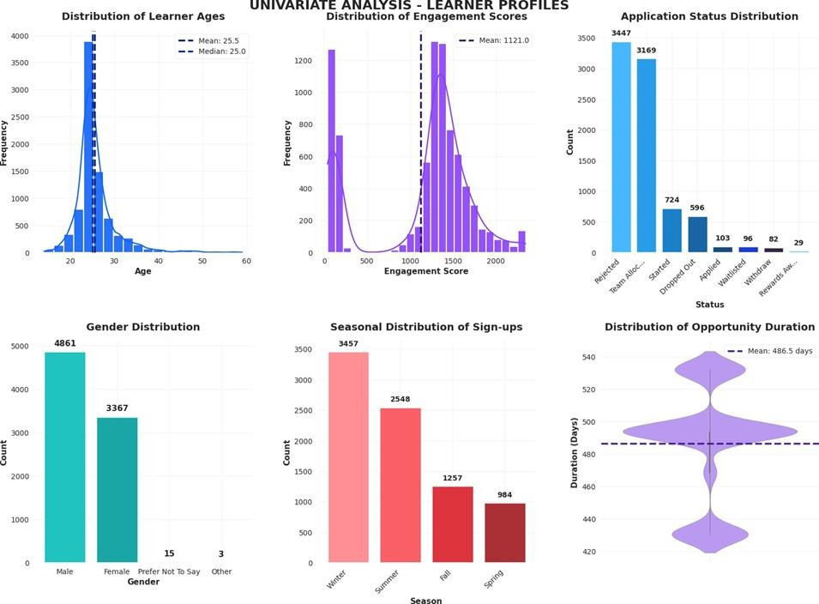

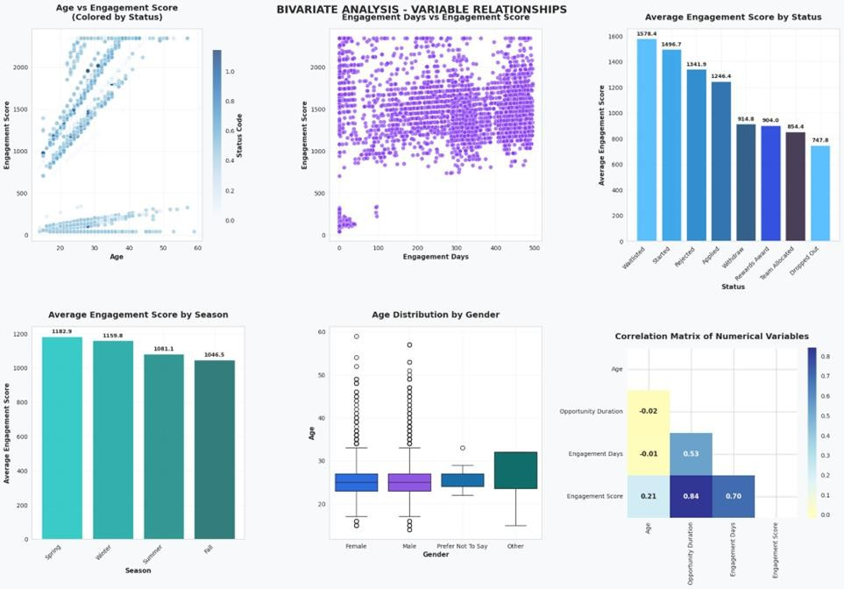

**Table 1: Univariate Analysis**

|  |  |
| --- | --- |
| **Aspect** | **Details** |
| **Figure** | 1. Distribution of Learner Ages 2. Distribution of Engagement Scores 3. Application Status Distribution 4. Gender Distribution 5. Seasonal Patterns 6. Opportunity Duration Distribution |
| **Columns used** | - Age - Engagement Score - Status Description - Gender - Seasonal Patterns - Opportunity Duration |
| **Why used** | To explore individual variable distributions and identify patterns, outliers, and central tendencies (mean, median). |
| **How it matters** | - Understand **learner demographics and engagement patterns**.- Reveal trends in **opportunity duration, seasonal participation, and status distribution**.- Guides feature selection and further analyses. |
| **Importance** | Provides a **baseline understanding** of dataset characteristics, enabling better decisions for targeted interventions and program optimization. |

**Table 2: Bivariate Analysis**

|  |  |
| --- | --- |
| **Aspect** | **Details** |
| **Figure** | 1. Age vs Engagement Score (Colored by Status) 2. Engagement Days vs Engagement Score 3. Average Engagement Score by Status 4. Average Engagement Score by Season 5. Age Distribution by Gender 6. Correlation Matrix of Numerical Variables |
| **Columns used** | * Age - Engagement Score - Normalized Status Code - Engagement Days - Status Description - Seasonal Patterns * Gender - Opportunity Duration |
| **Why used** | To explore **relationships between two variables** and identify correlations, patterns, and trends across different categories or groups. |
| **How it matters** | - Highlights **key relationships** influencing engagement.- Identifies **strongly correlated variables**, supporting feature selection.- Provides insight into **demographic and temporal patterns** affecting engagement. |
| **Importance** | Supports **data-driven decision-making** by revealing interaction effects, helping optimize content delivery and learner engagement strategies. |

1. **Compare Data Groups:**

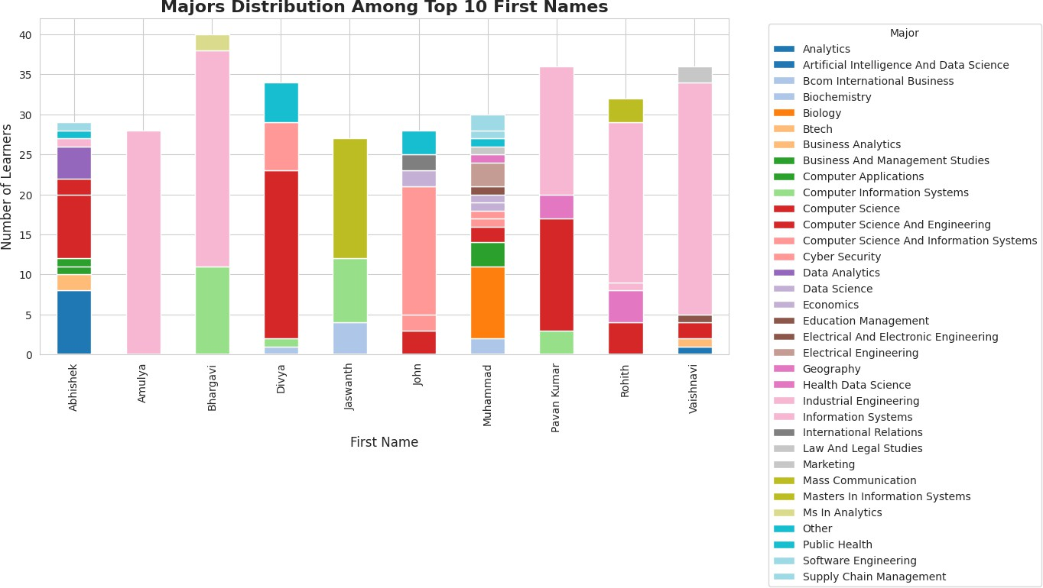

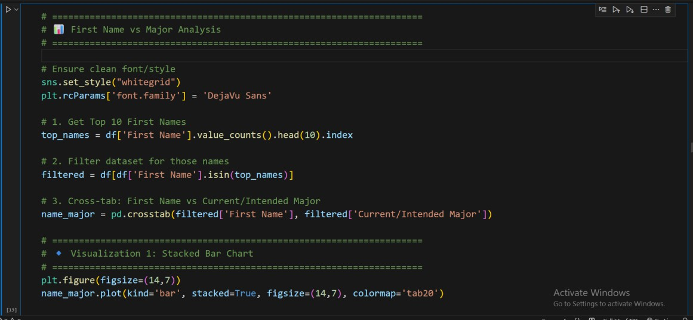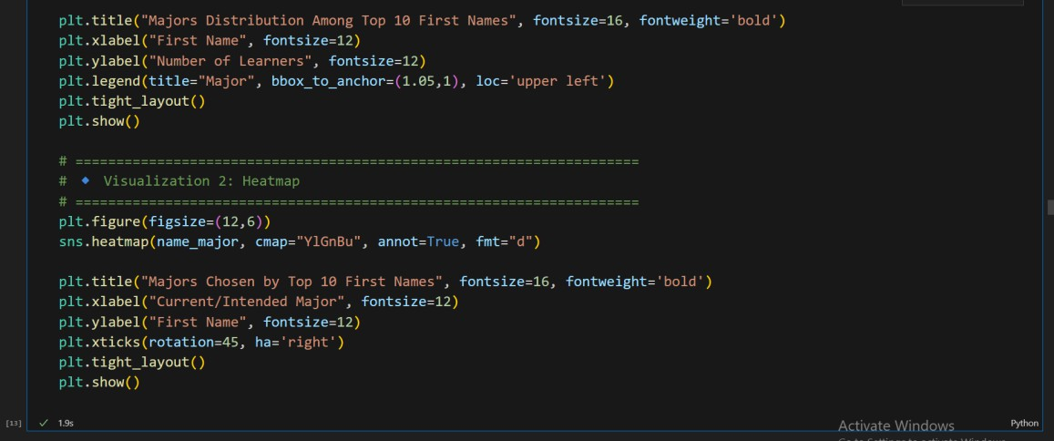

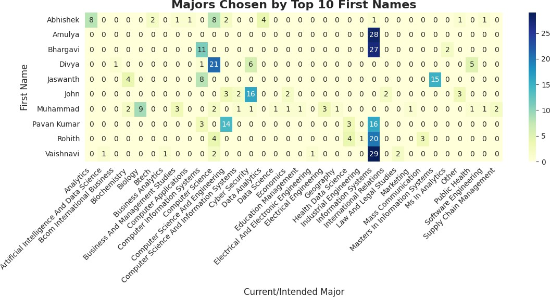

|  |  |
| --- | --- |
| **Aspect** | **Details** |
| **Figure** | 1. Stacked Bar Chart – Majors Distribution Among Top 10 First Names 2. Heatmap – Majors Chosen by Top 10 First Names |
| **Columns used** | First Name, Current/Intended Major |
| **Why used** | To analyze how the most common first names among learners relate to their chosen or intended majors. Stacked bar charts show proportional distributions across majors for each name, while the heatmap highlights frequency patterns with intensity. |
| **How it matters** | - Reveals if certain first names (possibly linked to cultural/regional groups) have concentrated preferences for particular majors. - Stacked bar chart helps compare distribution visually across names. - Heatmap allows easy spotting of strong/weak associations between names and majors. |
| **Importance** | Provides demographic insights into naming trends and academic interests. Useful for identifying cultural or regional influences in field selection, which can inform outreach strategies, diversity analysis, and targeted engagement. |

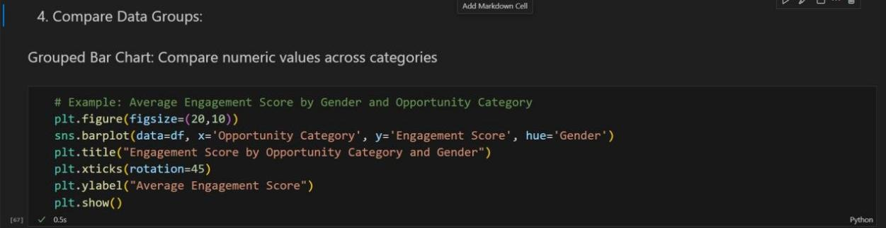

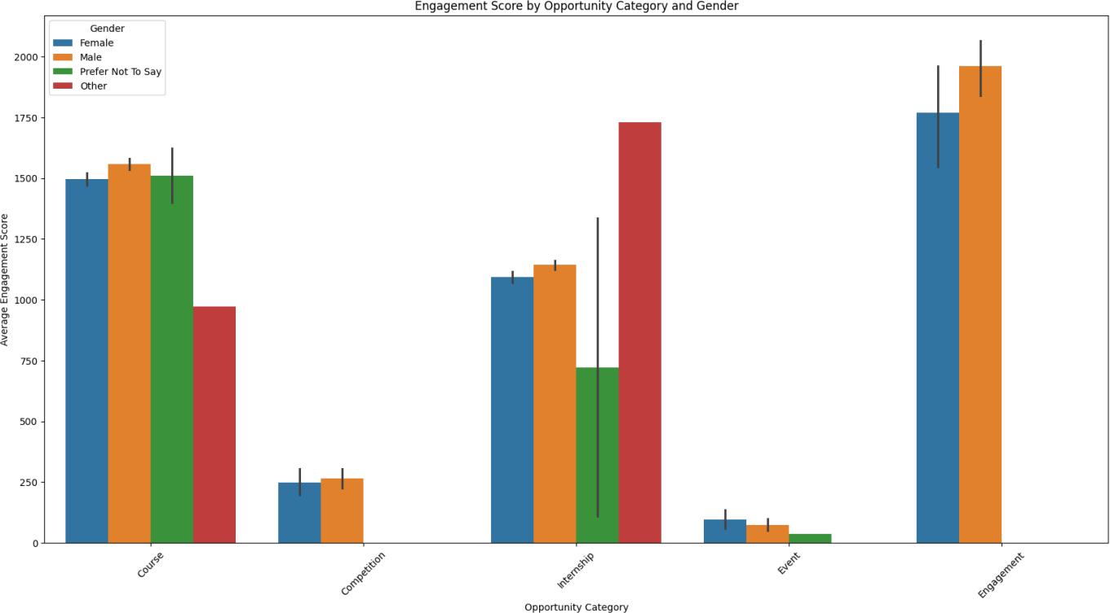

|  |  |
| --- | --- |
| **Aspect** | **Details** |
| **Figure** | Engagement Score by Opportunity Category and Gender (Bar Chart) |
| **Columns used** | Opportunity Category, Engagement Score, Gender |
| **Why used** | To compare **average engagement scores** across opportunity categories for different genders. Helps identify disparities or trends in participation and engagement. |
| **How it matters** | * Highlights which opportunity categories are **more engaging for male or female learners**. * Supports **targeted interventions** to improve engagement. * Useful for understanding **demographic differences** in participation. |
| **Importance** | This visualization is important for **decision-making and program optimization**, ensuring equitable and effective engagement across genders. |

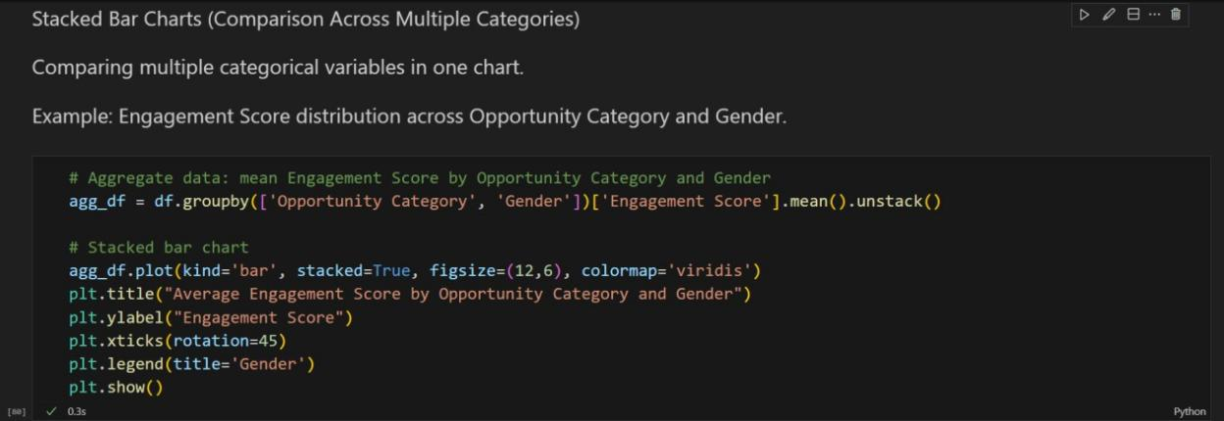

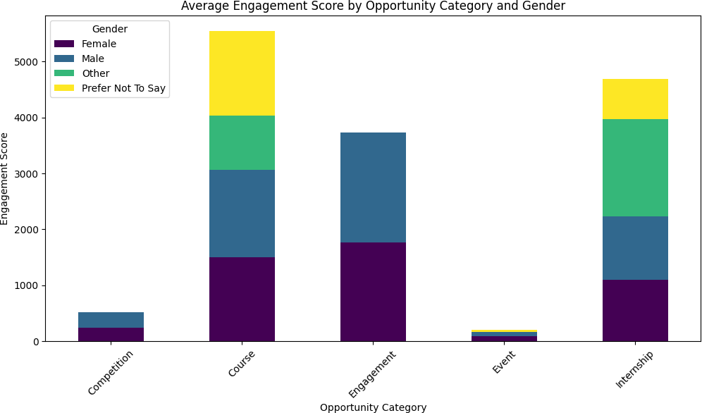

|  |  |
| --- | --- |
| **Aspect** | **Details** |
| **Figure** | Average Engagement Score by Opportunity Category and Gender (Stacked Bar Chart) |
| **Columns used** | Opportunity Category, Gender, Engagement Score |
| **Why used** | To show **combined contributions** of male and female learners to the average engagement score across opportunity categories. Stacked bars make it easy to compare totals and subgroup contributions. |
| **How it matters** | * Highlights **gender-wise differences** in engagement within each opportunity category. * Helps in **identifying categories where one gender is more engaged**. * Useful for planning **targeted interventions** and improving overall engagement. |
| **Importance** | Stacked bar charts provide a **clear visual of subgroup contributions**, making it easier to communicate patterns to stakeholders and guide decision-making. |

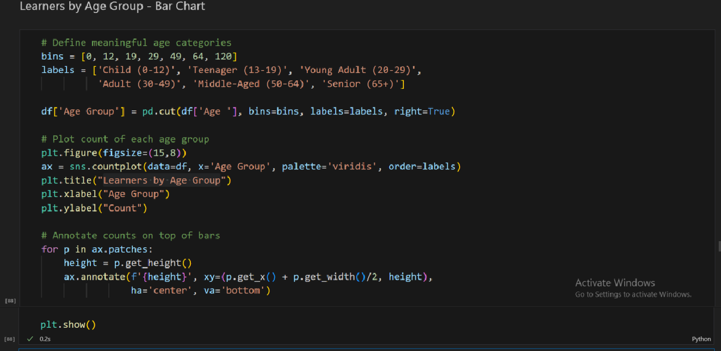

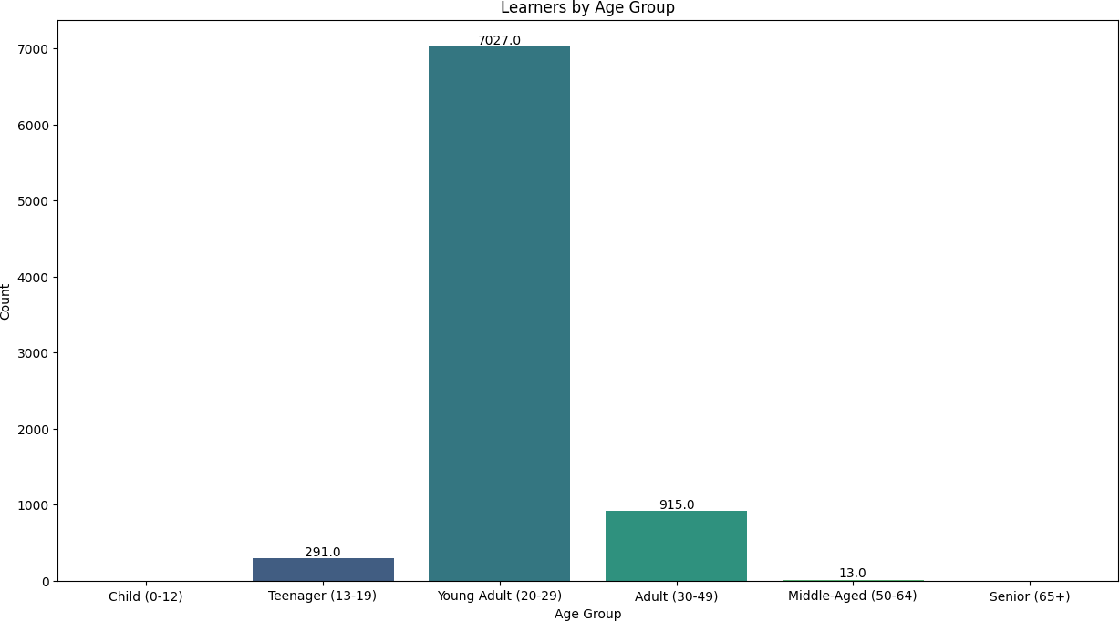

|  |  |
| --- | --- |
| **Aspect** | **Details** |
| **Figure** | Learners by Age Group (Bar Chart) |
| **Columns used** | Age, Age Group (categorized) |
| **Why used** | To visualize the **distribution of learners across meaningful age groups**, providing insight into the demographic composition of the dataset. |
| **How it matters** | * Identifies which age groups have the **highest or lowest participation**. * Helps in **targeting programs** and designing age-appropriate opportunities. * Useful for understanding **learner demographics** and planning engagement strategies. |
| **Importance** | Annotating counts on bars makes it easier to **quantify each group**, which is important for reporting and stakeholder insights. |

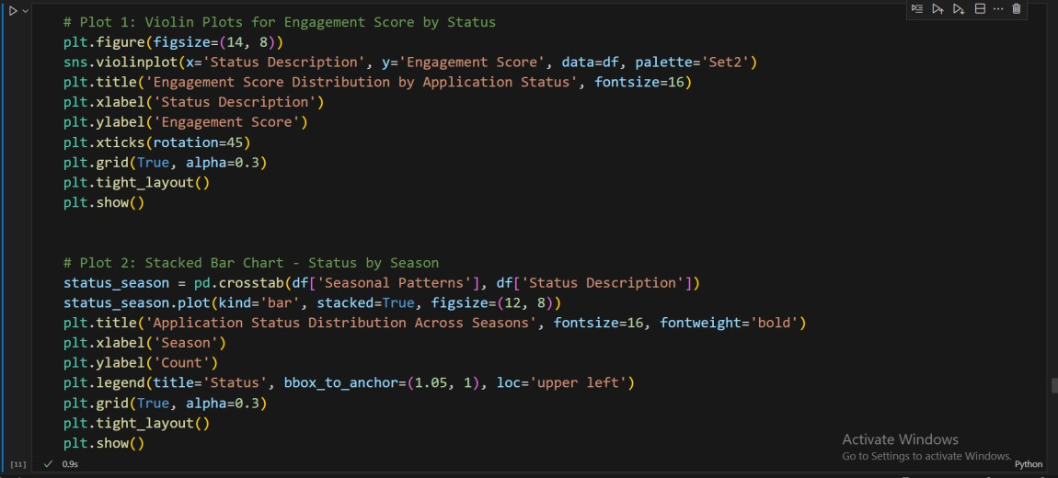

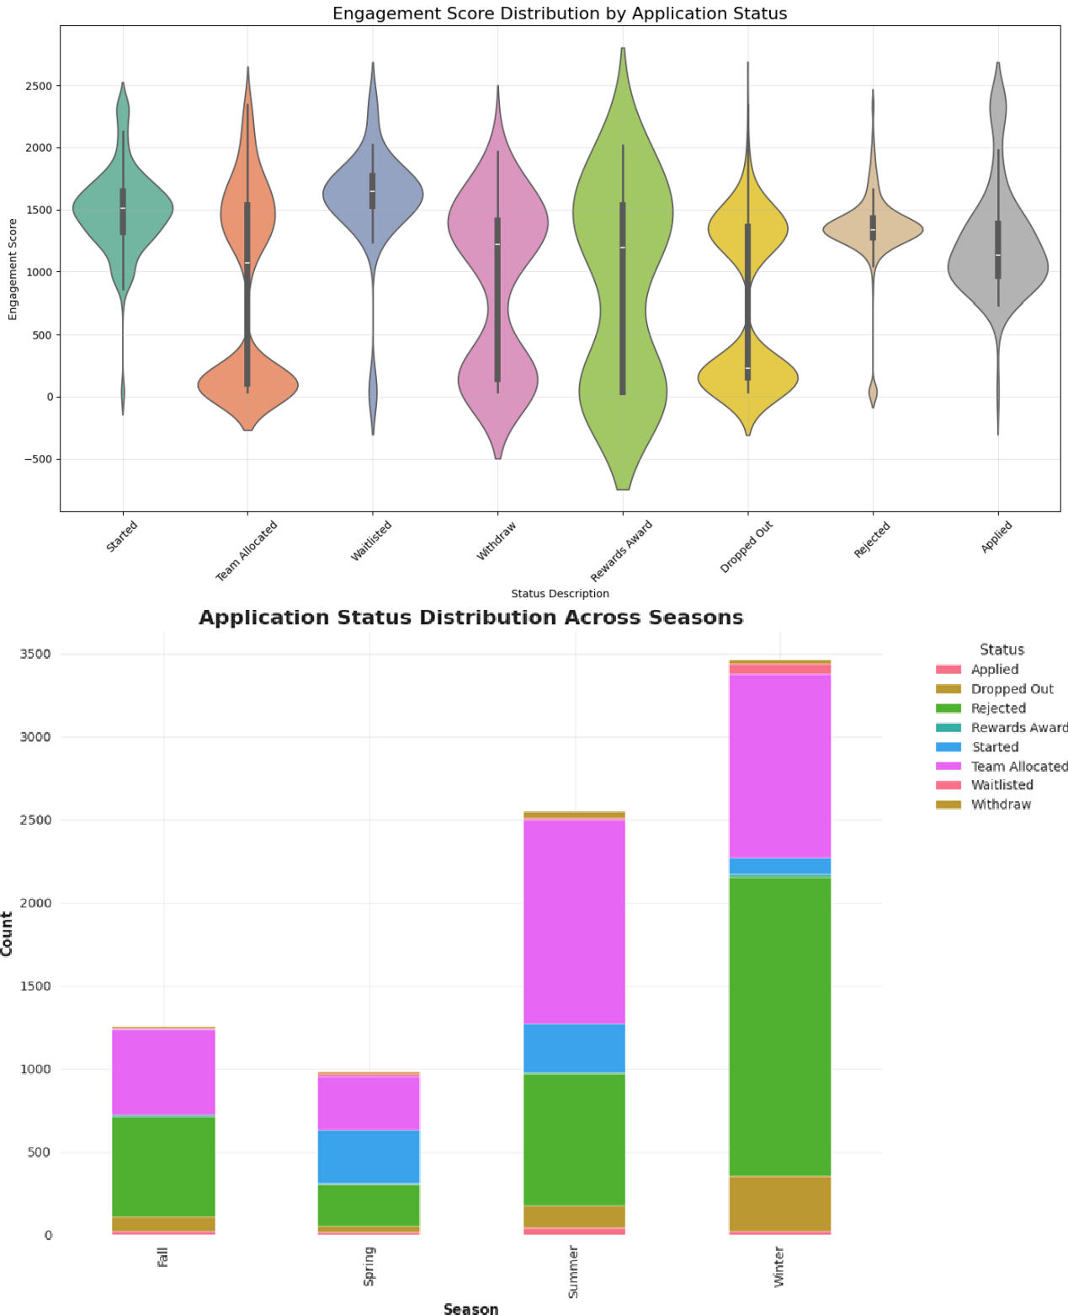

|  |  |
| --- | --- |
| **Aspect** | **Details** |
| **Figure** | 1. Engagement Score Distribution by Application Status (Violin Plot) 2. 2. Application Status Distribution Across Seasons (Stacked Bar Chart) |
| **Columns used** | Status Description, Engagement Score , Seasonal Patterns |
| **Why used** | * Violin Plot: To visualize the **distribution and spread** of engagement scores across different application statuses. * Stacked Bar Chart: To show how **application statuses vary across seasons**, highlighting seasonal trends. |
| **How it matters** | * Reveals which **statuses are associated with higher or lower engagement**. * Shows **seasonal patterns in applications**, helping plan targeted interventions. * Helps identify **status-specific engagement trends** over time. |
| **Importance** | Enables **strategic decision-making** by connecting engagement levels with application statuses and seasonal trends, improving program planning and learner retention. |

1. **Correlation Matrix Analysis:**

A correlation matrix was generated to identify relationships between numeric features. The correlation coefficient values range from -1 (strongly negative) to +1 (strongly positive), with values near zero indicating little to no linear relationship.

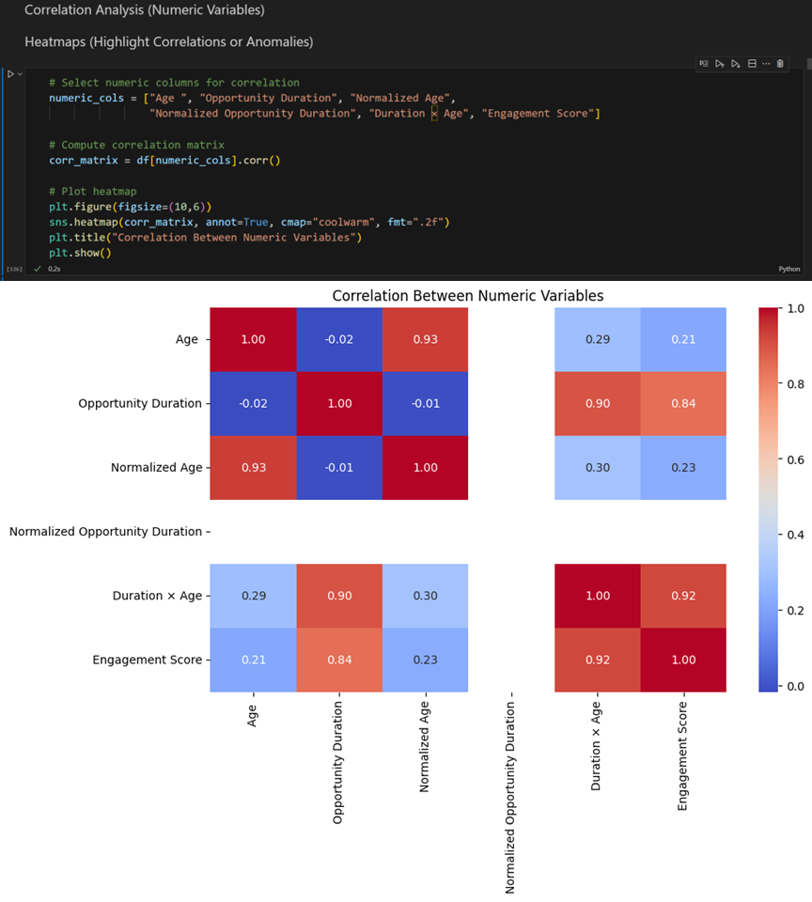

|  |  |
| --- | --- |
| **Aspect** | **Details** |
| **Figure** | Correlation Heatmap of Numeric Variables |
| **Columns used** | Age, Opportunity Duration, Normalized Age, Normalized Opportunity Duration, Duration × Age, Engagement Score |
| **Why used** | To visually represent relationships and correlations between key numeric features. Helps identify which variables are strongly related or independent, useful for feature analysis and model building. |
| **How it matters** | * Understanding correlations guides feature selection and avoids redundancy. * Strong correlations may indicate potential predictors for engagement or opportunity outcomes. * Weak or negative correlations highlight features that contribute unique information. |
| **Importance** | Provides an intuitive way to communicate patterns to stakeholders, making it easier to interpret numerical relationships. |

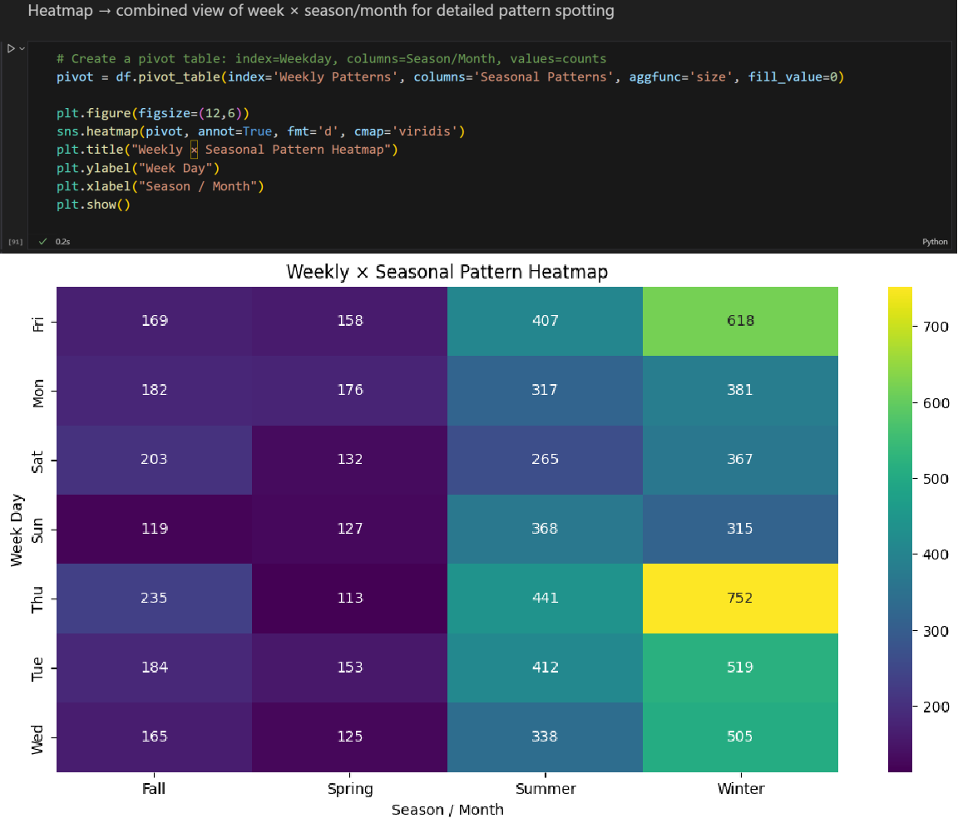

|  |  |
| --- | --- |
| **Aspect** | **Details** |
| **Figure** | Weekly × Seasonal Pattern Heatmap |
| **Columns used** | Weekly Patterns (Weekdays), Seasonal Patterns (Seasons) |
| **Why used** | To visualize how opportunities or learner engagements are distributed across weekdays and seasons/months. |
| **How it matters** | * Identifies peak days and months for engagement * Helps in planning and scheduling opportunities- Reveals seasonal effects on activity |
| **Importance** | Allows quick comparison of daily vs seasonal trends, helping stakeholders understand temporal patterns in the data |

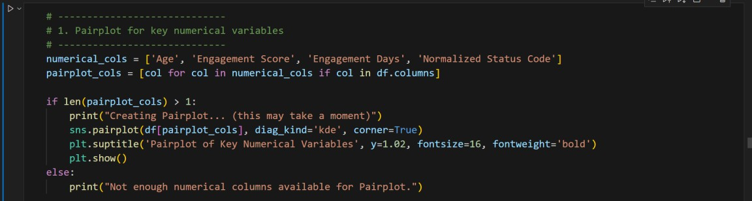

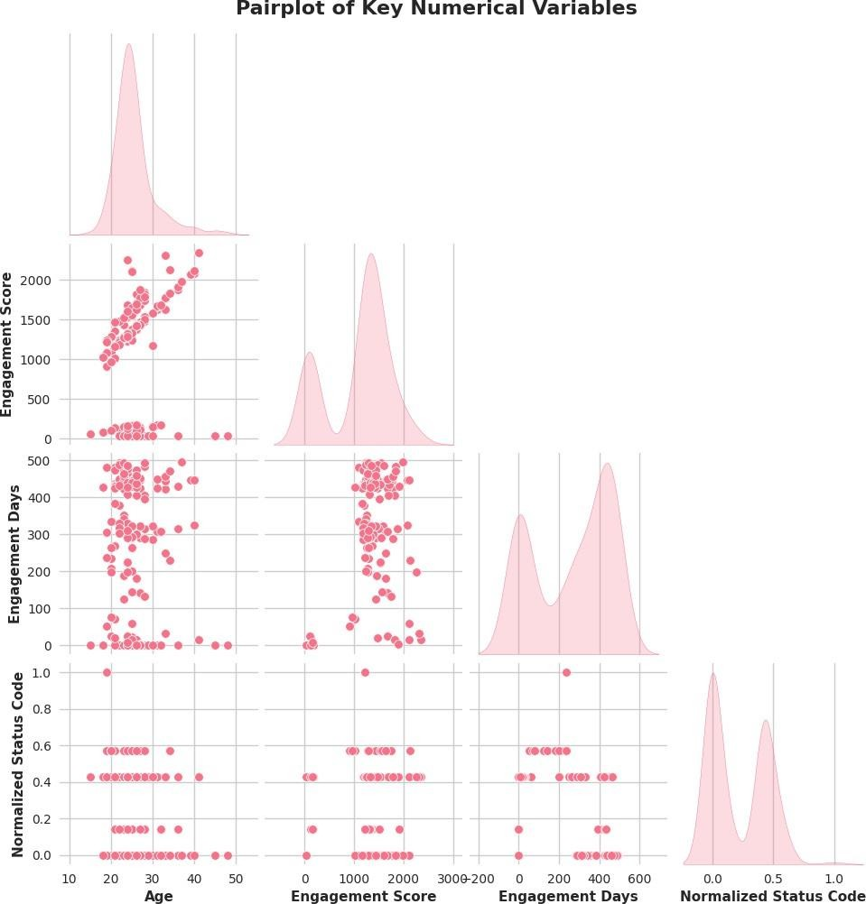

## Patterns and Correlations:

**Signup vs. Completion:** While signups fluctuate monthly, completions follow a similar but more subdued trend. There is a clear positive correlation, but the gap between signups and completions remains wide, highlighting a key challenge in converting registered users into successful participants.

**Demographics:**

**Age:** The user base is predominantly young, with a strong peak in the 23-27 age group. This group also exhibits the highest completion rate

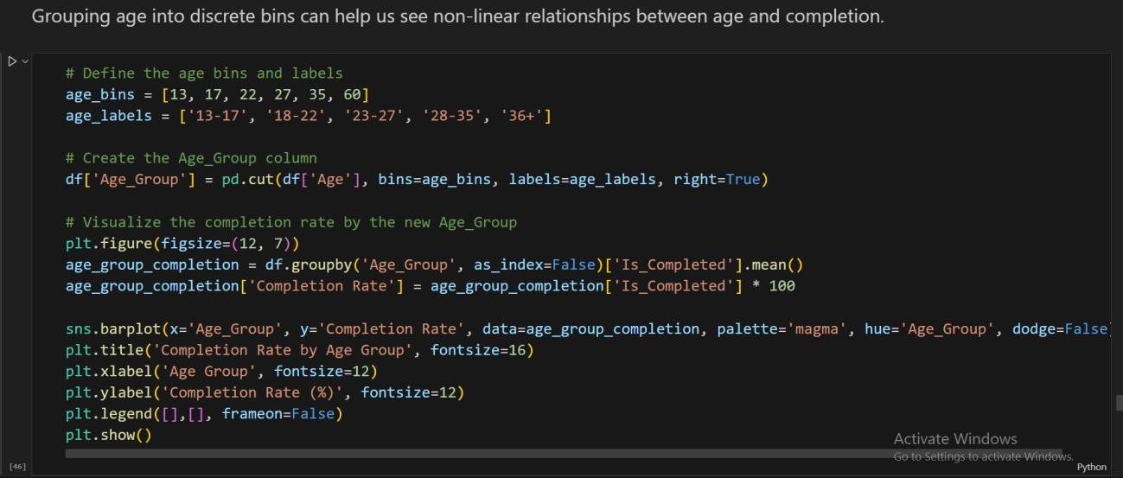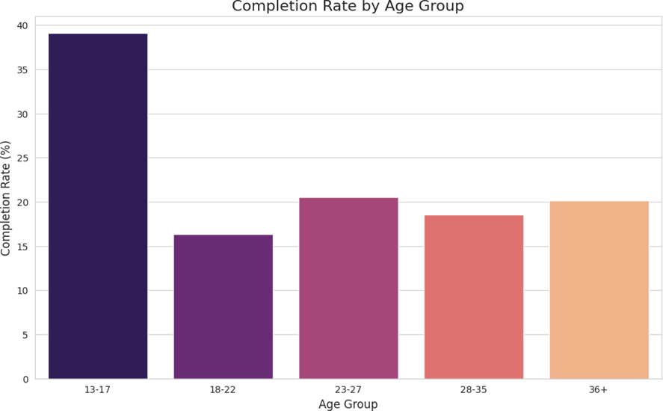

|  |  |
| --- | --- |
| **Aspect** | **Details** |
| **Figure** | Completion Rate by Age Group **-**Bar chart |
| **Columns Used** | Age, Age_Group, Is_Completed |
| **Why Used** | To evaluate how completion varies across different age groups. |
| **How it Matters** | Shows which age groups are more likely to complete applications, highlighting user engagement patterns. |
| **Importance** | Guides targeted interventions and engagement strategies based on age demographics. |

**Gender:** While there are more male than female users, the ANOVA test (p=0.1125) showed no statistically significant difference in engagement scores between genders. However, completion rates for females are slightly lower.

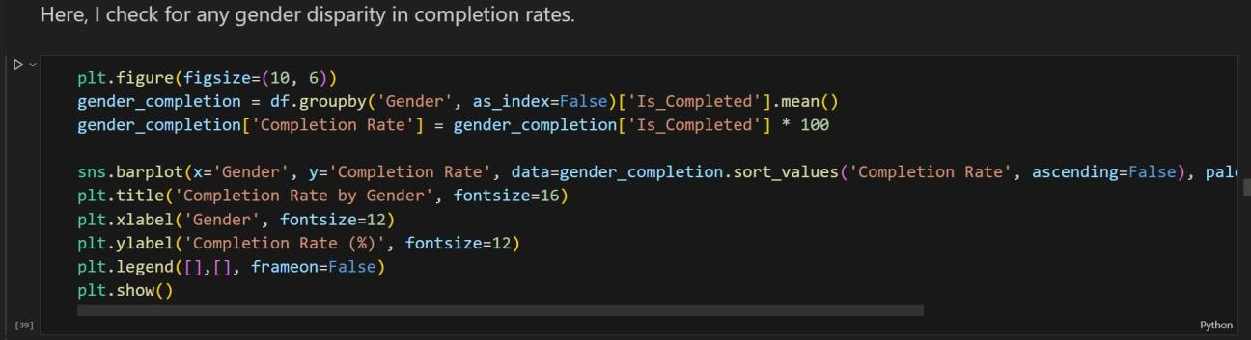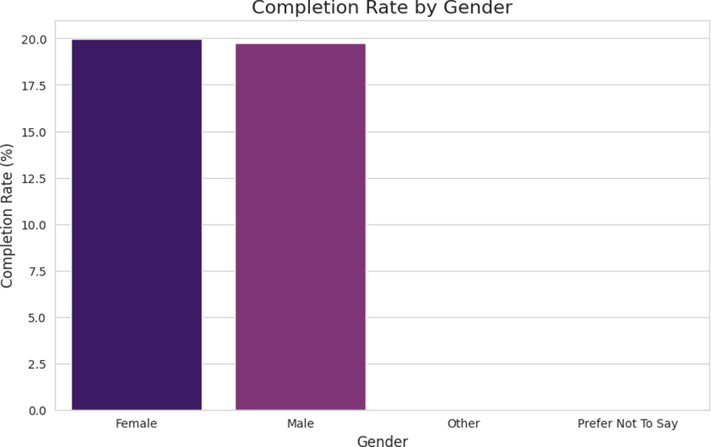

|  |  |
| --- | --- |
| **Aspect** | **Details** |
| **Figure** | Completion Rate by Gender - Bar chart |
| **Columns Used** | Gender, Is_Completed |
| **Why Used** | To compare completion rates between different genders. |
| **How it Matters** | Highlights gender-based differences in engagement and completion patterns. |
| **Importance** | Supports targeted interventions to improve completion rates across genders. |

## Geography:

The user base is dominated by the United States and India. However, completion rates do not vary significantly between US and non-US users, and there is no strong pattern among the top 10 countries.

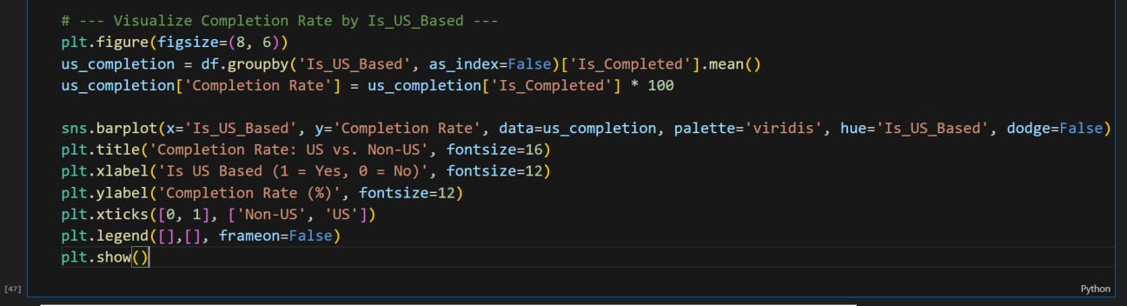

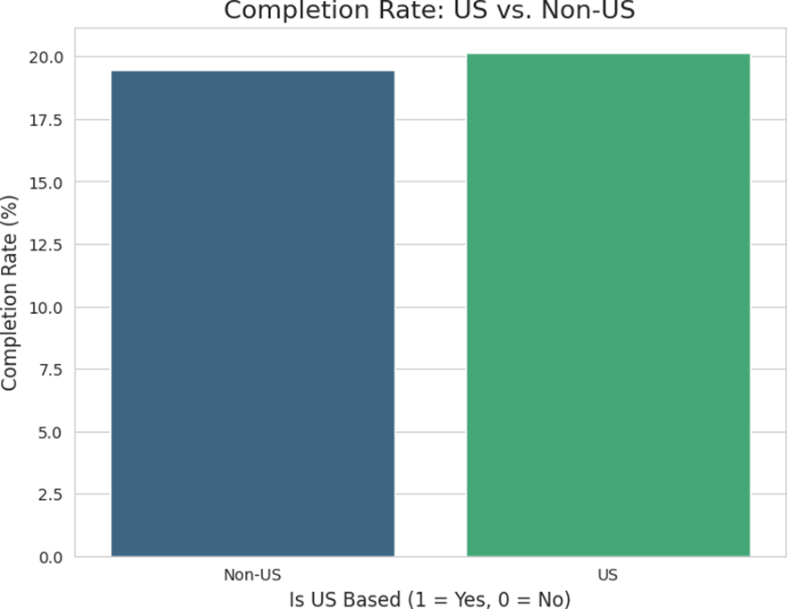

|  |  |
| --- | --- |
| **Aspect** | **Details** |
| **Figure** | Completion Rate: US vs Non-US - Bar chart |
| **Columns Used** | Country, Is_US_Based, Is_Completed |
| **Why Used** | To compare completion rates between US-based and non-US learners. |
| **How it Matters** | Reveals geographic differences in engagement and completion patterns. |
| **Importance** | Helps tailor regional strategies and interventions to improve completion rates. |

1. **Uncovering Relationships Between Variables:**

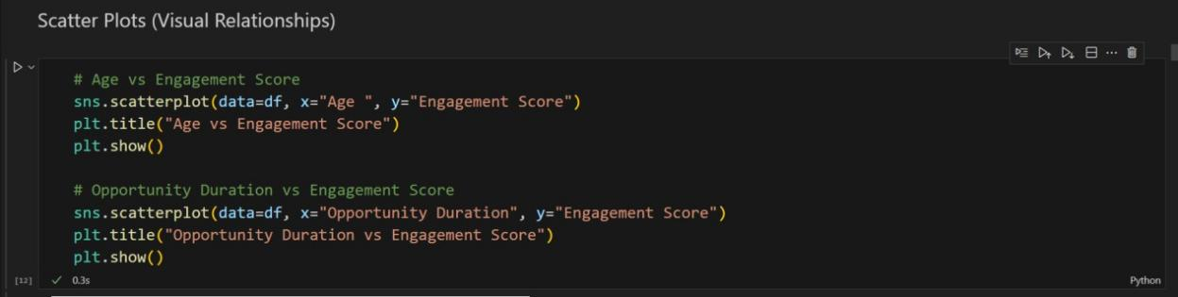

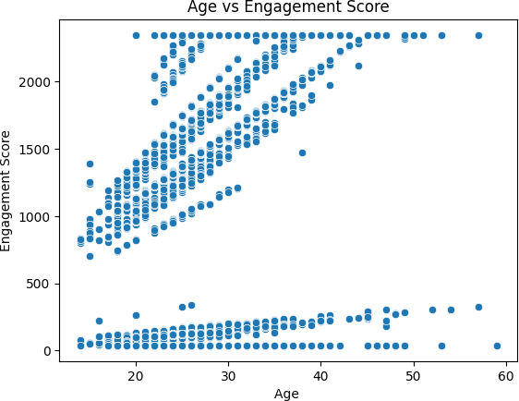

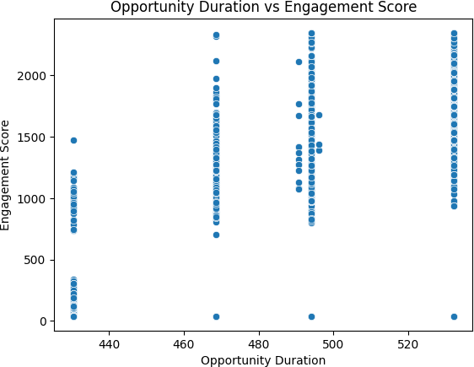

|  |  |
| --- | --- |
| **Aspect** | **Details** |
| **Figure** | Age vs Engagement Score (Scatterplot)  Opportunity Duration vs Engagement Score (Scatterplot) |
| **Columns used** | * Age (for first plot) * Engagement Score - Opportunity Duration (for second plot) |
| **Why used** | To visually examine the **relationship between age and engagement**, and **opportunity duration and engagement**. Scatterplots help detect trends, patterns, and possible outliers in the data. |
| **How it matters** | * Identifies whether age or opportunity duration has an impact on engagement. * Helps understand **learner behavior** in relation to time and demographics. * Useful for **feature selection** in predictive modeling. * Detects clusters, trends, or anomalies in engagement data. |
| **Additional point** | These plots allow stakeholders to **quickly see potential influences** on engagement and make informed decisions for planning opportunities. |

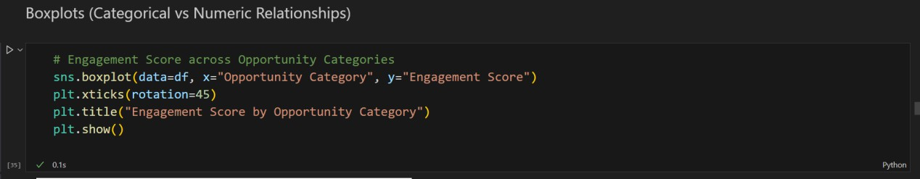

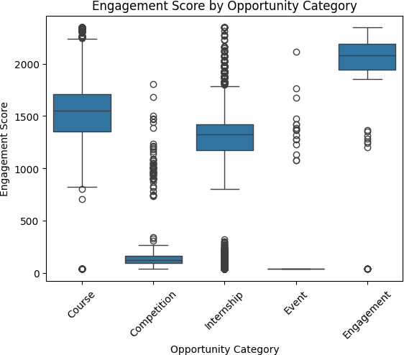

|  |  |
| --- | --- |
| **Aspect** | **Details** |
| **Figure** | Engagement Score by Opportunity Category (Boxplot) |
| **Columns used** | Opportunity Category, Engagement Score |
| **Why used** | To visualize the **distribution of engagement scores** across different opportunity categories. Boxplots help identify medians, variability, and outliers within each category. |
| **How it matters** | * Shows which categories have higher or lower engagement. * Highlights **variability and consistency** of engagement in each category. * Helps in **identifying categories that perform well** or need improvement. * Useful for decision-making and planning targeted interventions. |
| **Importance** | Outliers in engagement scores can reveal exceptional learner responses or unusual activity patterns. |

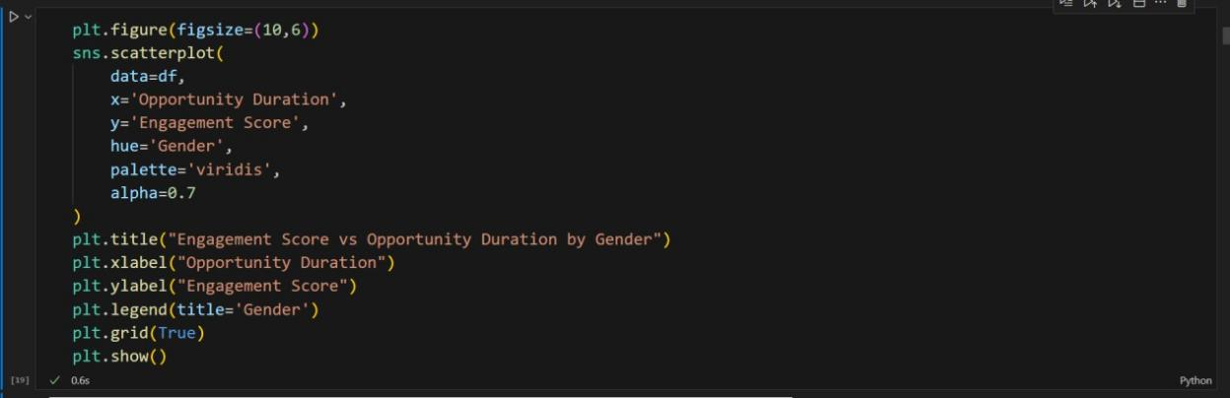

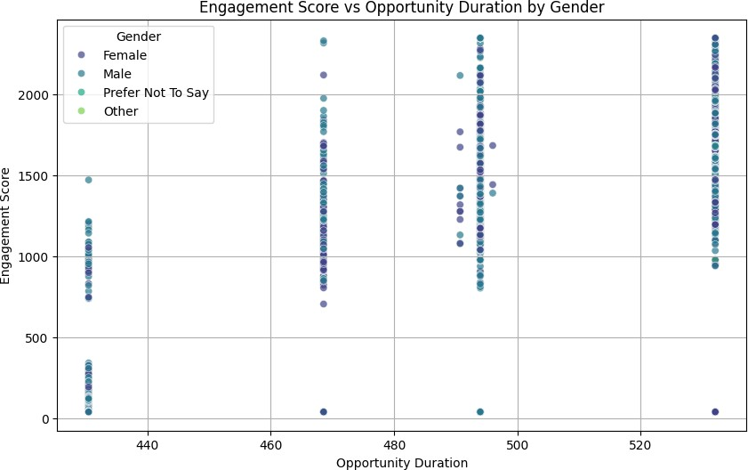

|  |  |
| --- | --- |
| **Aspect** | **Details** |
| **Figure** | Engagement Score vs Opportunity Duration by Gender (Scatter Plot) |
| **Columns used** | - Opportunity Duration - Engagement Score - Gender |
| **Why used** | To visualize **how engagement varies with opportunity duration** and whether gender influences this relationship. |
| **How it matters** | - Shows **trends and patterns** between opportunity length and engagement.- Highlights **gender-specific differences** in engagement.- Helps identify which opportunities may need targeted interventions based on gender. |
| **Importance** | Supports **data-driven insights** for optimizing course duration and engagement strategies, while considering gender differences in participation or outcomes. |

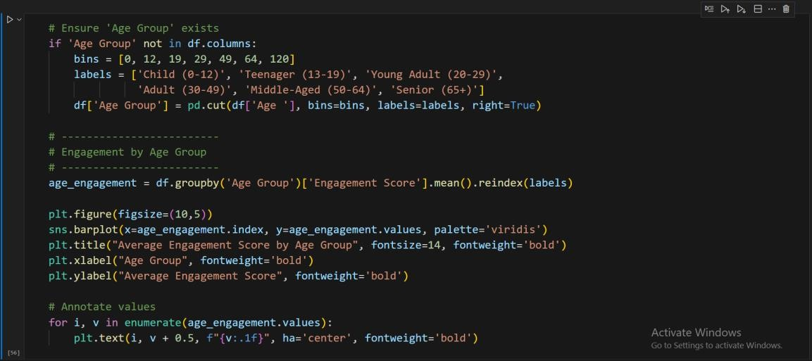

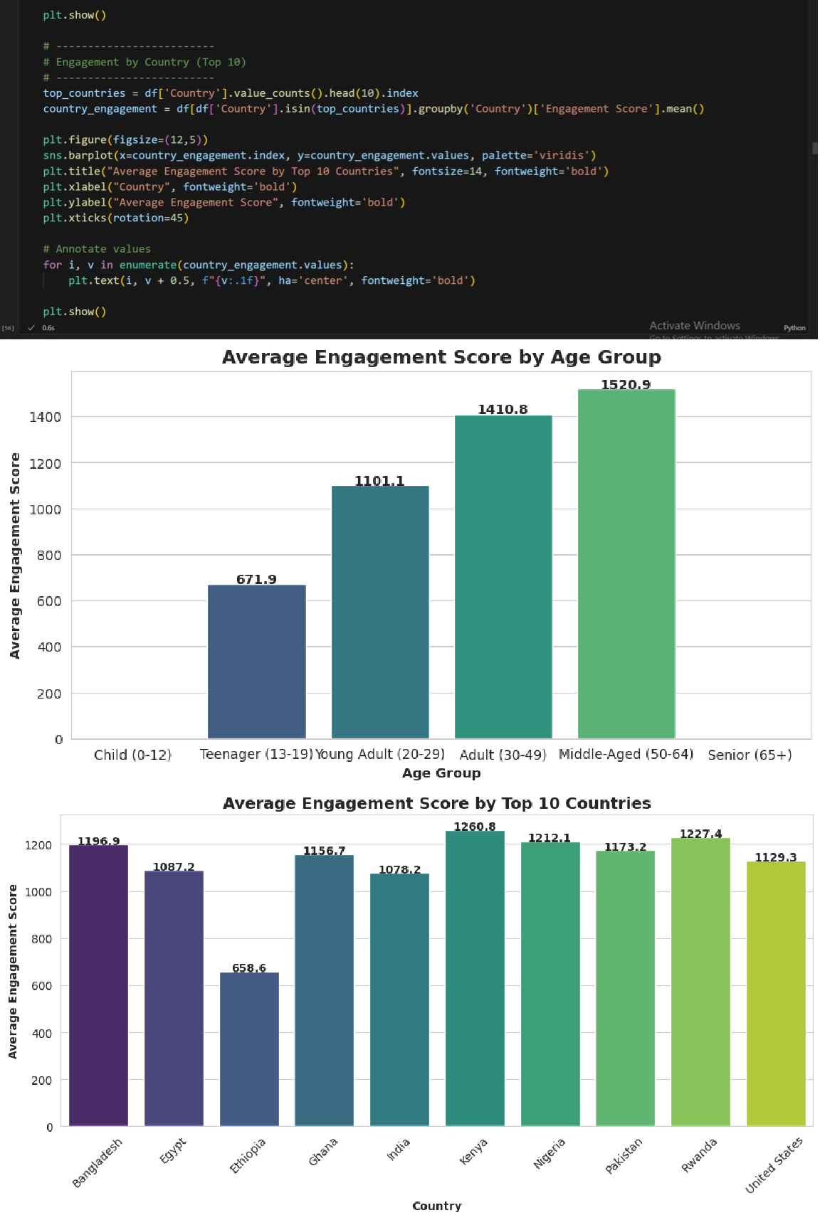

|  |  |  |
| --- | --- | --- |
| **Aspect** | **Average Engagement by Age Group** | **Average Engagement by Top 10 Countries** |
| **Figure** | Bar chart – Average Engagement Score by Age Group | Bar chart – Average Engagement Score by Top 10 Countries |
| **Columns used** | Age Group, Engagement Score | Country, Engagement Score |
| **Why used** | To measure engagement patterns across different age groups | To measure engagement patterns across top 10 countries |
| **How it matters** | Identifies which age brackets are more engaged | Identifies which countries have higher engagement |
| **Importance** | Helps target strategies or interventions by age | Helps target strategies or interventions by geography |

1. **Statistical & Outliers Analysis:**

**Engagement Score Analysis:** *(Statistical)*

**By Category:** ANOVA results (p < 0.0001) confirm a significant difference in engagement scores across opportunity categories. 'Course' opportunities are associated with the highest median engagement scores.

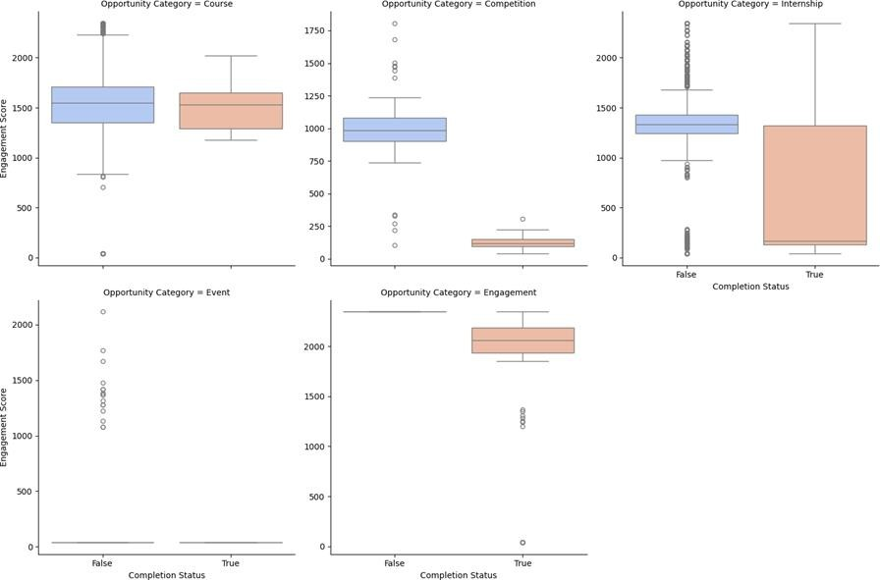

**By Completion Status:** Surprisingly, users who did *not* complete opportunities have a higher median 'Engagement Score'. This suggests the metric may be rewarding prolonged, unsuccessful effort rather than efficient completion.

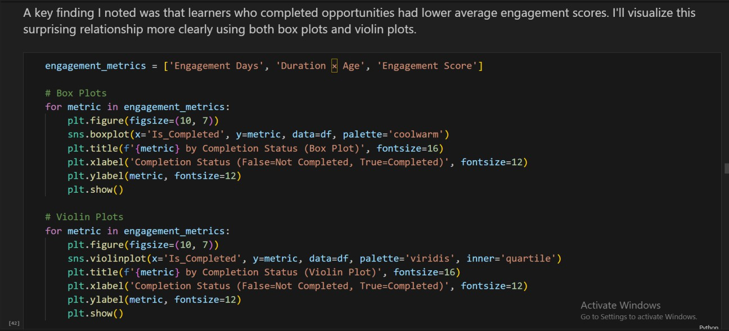

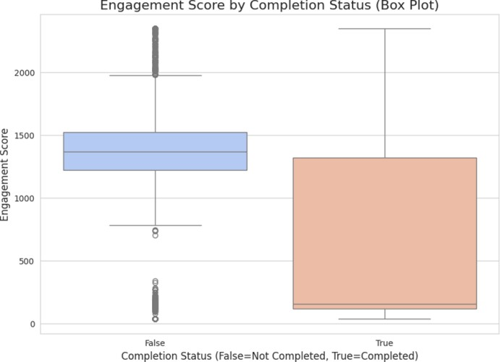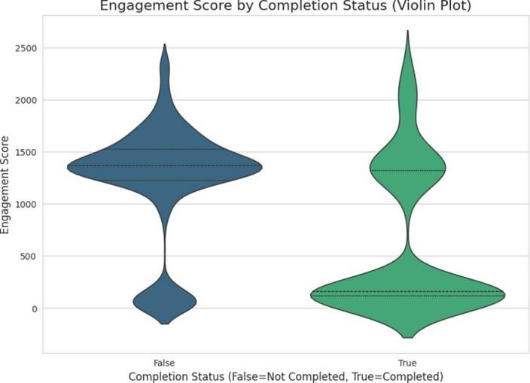

|  |  |
| --- | --- |
| **Aspect** | **Details** |
| **Figure** | Engagement Metrics by Completion Status (Box & Violin Plots) |
| **Columns Used** | Is_Completed, Engagement Days, Duration × Age, Engagement Score |
| **Why Used** | To compare engagement behaviors between completed and non-completed learners |
| **How it Matters** | Shows distribution, spread, and central tendency differences for key engagement metrics |
| **Importance** | Helps identify engagement patterns that may predict completion and inform interventions |

**Outliers and Anomalies Analysis:** *(Outliers)*

*Outliers are data points that deviate significantly from the norm, possibly indicating errors, unique cases, or significant anomalies.*

**Completion Time Outliers:** The 'Time_to_Apply' metric has significant outliers, with some users taking over a year to apply. These users are almost exclusively in the non-completed group.

**Low Completion Days & Categories:** The Chi-squared test (p < 0.0001) confirms a strong association between 'Opportunity Category' and 'User Status'. The most significant anomaly is in the 'Internship' category, which accounts for a staggering 3,447 'Rejected' users. This is the single largest bottleneck in the user journey.

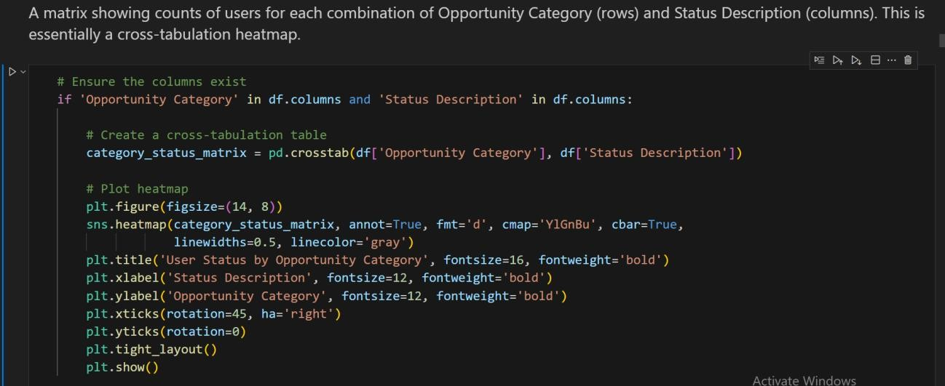

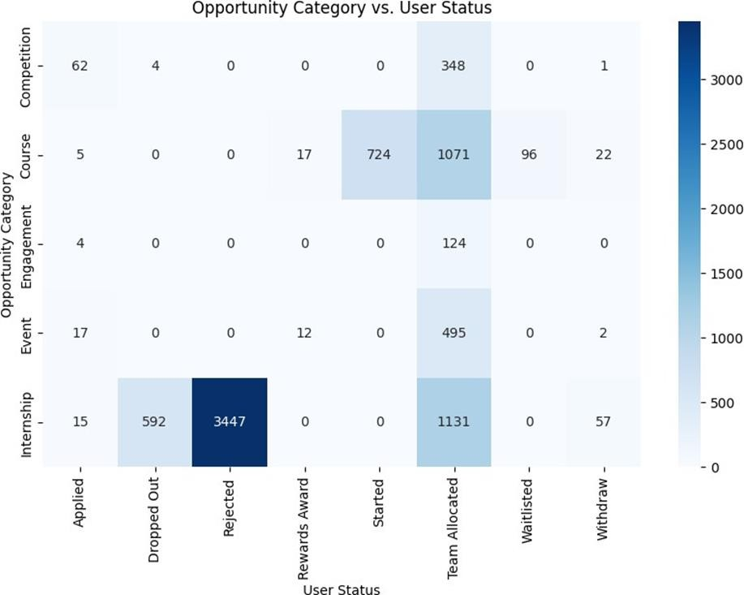

|  |  |
| --- | --- |
| **Aspect** | **Details** |
| **Figure** | User Status by Opportunity Category (Heatmap) |
| **Columns Used** | Opportunity Category, Status Description |
| **Why Used** | To visualize the distribution of user statuses across opportunity types |
| **How it Matters** | Highlights which opportunity categories have higher or lower completion or other status types |
| **Importance** | Helps prioritize opportunities for engagement improvements or targeted interventions |

**Few important column’s Outliers Detection:**

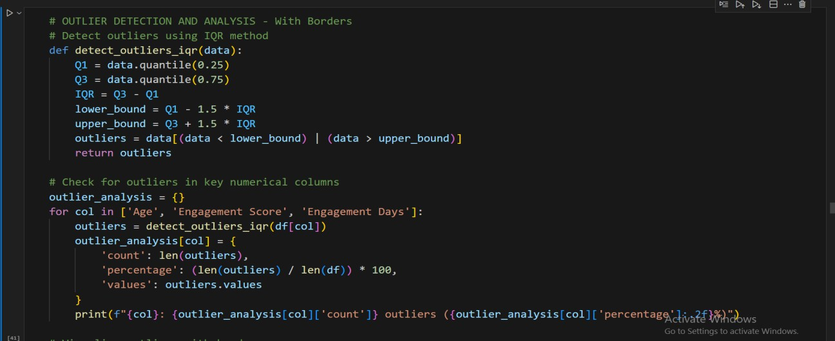

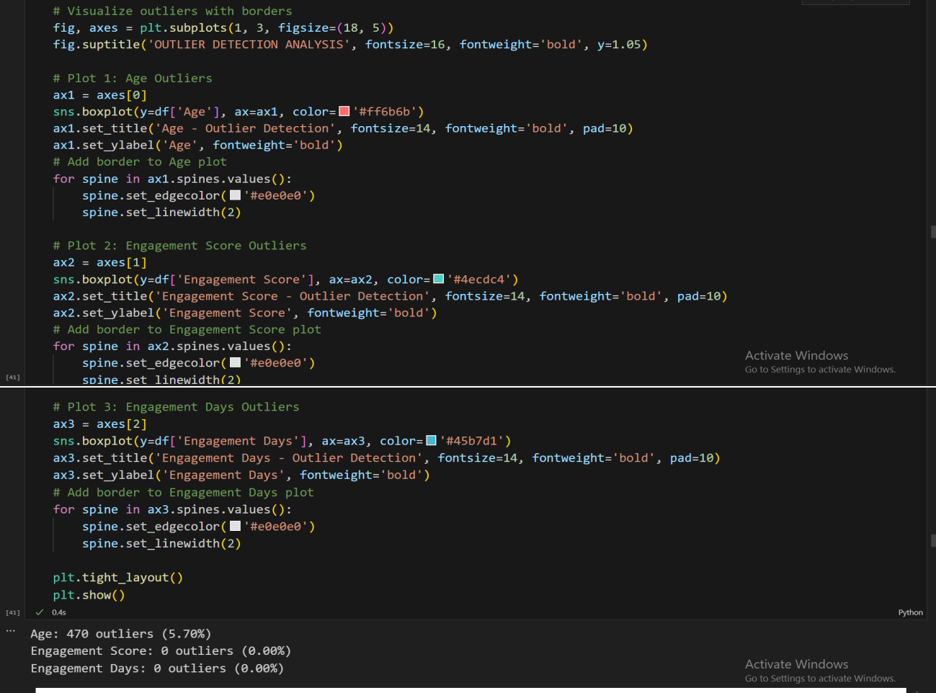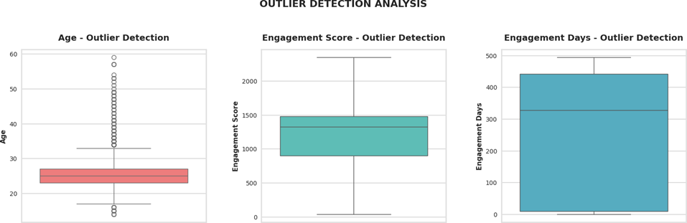

|  |  |  |  |
| --- | --- | --- | --- |
| **Aspect** | **Age Outliers** | **Engagement Score Outliers** | **Engagement Days Outliers** |
| **Figure** | Boxplot with border | Boxplot with border | Boxplot with border |
| **Columns Used** | Age | Engagement Score | Engagement Days |
| **Why Used** | To detect unusually low or high ages in dataset | To detect unusually low or high engagement scores | To detect unusually low or high engagement days |
| **How it Matters** | Identifies learners outside typical age range | Identifies extreme engagement behaviors | Identifies learners with abnormal engagement duration |
| **Importance** | Helps handle anomalies or segment analysis by age | Supports cleaner modeling and reliable insights | Supports cleaner modeling and reliable insights |

**Global Outliers:** Far from all other points.

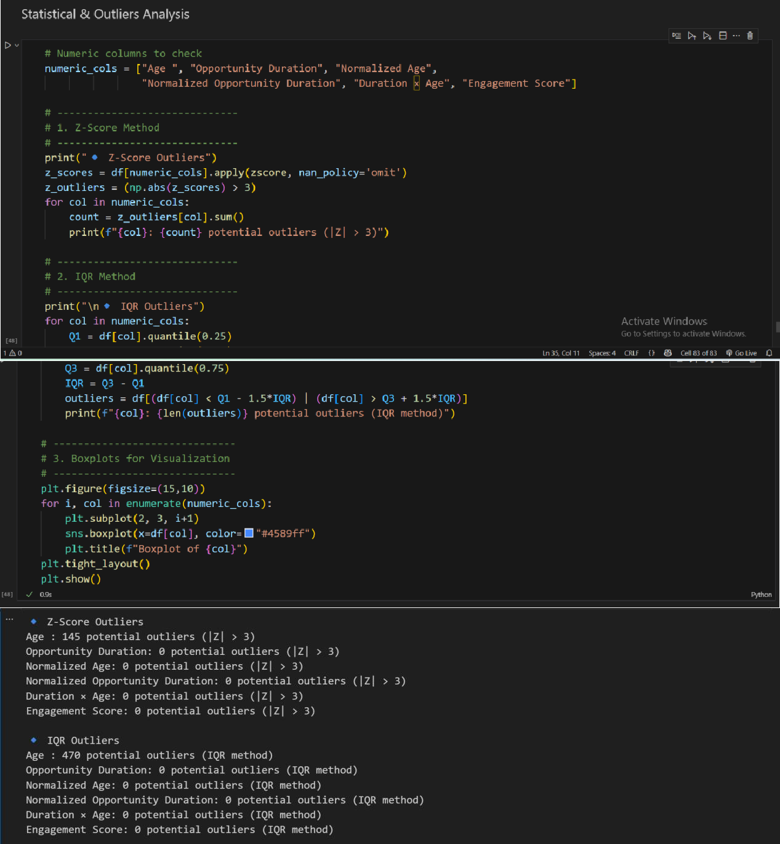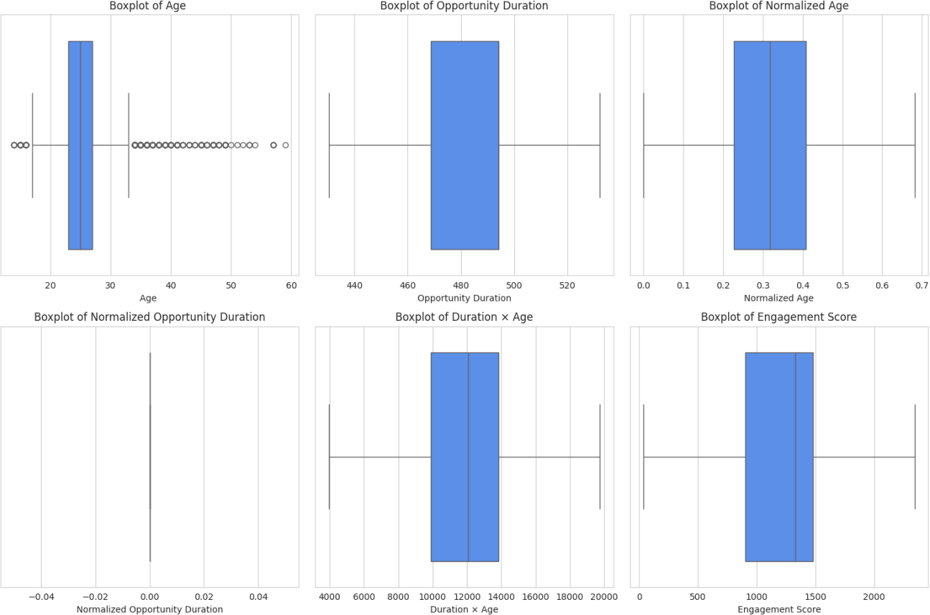

|  |  |
| --- | --- |
| **Aspect** | **Outlier Detection in Numeric Columns** |
| **Figure** | Boxplots for each numeric column |
| **Columns used** | Age , Opportunity Duration, Normalized Age, Normalized Opportunity Duration, Duration × Age, Engagement Score |
| **Why used** | To detect unusual or extreme values in numeric features that could skew analysis or model performance |
| **How it matters** | Identifies potential data errors, extreme behaviors, or edge cases; informs decisions about data cleaning, transformation, or robust modeling |
| **Importance** | Ensures data quality, prevents biased statistical results, and improves reliability of downstream analyses or predictive models |

**Contextual Outliers:** Outliers in specific contexts.

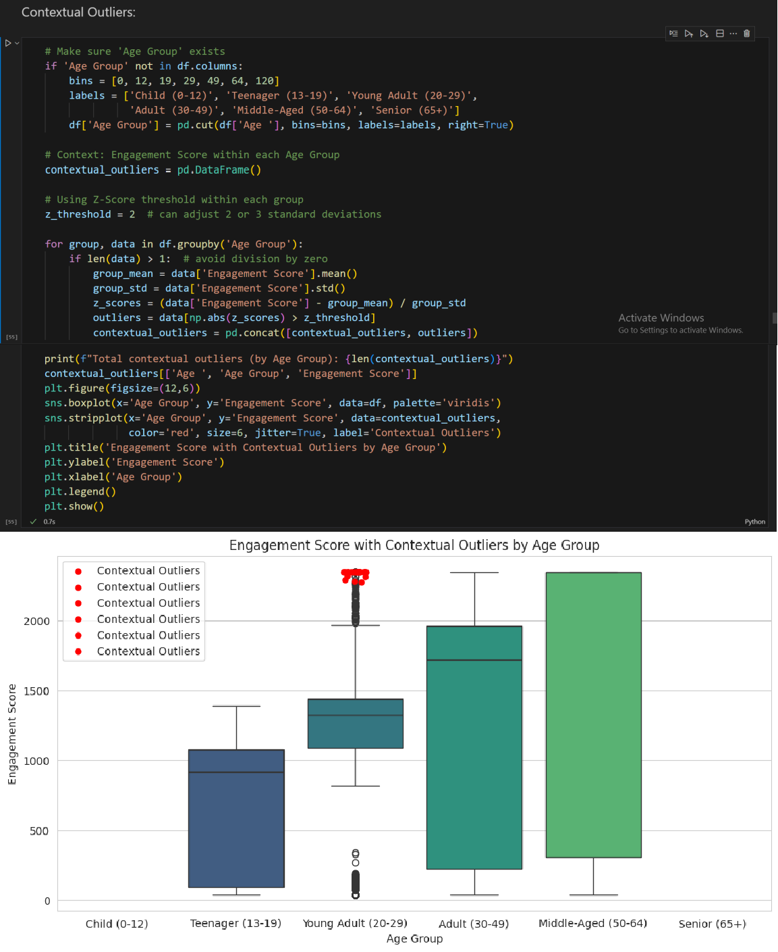

|  |  |
| --- | --- |
| **Aspect** | **Details** |
| **Figure** | Contextual Outliers in Engagement Score by Age Group (Boxplot with overlaid strip plot highlighting outliers) |
| **Columns used** | Age , Age Group, Engagement Score |
| **Why used** | To detect unusually high or low engagement scores within each age group context, rather than across the whole dataset |

|  |  |
| --- | --- |
| **Aspect** | **Details** |
| **How it matters** | Identifies users whose engagement is atypical for their age bracket, enabling targeted interventions or deeper analysis |
| **Importance** | Improves understanding of age-specific engagement patterns and helps prevent skewed insights caused by extreme values |

**Collective Outliers:**Groups that deviate collectively.

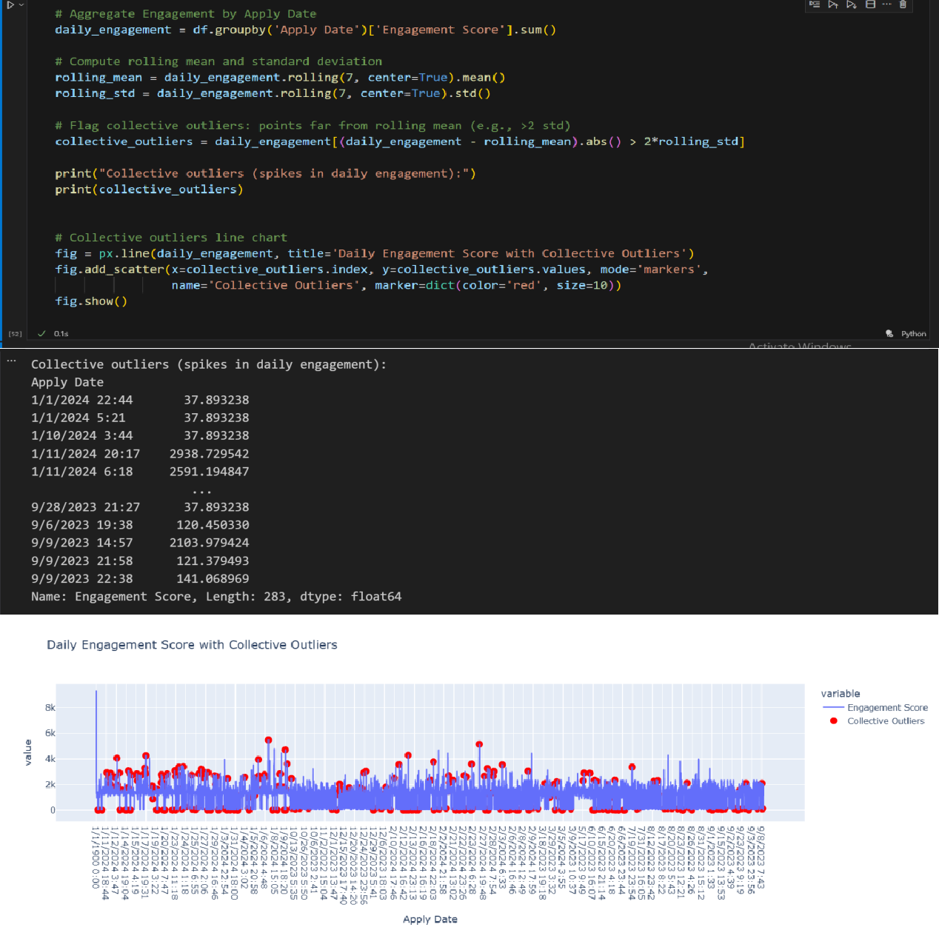

|  |  |
| --- | --- |
| **Aspect** | **Daily Engagement Score with Collective Outliers** |
| **Figure** | Line Chart with Outlier Markers |
| **Columns used** | Apply Date, Engagement Score |
| **Why used** | To visualize daily engagement trends and highlight unusual spikes that deviate significantly from the 7-day rolling mean |
| **How it matters** | Helps detect abnormal activity patterns, potential anomalies, or events causing engagement surges |
| **Importance** | Supports anomaly detection, data quality checks, and operational or strategic decisions to address or investigate spikes |

1. **Critical Anomaly:** *(Visualized in Excel)*

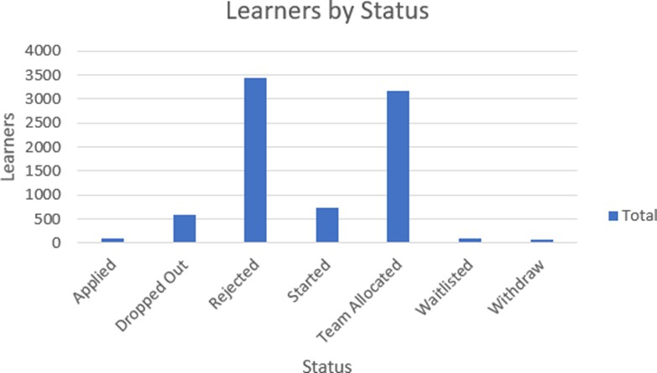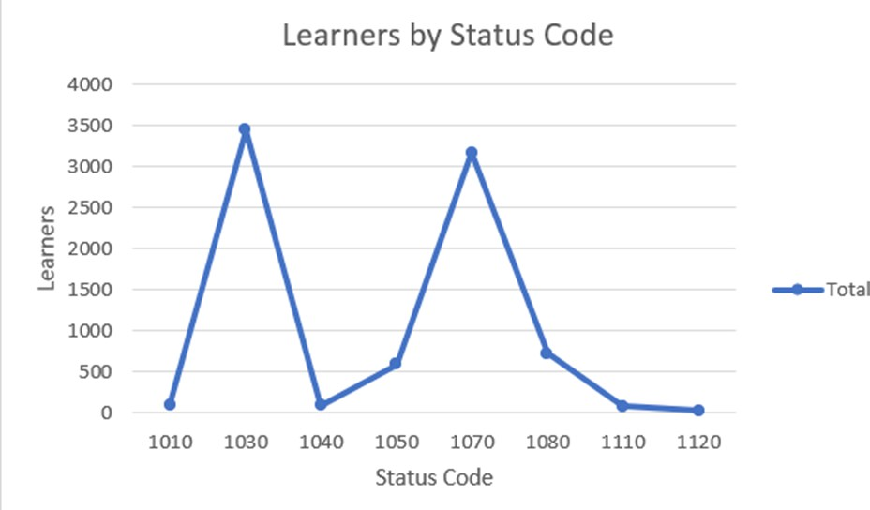

|  |  |  |
| --- | --- | --- |
| **Aspect** | **Learners by Status (Bar Chart)** | **Learners by Status Code (Line Chart)** |
| **Figure** | Bar chart showing learner counts per Status Description | Line chart showing learner counts across numeric Status Codes |
| **Columns used** | Status Description | Status Code |
| **Why used** | To visualize **categorical distribution** of learner statuses (e.g., Completed, Dropped, In-progress) | To visualize **numeric patterns** in learner outcomes and identify trends or anomalies |
| **How it matters** | Highlights where users are **progressing or dropping off**, useful for identifying bottlenecks | Helps spot **irregularities or critical anomalies** in coded data; supports mapping codes to descriptions |
| **Importance** | Identifies areas needing **intervention** to improve completion rates | Supports **quantitative monitoring**, automated checks, and anomaly detection |

1. **Trend Analysis and Pattern Identification:**

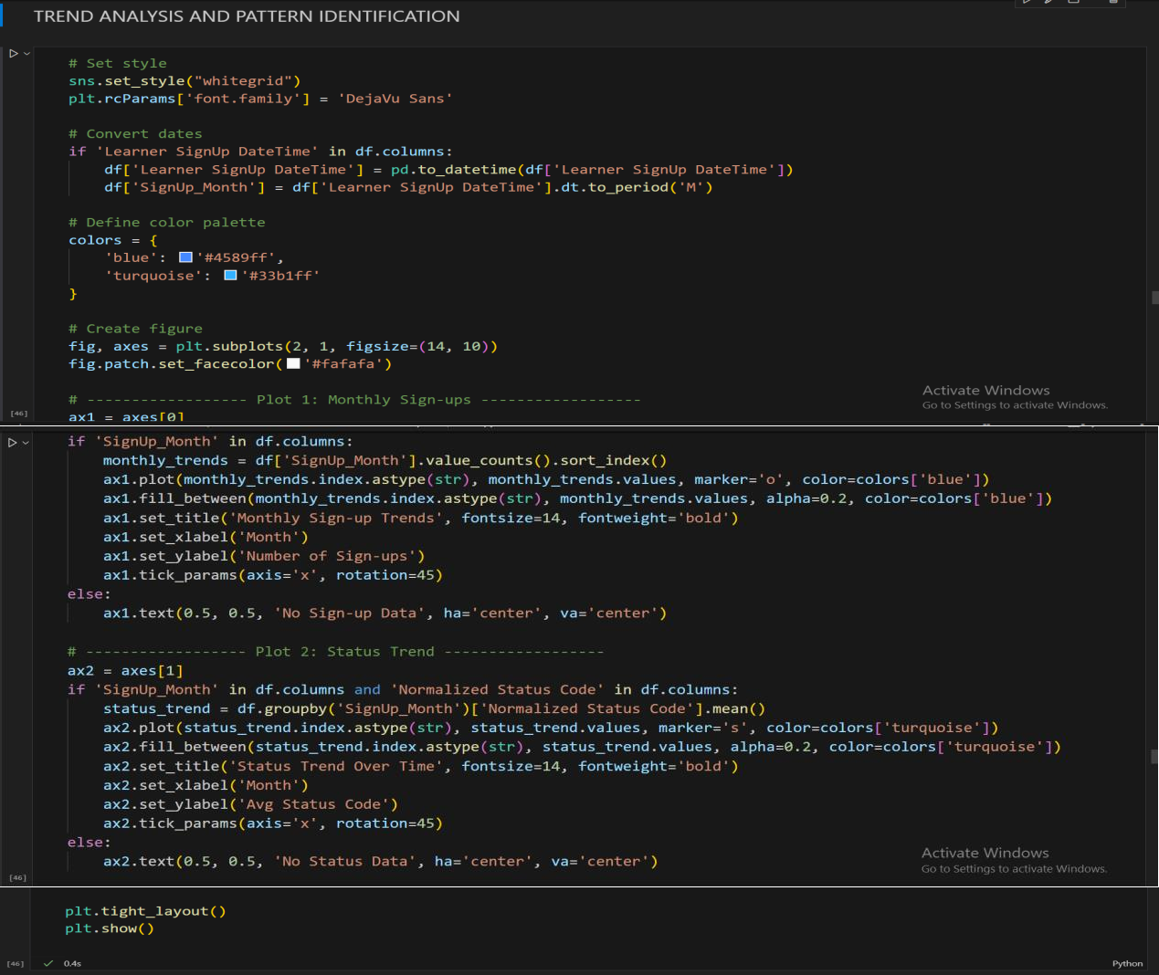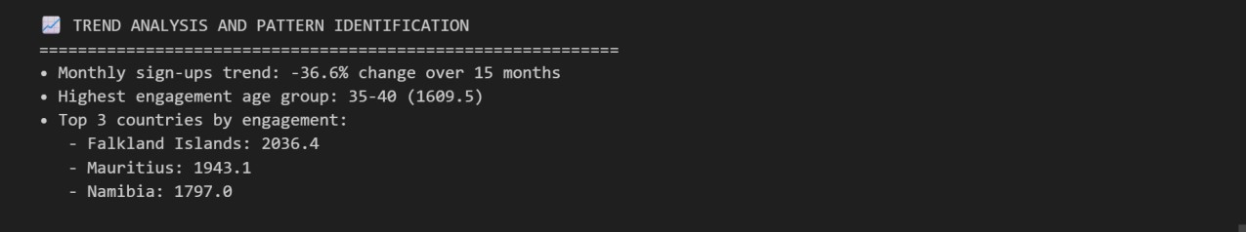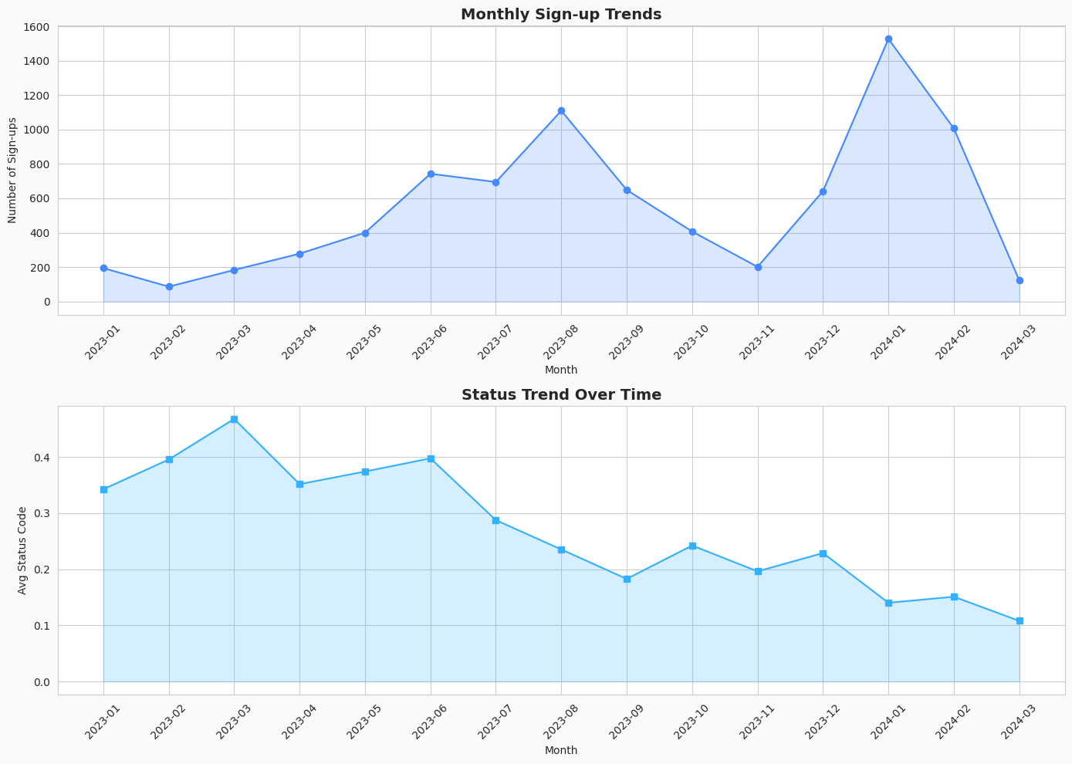

|  |  |  |
| --- | --- | --- |
| **Aspect** | **Monthly Sign-up Trends** | **Status Trend Over Time** |
| **Figure** | Line chart with markers and shaded area | Line chart with markers and shaded area |
| **Columns Used** | Learner SignUp DateTime / Exctracted SignUp Month | Extracted SignUp Month, Normalized Status Code |
| **Why Used** | To track the number of sign-ups per month | To track changes in average status code over time |
| **How it Matters** | Shows growth patterns, fluctuations, and seasonality | Reveals trends in user progress or engagement over time |
| **Importance** | Helps identify peak signup periods and plan campaigns | Helps monitor user status progression and spot anomalies |

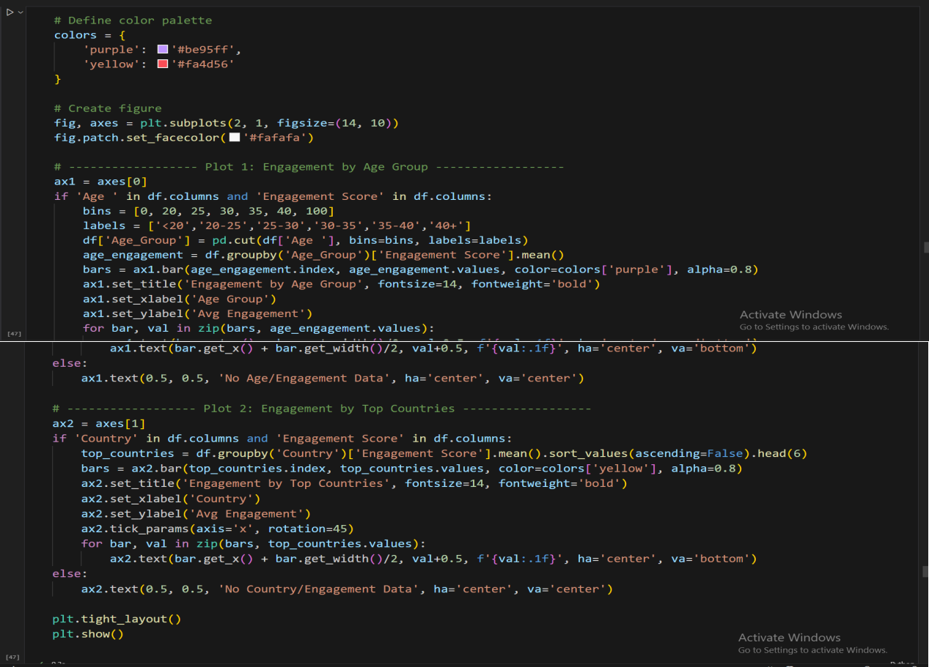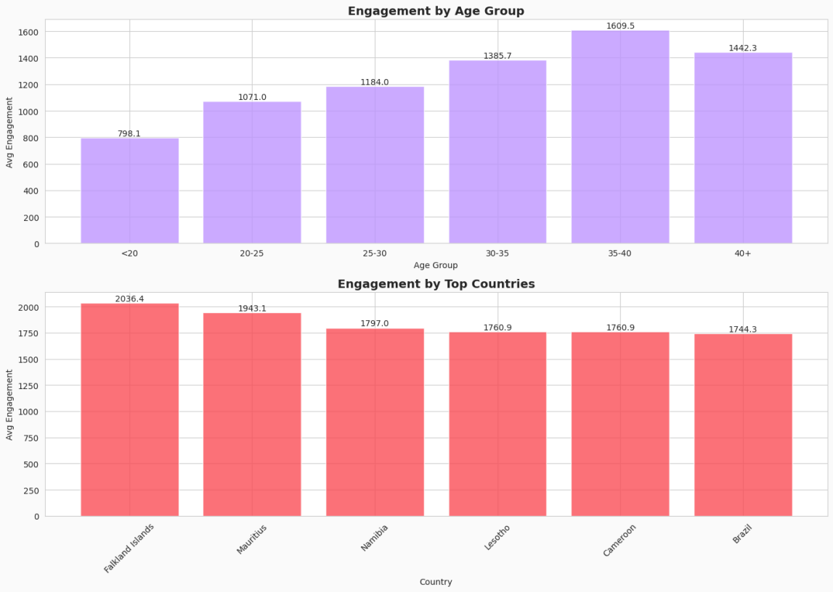

|  |  |  |
| --- | --- | --- |
| **Aspect** | **Engagement by Age Group** | **Engagement by Top Countries** |
| **Figure** | Bar chart – Avg Engagement Score by Age Group | Bar chart – Avg Engagement Score by Top Countries |
| **Columns Used** | Age_Group, Engagement Score | Country, Engagement Score |
| **Why Used** | To analyze engagement patterns across age brackets | To analyze engagement patterns across top countries |

|  |  |  |
| --- | --- | --- |
| **Aspect** | **Engagement by Age Group** | **Engagement by Top Countries** |
| **How it Matters** | Identifies which age groups are more engaged | Identifies countries with higher engagement |
| **Importance** | Helps target strategies or interventions by age | Helps target strategies or interventions geographically |

1. **Time Series Analysis:**

**Completion Trends:**

**Analysis Goals:** The primary objective of this analysis is to understand the key trends and drivers behind user signups and completions. By examining user demographics, engagement patterns, and opportunity types, we aim to identify actionable insights to improve completion rates and overall platform success.

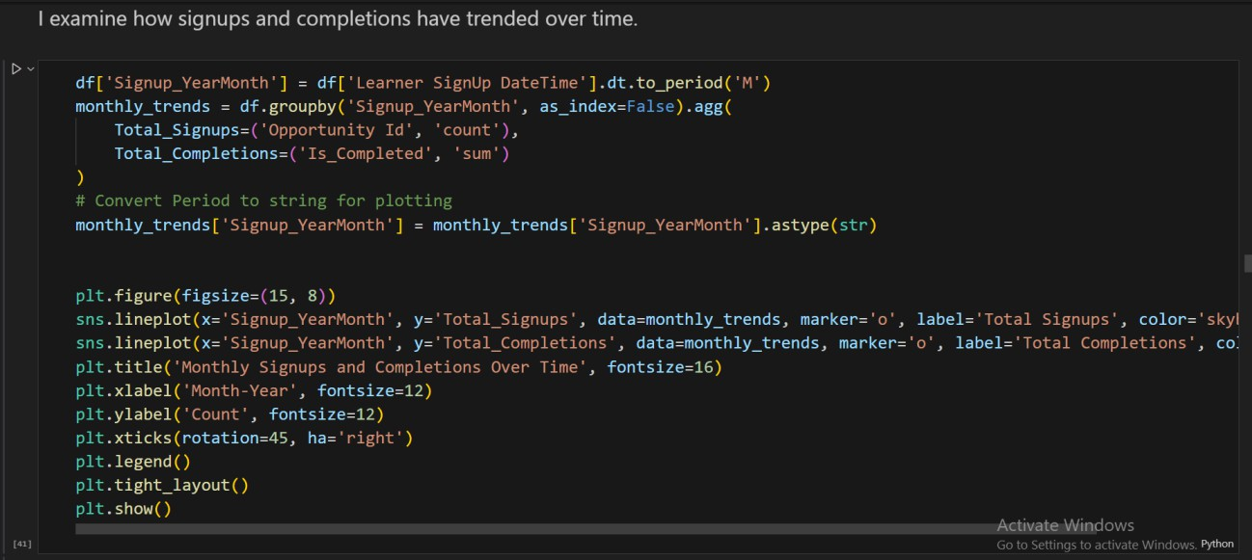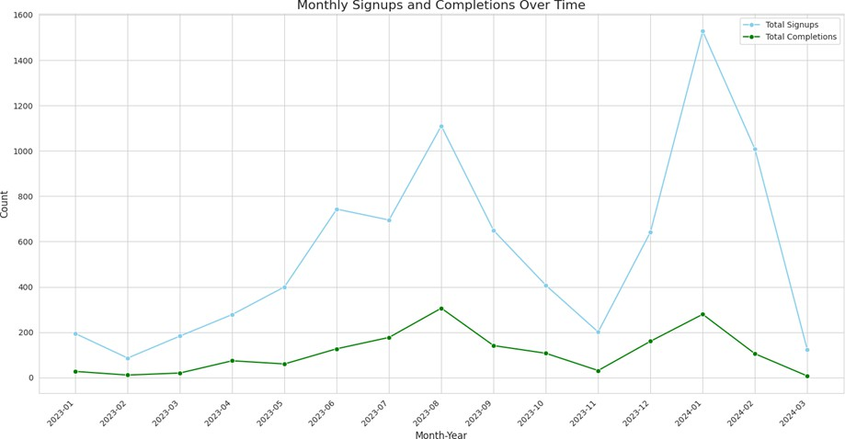

|  |  |
| --- | --- |
| **Aspect** | **Details** |
| **Figure** | Monthly Signups & Completions Over Time- Line Chart |
| **Columns Used** | Learner SignUp DateTime, Opportunity Id, Is_Completed |
| **Why Used** | To track monthly trends of new signups and completions. |
| **How it Matters** | Shows growth patterns, fluctuations, and retention over time. |
| **Importance** | Helps identify peak signup periods, monitor completion trends, and plan engagement strategies. |

**Growth and Fluctuations:** Analysis of monthly signups reveals significant fluctuations over time.

There are clear peaks and troughs in user registration, indicating seasonal or event- driven engagement.

**Seasonality:** Signup patterns show distinct seasonality, with certain months exhibiting higher registration activity. These peaks represent key opportunities for targeted marketing and user acquisition campaigns. The 'Seasonal Patterns' column, derived from signup dates, categorizes these into 'Winter', 'Spring', 'Summer', and 'Fall'.

**Spikes/Drops:** The time-series data shows notable spikes and drops in signups. These often correlate with the launch or conclusion of specific high-traffic opportunities.

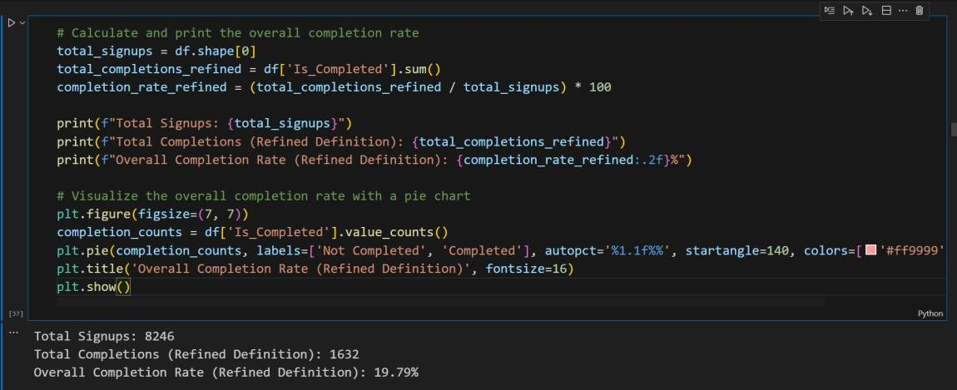

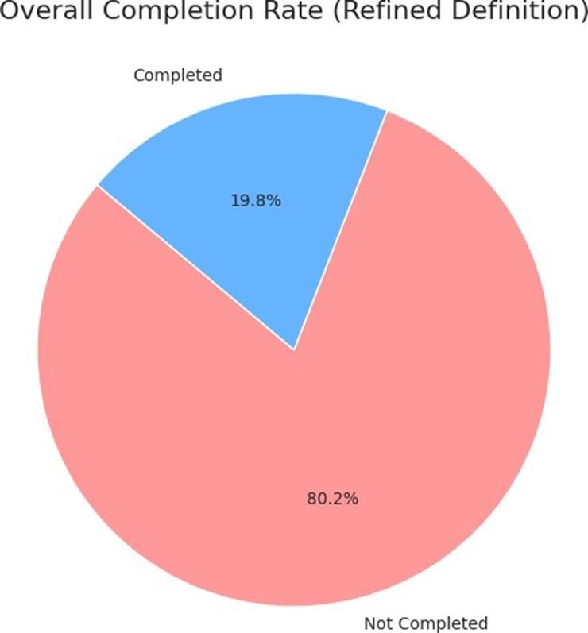

**Overall Stability:** The overall completion rate, based on a refined definition where success is measured by reaching 'Team Allocated' for Internships/Competitions and 'Rewards Award' for Events/Courses, is 19.8%. While this provides a baseline, the rate shows significant instability when broken down by opportunity type.

|  |  |
| --- | --- |
| **Aspect** | **Details** |
| **Figure** | Overall Completion Rate (Refined Definition) - Pie Chart |
| **Columns Used** | Status Description, Is_Completed (generalized in code) |
| **Why Used** | To show the proportion of learners who completed based on a refined definition. |
| **How it Matters** | Highlights completion trends and identifies the share of users finishing tasks. |
| **Importance** | Helps assess effectiveness of programs, identify gaps, and guide interventions to improve completion. |

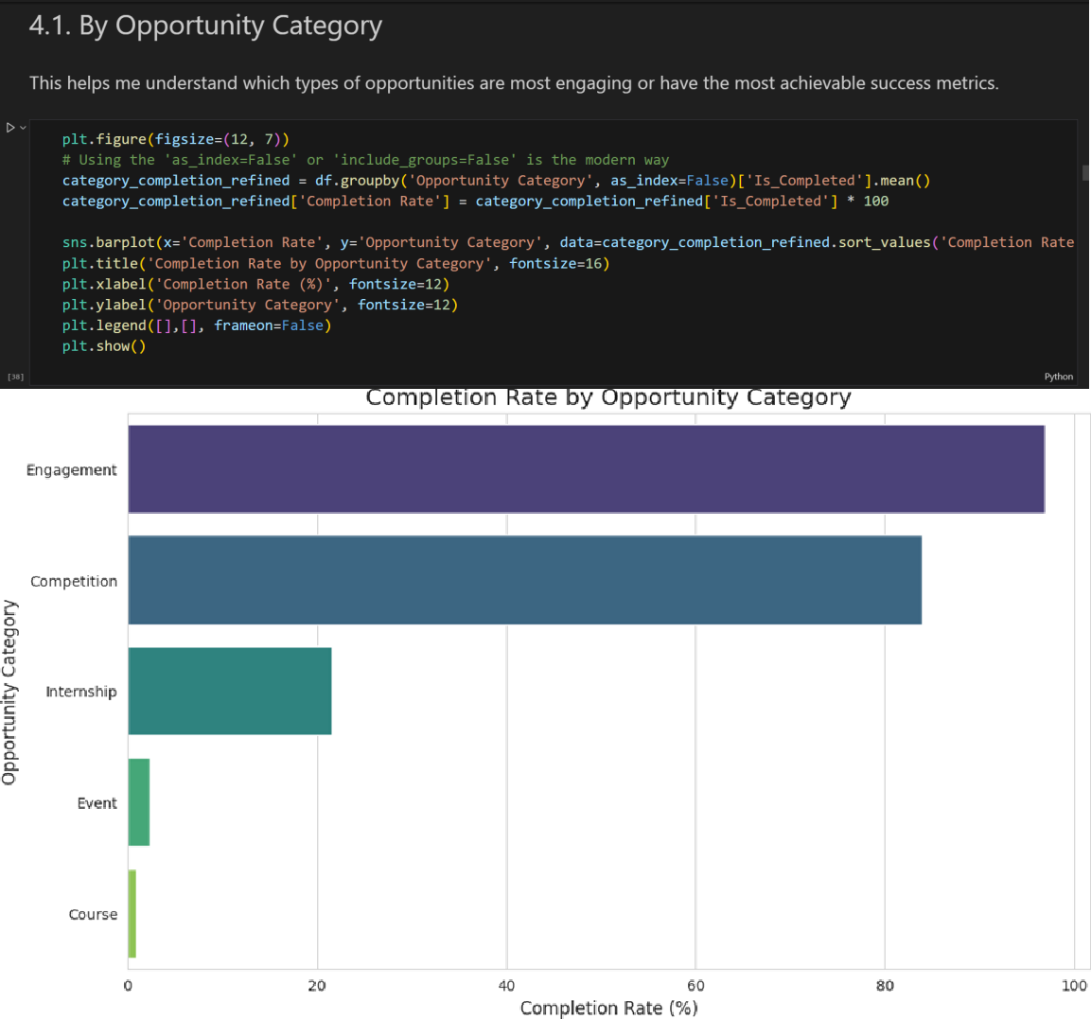

**Completion Rate by Opportunity Category:** The 'Engagement' category shows the highest completion rate, although it has the lowest number of participants. 'Competition' and 'Internship' opportunities have notably lower completion rates, with 'Internship' being the most popular but also the most challenging for users to complete.

|  |  |
| --- | --- |
| **Aspect** | **Details** |
| **Figure** | Completion Rate by Opportunity Category (Horizontal Bar Chart) |

|  |  |
| --- | --- |
| **Aspect** | **Details** |
| **Columns Used** | Opportunity Category, Is_Completed |
| **Why Used** | To measure completion rates across different opportunity categories. |
| **How it Matters** | Identifies which categories have higher or lower completion performance. |
| **Importance** | Helps prioritize or improve specific opportunity types to enhance overall completion. |

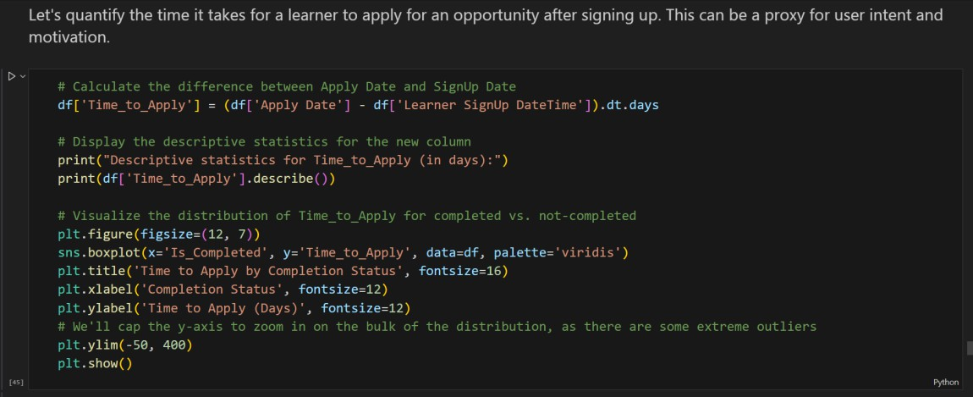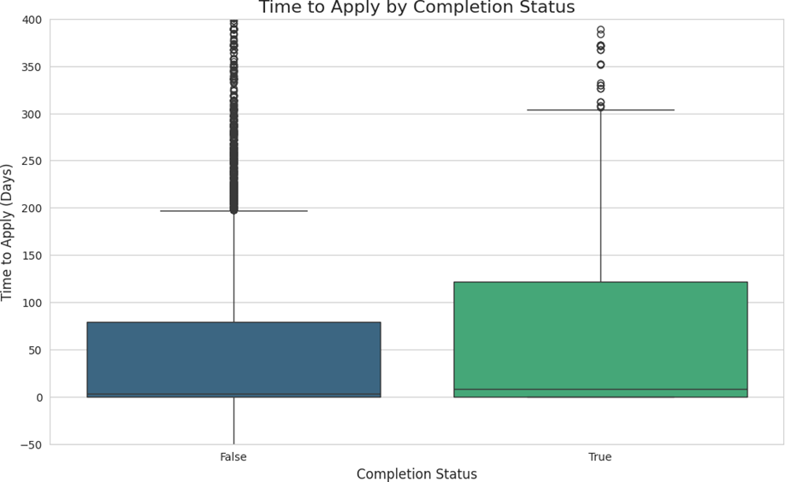

**Time Variations:** Analysis of 'Time_to_Apply' shows that users who successfully complete opportunities tend to apply much faster after signing up, with a median application time of just a few days compared to a much wider and higher distribution for non-completers.

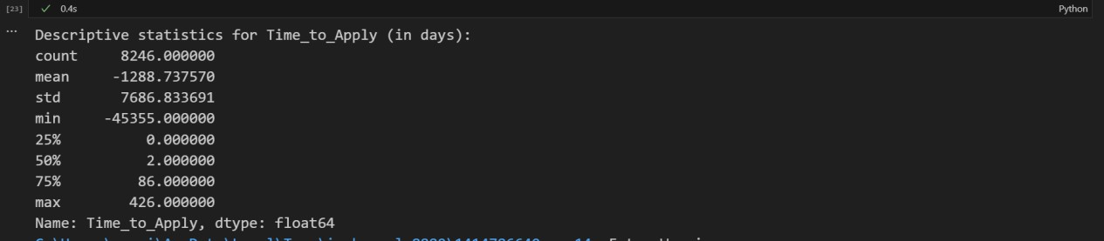

|  |  |
| --- | --- |
| **Aspect** | **Details** |
| **Figure** | Time to Apply by Completion Status - Boxplot |
| **Columns Used** | Learner SignUp DateTime, Apply Date, Is_Completed |

|  |  |
| --- | --- |
| **Aspect** | **Details** |
| **Why Used** | To analyze the time gap between signup and application submission. |
| **How it Matters** | Highlights differences in application behavior between completed and non-completed users. |
| **Importance** | Identifies potential delays or bottlenecks in the application process, informing process improvements and user engagement strategies. |

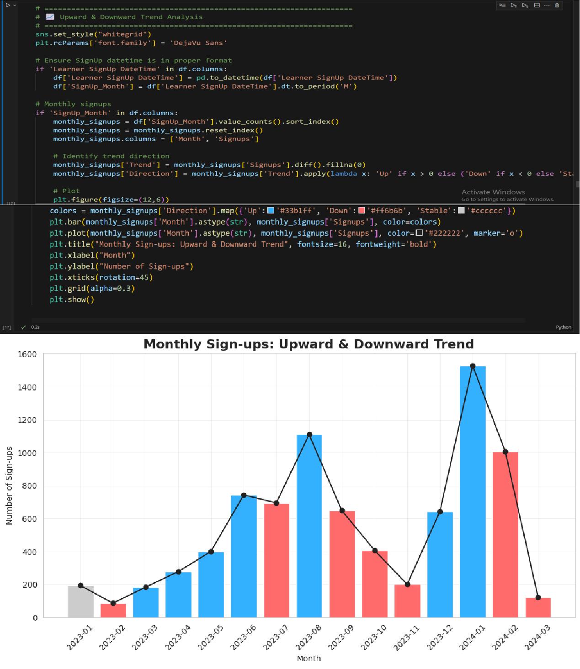**Upward & Downward Trend:**

|  |  |
| --- | --- |
| **Aspect** | **Details** |
| **Figure** | Bar chart with line overlay – Monthly Sign-ups highlighting Upward, Downward, and Stable trends |
| **Columns used** | Learner SignUp DateTime |
| **Why used** | To visualize the month-to-month trend of learner sign-ups, identifying periods of growth, decline, or stability. The color-coded bars indicate the direction of change. |
| **How it matters** | * Quickly shows months with increasing or decreasing learner activity. * Helps correlate trends with events, campaigns, or seasonality. * Highlights periods requiring intervention or further analysis. |

|  |  |
| --- | --- |
| **Aspect** | **Details** |
| **Importance** | Supports operational and strategic planning by identifying peak and low periods for learner engagement. Useful for resource allocation, targeted campaigns, and understanding growth patterns over time. |

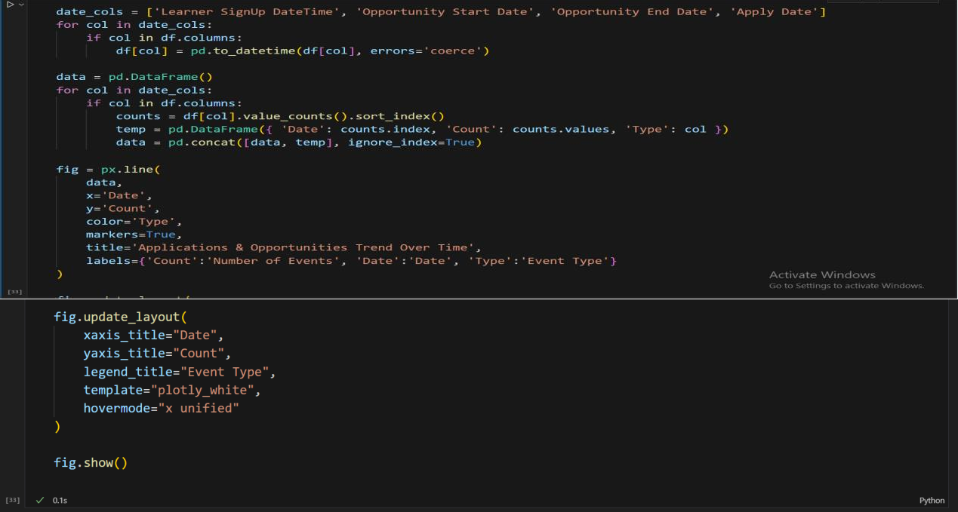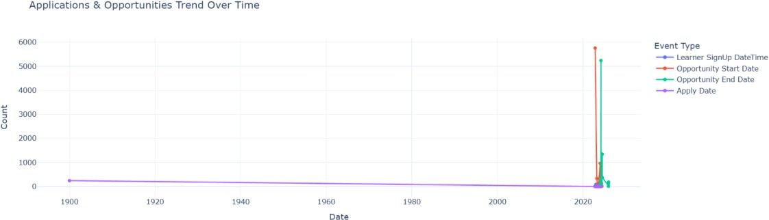

|  |  |
| --- | --- |
| **Aspect** | **Details** |
| **Figure** | Applications & Opportunities Trend Over Time **(**Multi-line chart showing counts of events over time) |
| **Columns used** | Learner SignUp DateTime, Opportunity Start Date, Opportunity End Date, Apply Date |
| **Why used** | To visualize trends in applications, opportunity starts, ends, and applications over the entire timeline |
| **How it matters** | Helps identify peak periods, seasonal trends, or gaps in user engagement and opportunity launches |
| **Importance** | Supports resource planning, marketing campaigns, and understanding temporal dynamics of learner behavior and opportunity lifecycle |

**Seasonal Trends:**

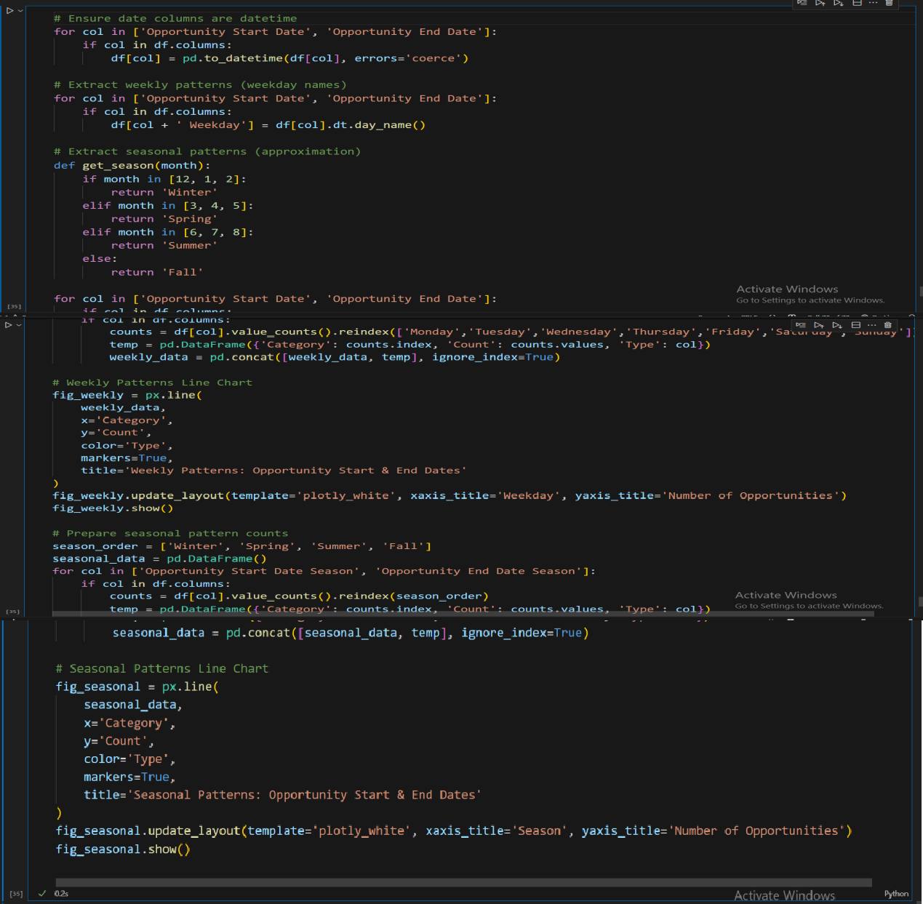

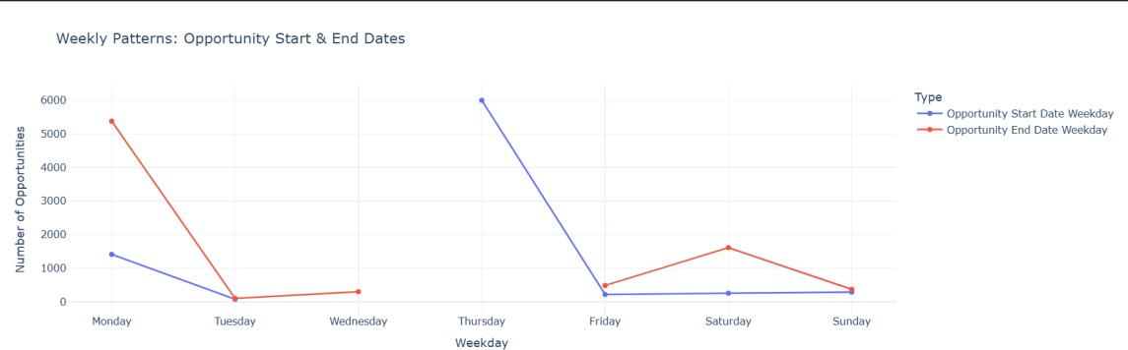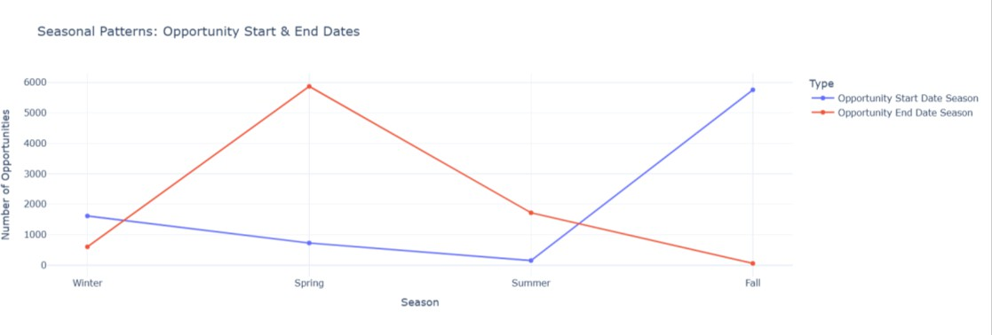

|  |  |
| --- | --- |
| **Aspect** | **Weekly & Seasonal Patterns of Opportunities** |
| **Figures** | 1. Weekly Patterns: Opportunity Start & End Dates (Line Chart) 2. Seasonal Patterns: Opportunity Start & End Dates (Line Chart) |
| **Columns used** | Opportunity Start Date, Opportunity End Date, Weekly Patterns, Seasonal Patterns |
| **Why used** | To visualize temporal trends in opportunity start and end dates across weekdays and seasons |
| **How it matters** | Highlights which days and seasons have higher activity, enabling scheduling, marketing, and resource allocation insights |
| **Importance** | Supports operational planning, identifies peak opportunity periods, and helps anticipate learner engagement patterns |

**Cyclical Trends:**

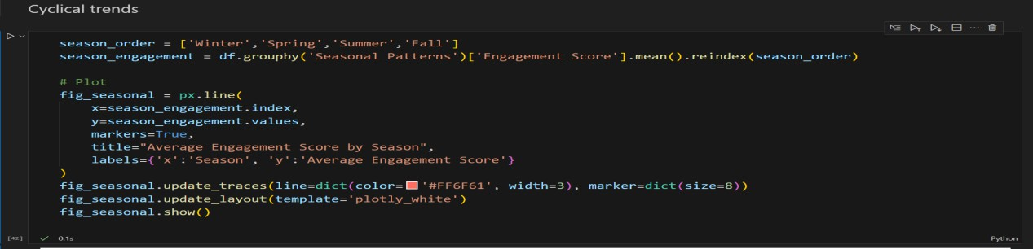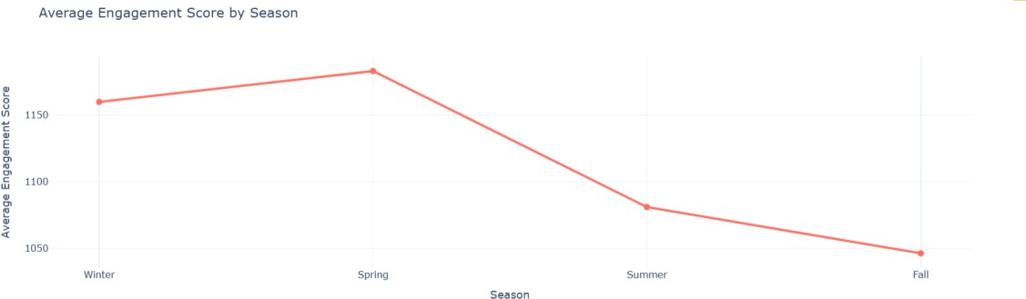

|  |  |
| --- | --- |
| **Aspect** | **Details** |
| **Figure** | Average Engagement Score by Season **(**Line Chart) |
| **Columns used** | Seasonal Patterns, Engagement Score |
| **Why used** | To analyze how average engagement varies across different seasons |
| **How it matters** | Reveals seasonal trends in engagement, helping plan campaigns, content releases, or interventions to boost learner activity |
| **Importance** | Identifies high- and low-engagement periods, supports strategic decision-making, and improves overall engagement management |

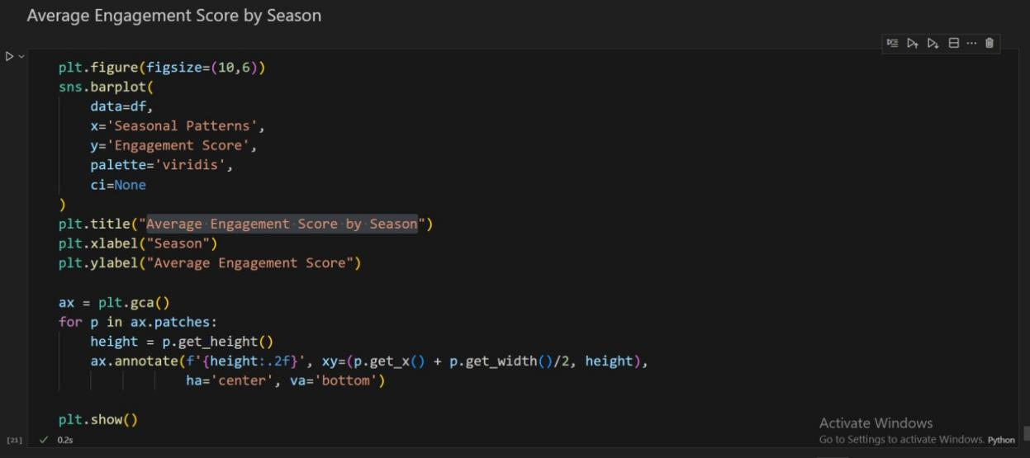

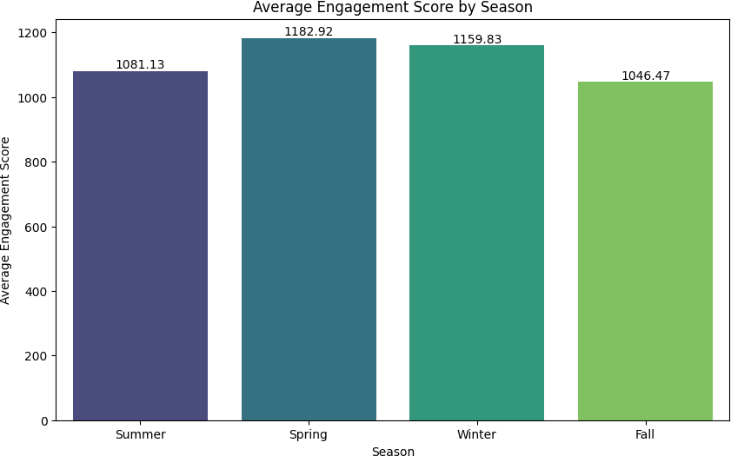

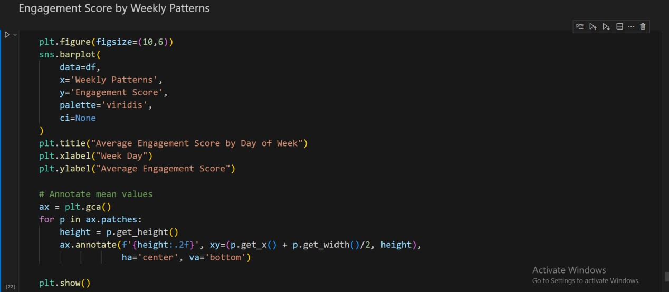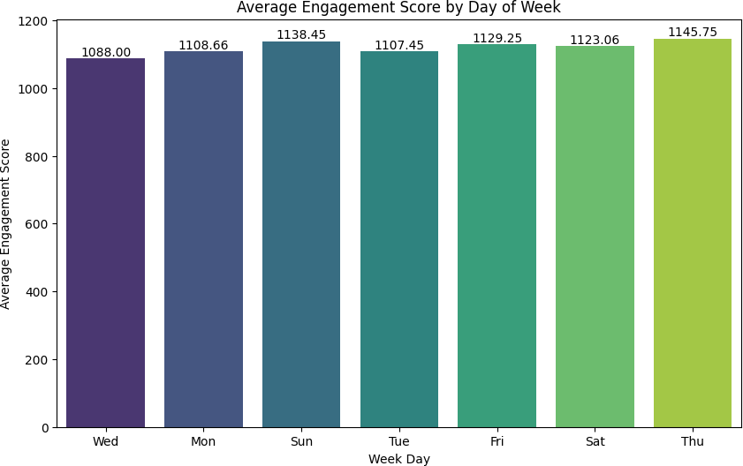

|  |  |
| --- | --- |
| **Aspect** | **Details** |
| **Figure** | 1. Average Engagement Score by Season (Bar Plot) 2. Average Engagement Score by Weekday (Bar Plot) |
| **Columns used** | Seasonal Patterns, Weekly Patterns, Engagement Score |
| **Why used** | To show **how engagement scores vary by season and day of the week**, revealing temporal patterns in user activity. |
| **How it matters** | * Identifies **peak seasons and weekdays** for higher engagement. * Supports planning and scheduling of opportunities or interventions. * Helps detect trends that may influence participation rates. |
| **Importance** | Provides actionable insights for **timing strategies**, ensuring programs are scheduled to maximize learner engagement.   * Weekly Patterns → Shows engagement trends over the week. * Seasonal Patterns → Captures cyclical variations across seasons. |

1. **Exporting Key Findings for Report:**

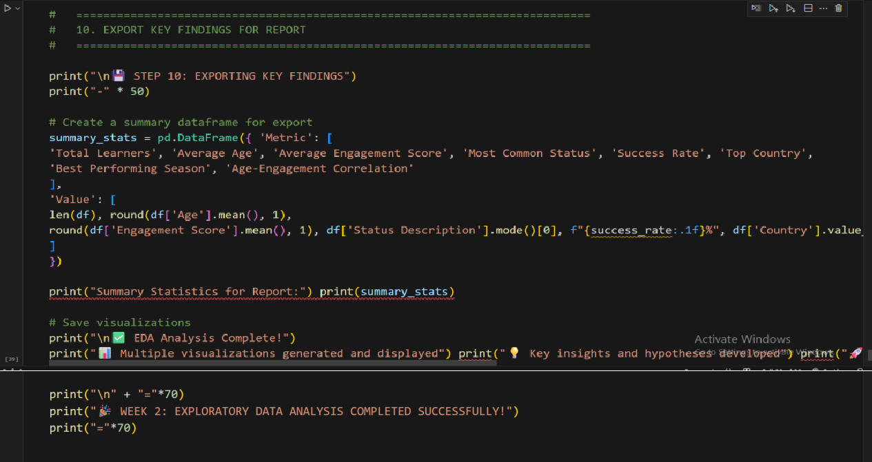

***OUTPUT:***

* + STEP 10: EXPORTING KEY FINDINGS

Summary Statistics for Report:

Metric Value

1. Total Learners 8246
2. Average Age 25.5
3. Average Engagement Score 1121.0
4. Most Common Status Rejected
5. Success Rate 10.1%
6. Top Country United States
7. Best Performing Season Spring
8. Age-Engagement Correlation 0.215

✅ EDA Analysis Complete!

* + Multiple visualizations generated and displayed
  + Key insights and hypotheses developed

======================================================================

* + WEEK 2: EXPLORATORY DATA ANALYSIS COMPLETED SUCCESSFULLY!

======================================================================

# Important Key Insights Identified

1. **Age–Engagement Correlation**

|  |  |  |
| --- | --- | --- |
| **Metric** | **Value** | **Insight** |
| Age–Engagement Correlation | 0.215 | Older learners show slightly higher engagement |

1. **Status-wise Performance**

|  |  |  |  |
| --- | --- | --- | --- |
| **Status Description** | **Engagement Score (Mean)** | **Count** | **Age (Mean)** |
| Applied | 1246.44 | 103 | 24.83 |
| Dropped Out | 747.83 | 596 | 25.78 |
| Rejected | 1341.89 | 3447 | 25.54 |
| Rewards Award | 904.00 | 29 | 26.07 |
| Started | 1496.74 | 724 | 24.94 |
| Team Allocated | 854.42 | 3169 | 25.45 |
| Waitlisted | 1578.45 | 96 | 25.33 |
| Withdraw | 914.82 | 82 | 25.35 |

1. **Seasonal Performance Patterns**

|  |  |  |  |
| --- | --- | --- | --- |
| **Season** | **Engagement Score (Mean)** | **Normalized Status Code** | **Normalized Age** |
| Fall | 1046.47 | 0.20 | 24.97 |
| Spring | 1182.92 | 0.35 | 24.73 |
| Summer | 1081.13 | 0.30 | 25.90 |
| Winter | 1159.83 | 0.18 | 25.51 |

1. **Gender-based Analysis**

|  |  |  |  |
| --- | --- | --- | --- |
| **Gender** | **Engagement Score (Mean)** | **Age (Mean)** | **Normalized Status Code** |
| Female | 1104.66 | 25.34 | 0.25 |
| Male | 1131.50 | 25.54 | 0.23 |
| Other | 1477.58 | 26.33 | 0.19 |
| Prefer Not To Say | 1307.99 | 25.60 | 0.50 |

# Hypothesis Development Recommendations

Based on Week-2 exploratory analysis, the following hypotheses are proposed. Each is testable, data-driven, and aligned with observed dataset patterns. Alongside, recommended statistical or machine learning methods are provided to validate them in Week-3.

1. **Demographic Influences on Engagement and Completion**
   * Age is significantly associated with learner engagement, with the 23–27 age group showing higher participation and completion.

Recommended Test: ANOVA / Kruskal-Wallis (for comparing engagement across age groups).

* + Gender differences in engagement are minimal, but completion rates differ slightly between males and females.

Recommended Test: Chi-square test (completion × gender), independent t-test (engagement scores).

* + Geographic distribution affects engagement, with U.S. and India learners showing stronger activity than other countries.

Recommended Test: ANOVA / Kruskal-Wallis (engagement score across countries).

* + Learners from certain institutions or majors achieve higher completion rates. Recommended Test: Chi-square test (completion × institution/major), logistic regression (completion ~ institution/major).

1. **Opportunity Characteristics and Learner Outcomes**
   * Engagement varies significantly across opportunity categories, with “Courses” driving higher engagement.

Recommended Test: ANOVA / Post-hoc Tukey test.

* + Longer opportunity durations increase engagement but lower completion rates.

◻ Recommended Test: Correlation (duration × engagement), logistic regression (completion

~ duration).

* + “Engagement” opportunities achieve the highest completion rates despite low participation.

Recommended Test: Chi-square test (completion × opportunity category).

* + Competitions yield moderate engagement but lower completion than other categories. Recommended Test: ANOVA (engagement scores by category), Chi-square (completion × category).

1. **Temporal and Behavioral Dynamics**
   * Learners who apply quickly after signup (shorter “time-to-apply”) are more likely to complete.

Recommended Test: Logistic regression (completion ~ time-to-apply), Mann-Whitney U test.

* + Engagement and completion rates vary seasonally, with Spring performing best. Recommended Test: ANOVA (engagement ~ season), Chi-square (completion × season).
  + Weekday launches generate higher engagement compared to weekend launches. Recommended Test: Independent t-test (weekday vs weekend engagement).
  + Monthly signup peaks align with institutional cycles or opportunity launches. Recommended Test: Time-series decomposition / seasonal trend analysis.

1. **Engagement Metrics and Completion Behavior**
   * Higher engagement scores do not always predict completion.

Recommended Test: Correlation (engagement score × completion), Logistic regression.

* + Longer Engagement Days (application-to-start lag) reduce completion likelihood. Recommended Test: Logistic regression (completion ~ engagement days).
  + A reweighted Engagement Score emphasizing timely completion is a stronger predictor of success.

Recommended Test: Model comparison – logistic regression (old vs new score), ROC-AUC evaluation.

1. **Outliers and Anomalies as Predictive Signals**
   * Outliers in application timing (e.g., >1 year) strongly correlate with non-completion. Recommended Test: Outlier detection + Chi-square (completion × extreme delays).
   * Contextual outliers (e.g., unusually low engagement in high-performing age groups) reveal hidden learner challenges.

Recommended Test: Stratified boxplot analysis, ANOVA with interaction terms.

* + Collective anomalies in daily engagement (spikes/drops) are linked to event launches or deadlines.

Recommended Test: Time-series anomaly detection (moving average/ARIMA residual analysis).

1. **Completion Trends and Bottlenecks**
   * Low completion rates (~19.8%) are largely driven by Internship rejections. Recommended Test: Chi-square test (completion × category).
   * Early applicants complete at higher rates than late applicants. Recommended Test: Logistic regression (completion ~ time-to-apply quartiles).
   * Shorter, structured opportunities have higher completion than long, unstructured ones. Recommended Test: ANOVA / regression (completion ~ duration type).
2. **Cross-Feature Interactions**
   * Interaction of Age × Opportunity Duration influences engagement (younger learners sustain longer opportunities better).

Recommended Test: Two-way ANOVA / regression with interaction term.

* + Country × Opportunity Category interaction explains differences in completion trends. Recommended Test: Multi-way ANOVA / Chi-square test of independence.
  + Season × Weekday interaction influences signups and engagement, with peaks on specific weekdays in Spring.

Recommended Test: Two-way ANOVA / regression with interaction terms.

1. **Predictive Modeling for Hypothesis Validation**

In addition to classical hypothesis testing, predictive models can strengthen validation:

* + Logistic Regression: To predict completion likelihood from demographic, temporal, and engagement features.
  + Random Forest / Gradient Boosting: To identify top predictors of engagement and completion.
  + Survival Analysis: To model “time-to-apply” and completion behavior.
  + Clustering (K-Means): To segment learners based on age, engagement, and opportunity preferences.

# Conclusion

In Week-2, our team successfully advanced from dataset preparation to a comprehensive exploratory data analysis (EDA). Through systematic data cleaning, feature engineering, and visualization, we established a verified dataset free from missing values, duplicates, and inconsistencies. The EDA revealed critical patterns in learner demographics, opportunity participation, temporal behaviors, and engagement metrics. Key insights included the predominance of young learners (ages 23–27), higher engagement within “Courses” compared to “Internships,” seasonal variations favoring Spring, and disparities in completion driven by prolonged application delays and bottlenecks in internship opportunities.

Beyond descriptive analysis, we translated these findings into structured, testable hypotheses that will form the foundation for Week-3’s statistical validation and predictive modeling. The hypotheses span demographic factors, opportunity characteristics, temporal dynamics, engagement behaviors, and anomaly detection, ensuring that subsequent analyses are both evidence-driven and actionable.

Overall, Week-2 provided not only a deeper understanding of the dataset but also a roadmap for data-driven decision-making. By combining exploratory insights with clearly defined hypotheses, the groundwork has been laid for rigorous testing, advanced analytics, and the development of predictive models in the next phase of the project.

## Next Steps For Week-3:

* We will learn the fundamentals of predictive modeling and its business applications.
* We will explore churn analysis techniques to identify factors driving student drop-offs.
* We will build and train predictive models (Logistic Regression, Decision Trees, Random Forests) using historical data.
* We will evaluate model performance using accuracy, precision, recall, and F1-score.
* We will interpret feature importance to identify key drivers of student churn.
* We will develop actionable strategies for improving student retention based on insights.
* We will prepare a structured report summarizing models, results, and recommendations.